Alyth Primary Nursery – Home Learning - Week beginning 15th February 2021
Literacy  Taking part in conversations  Choose different subjects that you find interesting and make these the focus of conversations, e.g. at the dining table, on your walks.  Remember that you need to take turns to talk and it is important to listen to each other. | Numeracy  Money – using coins to pay for snacks  Make up a snack box for the week. Price each snack 1p, 2p, 5p or 10p (or up to £2 for a challenge). When it is snack time, choose the right coin to ‘pay’ for your snack.  Big challenge – adding up – use a variety of coins to make up the correct amount.  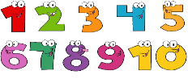  This Photo by Unknown Author is licensed under CC BY-NC  Continue with number games / songs / rhymes / counting skills | Health and Wellbeing  Turn-taking skills  Practise good turn-taking skills through games e.g.  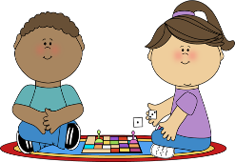  Pairs  Snap  Snakes and Ladders  Hide and Seek  Make sure that you play the game until the end.  Remember that you don’t always have to win!
Other Curricular areas  Senses – hearing  - Put a blindfold on and listen carefully to the noises around you. What can you hear? You could try this indoors and outdoors.  - Use yoghurt pots to make walkie-talkies attached by string. Listen carefully to what your partner says. Try it with the string loose, then tight. Is there any difference in the sound?  - Go on a ‘listening walk’. | Fine Motor skills  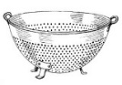  Use dry spaghetti or pipe cleaners to ‘thread’ through the holes in a colander. | Gross Motor skills  Go play in the snow. Build a snow creation or go sledging. Is the snow soft or hard, heavy or light, cold or hot?  Fill a box, bowl, bucket with snow – what shapes do they make?
Sensory  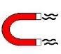  Fill a glass jar with water.  Place metal paper clips inside it.  Put the lid back on.  Get a magnet and place it next to the jar or try moving it around the jar and watch what happens.  What can you see happening? Why?  You could also fill a jar with very cold water and a jar with warm water and feel the difference. | Adventures with Alice  Thinking skills  Put a wide variety of items in a box or basket for your child to investigate.  What do they do?  Do they sort them in different ways?  Do they use them in a creative way?  Do they use lots of different words to describe the items in the box?  Do they ask questions about unfamiliar items? | Passport to Play  Active play – activities to make your heart beat faster!  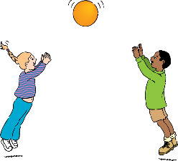  - do star jumps  - dance and spin around (not too much!)  - walk at a fast pace on your daily walks  Can you think of any more ideas?

