Alyth Nursery – Home Learning - Week beginning 18th January 2021
Literacy  Practise following instructions. Remember to listen carefully to the instruction before you start to do it. It is important to listen for all the information. If you want a challenge, try 2 or 3 part instructions.  Can you recall any of the facts you learned last week from information books, etc?  Draw a self-portrait. Remember to add lots of detail. | Numeracy  Money – set up a little shop. It could sell toys, books, shoes or anything you want. You can use toy money or real money (coins). Can you identify each coin’s amount?  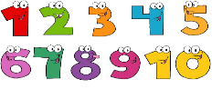  This Photo by Unknown Author is licensed under CC BY-NC  Continue with number games / songs / rhymes. Snakes and ladders is a great one to play.  Collect different shapes of junk for next week’s shape task. | Health and Wellbeing  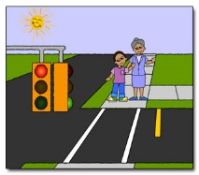  When you are out for your daily walk, practise your road safety skills.  -Find a safe place to cross.  -Remember to look left right, left again.  -If it is safe, cross carefully and keep looking and listening.  Why not play this listening game when you get back.  What's that sound? | Road Safety Scotland
Other Curricular areas  Technology  Where does our food come from? Have a look at food packaging. Where has your food come from? You might like to look at a world map to find some of the places. | Fine Motor skills  Choose a jigsaw to do. Can you do it yourself?  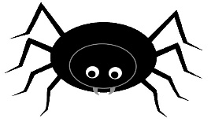  Try finger rhymes, e.g. ‘Incy Wincy Spider’, ‘Two Little Dicky Birds’.  Do some dot-to-dot pictures. Try to hold your pencil correctly. | 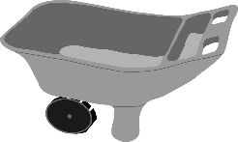  Gross Motor skills  Pushing and pulling  Have a look around the house to see what could be used as a ‘vehicle’ to practise pushing and pulling skills, e.g a wheelbarrow, a pram, a sit-in toy car, a washing basket, a tray, a box. Put some toys in your ‘vehicle’ and push / pull them around. If that is too easy, try something heavier!
Sensory  Freeze (or almost freeze) very small toys in ice and ask the children to chip away at the ice, e.g. with a small rolling pin, spoon, small wooden tools, to release the toy. Having a spray bottle with warm water helps, too! This is a fun activity to do outdoors.  Please wear goggles to protect the eyes from any bits of flying ice. | Adventures with Alice  Teddy treats  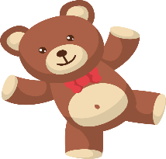  Choose a selection of teddy bears/soft toys. Use them to create adventures. Could an adventure happen in your den? Could you have a teddy bears’ picnic? Could you create a ‘car’ or ‘bus’ with little chairs / stools /cushions and go somewhere exciting? Does one of your toys do something mischievous?  Let your imagination run wild and have fun! | Passport to Play  Music  Build your own musical instruments. You can use bottles, tubs, tins, boxes and fill them with different things like rice, pasta, lentils, cotton buds, toys etc.  Dance, sing and play in your very own concert.  Experiment with sounds and play in a band. Play along to the beat of your favourite song.  Explore loud and soft, long and short, fast and slow sounds.

