Alyth Primary Eco Engineers
invite you a
School Uniform
Swap Shop

Open Monday 25th, Tuesday 26th and Wednesday 27th March after school from 3.15-4.00pm.
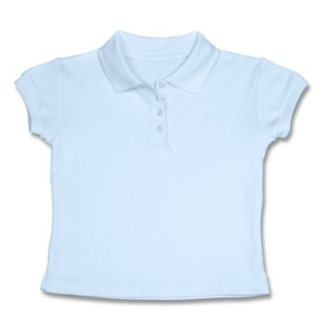
This Photo by Unknown Author is licensed under CC BY
DONATE
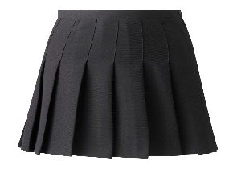
PICK-UP
SWAP

Bring in any items of school uniform you are finished with. (skirts, jumpers, cardigans, shirts, t-shirts, trousers). Donations can be handed in to the school office or to class teachers from Monday 11th March).
All items are available FREE of CHARGE. You don’t need to have donated to come along and take for your children.

