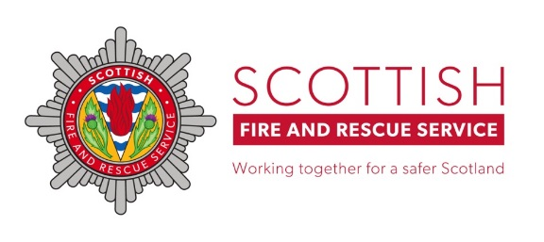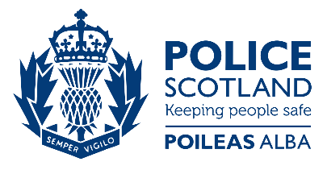
Dear Parents/Guardians,
Despite firework and bonfire season looking a lot different this year, Police Scotland and Scottish Fire & Rescue are keen to keep everyone safe during the festivities. In previous years we have seen firework-related anti-social behaviour (ASB) and we’re asking for your help to prevent this occurring again. We’re therefore offering the following advice:
- Unless supervised by an adult, please do not allow your children or young people to handle, purchase or set off fireworks.
- Do not allow your children or young people to be involved in, or accompany anyone who is involved in ASB or disorder.
- Please report any ASB or disorder you are aware of or hear of.
- Dispose of your rubbish appropriately leading up to bonfire weekend.
- Report any large objects that could form part of a bonfire to your local council office who will arrange for them to be removed.
- There are no local authority bonfire or firework displays this year. Please report instances where large groups of people are gathering (particularly in breach of COVID regulations) to Scottish Fire & Rescue, your local council, Police Scotland or Crimestoppers (details below).
- Please report any unauthorised fireworks sellers to Police or Crimestoppers
The laws covering fireworks are
No person under the age of 18 can possess an adult* firework in a public place
It is an offence to supply adult* fireworks to persons under 18
It is an offence to supply any fireworks to persons under 16
It is an offence to throw fireworks on a road or other public place

*Adult firework is any firework except for caps, cracker snaps, indoor fireworks, novelty matches, party poppers, serpents and throw downs
Our wish this year is to ensure residents feel safe in the area they reside in relation to fireworks and the Corona virus. The safety of those who live in our communities remains our top priority and any behaviour that places people or property at risk will not be tolerated.
Thank you for your understanding and assistance.
Kind regards
Scottish Fire & Rescue, Police Scotland

POLICE SCOTLAND 101
CRIMESTOPPERS 0800 555 111
IN AN EMERGENCY CALL 999

