Alyth Primary Nursery – Home Learning - Week beginning 25th January 2021
Literacy  Choose a favourite story to read each day. Have a discussion about the characters in the story.  What do they look like?  What are they wearing?  Do you see any patterns on their clothes?  Are they kind, helpful, naughty, etc? How do you know? Can you think of other words to describe them?  Are you like any of the characters?  Draw some of the characters from a story. You could cut out your characters and make them into finger puppets to retell the story. | Numeracy  Shape models – hopefully you collected some different shapes of junk last week. Your task this week is to create a model / models with your junk. Can you name any of the shapes you are using? Remember…if the shape is flat it is a 2D shape, e.g. circle, square. If the shape is not flat it is a 3D shape, e.g. cylinder, cube.  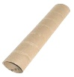  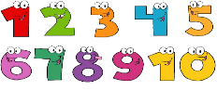  This Photo by Unknown Author is licensed under CC BY-NC  Continue with number games / songs / rhymes. | Health and Wellbeing  Preparing foods  We know that a lot of you enjoy being a snack helper at Nursery. Can you do the same at home? When preparing food, you could have a discussions, e.g.  Does the food need washed? Why?  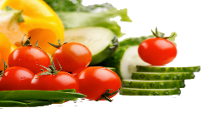  Can I eat the skin?  Is it a healthy food? Why?  What can I put in the recycling bins?  When having a fruit / vegetable snack, try to be creative and make faces, insects, pictures, etc. Let your imagination go wild!
Other Curricular areas  Science  What is the weather today?  You can make a grid to record the weather each day this week. Draw pictures of the weather into the grid and talk about the days of the week. i.e. it was sunny on Monday.  Talk about the weather. Is it cold or hot, wet or dry. When you are outside how does it make you feel? Can you see your breath? Why? How can we keep ourselves warm and dry when we are outside? Talk about the seasons. Why not visit the ABCya! Website and play the game.  Dress for the Weather • ABCya! | Fine Motor skills  Make pasta or cereal hoop necklaces.  Play ‘finger football’. You will need 2 ‘goals’ and a tiny ball. Flick the balls with your fingers to try to score a goal.  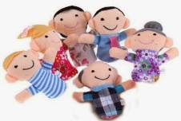  Puppet fun! If you have puppets, make up a puppet show and perform it to your family. | Gross Motor skills  Practise your balancing skills by…  -drawing a chalk line and very carefully walk along it, putting one foot very carefully in front of the other  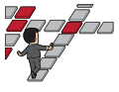  -creating a balance ‘bench’ from crates, wooden blocks  -standing on one leg, then the other  Challenge – balance something light on your head while doing these balancing activities.
Sensory  Make pop-corn in a pot.  Touch the kernels with clean hands before you put them in the pot. How do they feel?  Watch what happens in the pot and listen to the sound.  When they have cooled, touch the kernels with clean hands How do they feel now?  Talk about what happened during the heating process.  Enjoy eating the popcorn! | Adventures with Alice  Choose a bag or a box that you can find in the house. With an adult, choose a mixture of items to go inside your bag/box. Once you have done this, without looking, put your hand in the bag/box and feel the items. Can you guess what any of them are? Can you describe what you are feeling? Take turns with your adult to do this.  Have fun! | Passport to Play  Mark making!  If you have some paint in the house, why not find some different objects to make prints with. You could use a potato masher, a Lego brick, a toy car’s wheels, a plastic animal’s footprints, a fork, a cotton bud, scone cutter, the bottom of a bottle, box or tray. Dip them in some paint and make patterns on paper or cardboard. If you don’t have paint, why not try making marks in the snow or mud outside.  Have fun!

