Alyth Primary Nursery – Home Learning - Week beginning 1st February 2020
Literacy  Choose a favourite story to read each day. Have a discussion about the events in the story.  -Where does the story take place?  - Can you re-tell the story?  - Did you enjoy the story? Why?  - What happened in it that you liked?  - Were the events in the story exciting / scary / funny?  - Can you think of other words to describe the events in the story? | Numeracy  Measure  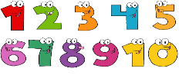  Have fun measuring around the house and garden. You can use anything to measure with.  This Photo by Unknown Author is licensed under CC BY-NC  Why not count how many steps it takes to cross your sitting room or how may spoons it would take to measure your bed. How tall are you? How could you find out? These are just suggestions. Can you think of other ways to measure things?  Continue with number games / songs / rhymes. | Health and Wellbeing  Independence skills. Can you…  - make your bed?  - choose your clothes for the day?  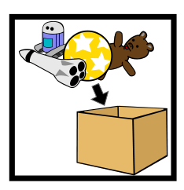  - get dressed / undressed?  - put your shoes on?  - serve yourself breakfast / snack?  - wash your own dishes?  - tidy up after you have played?  - tidy your bedroom?  - clean your own teeth?
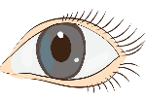  Other Curricular areas  Science – sight.  - Use tubes to make your own binoculars.  - Look through real binoculars if you have them.  - Use a magnifying glass to look at thigs really close up. Do they look different? In what way?  - Play ‘I spy’ with colours / letters / numbers, e.g. “I can see 2 of these.”  - Fill plastic bottles with coloured water and add stones, shells, gems, glitter, etc.  - What can you see at night time? Use a torch.  - What would it be like without our sight? Wear a blindfold and be guided around the house or garden by your grown-up or older sibling. | Fine Motor skills  Follow the pattern – You will need an adult to draw a pattern of dots or lines for you. These can be straight lines, squiggly lines or zig-zag lines. You then use your finger or a pencil to follow the pattern. Why not use small things to place on the pattern like pasta or beads.  - - - - - - - - - - - - - - - - - - - - - - - -  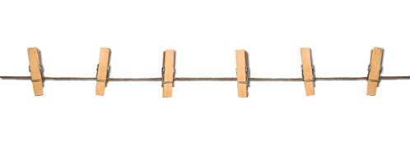  Create a mini washing line for your socks / toy’s clothes / baby clothes. Peg the items up on your washing line. | Gross Motor skills  Jump, reach and grab!  Cut out shapes and write a gross motor skill instruction on each, e.g. jump 5 times, wriggle along the floor on your tummy, keep a balloon in the air for a minute, touch your toes 8 times, hop across the room. Hang up the shapes just out of reach on, e.g. a piece of string or paper and each day the children have to jump up, reach and grab an activity to do.
Sensory  Gloop  Why not mix some cornflower and water into a tray.  You can add objects like spoons and containers for the children to fill and empty or just leave it empty and have fun explore what happens when you try to lift it in your hands. Use language to describe how it feel in your hands. This can be a messy activity so be prepared.  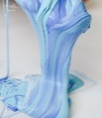  If you want to see how to make it then do an internet search for Gloop.  This Photo by Unknown Author is licensed under CC BY-SA-NC | Adventures with Alice  Rhymes / songs  The children all love rhyme and singing times at Nursery, so try to create a wee cosy corner at home with cushions, rhyme books, CD player, etc and enjoy singing nursery rhymes and songs together. You could also create your own rhyme / song bag and make clues to put inside, e.g. a star (‘Twinkle Twinkle’), a duck (‘5 Little Ducks’), a bucket ‘(Jack and Jill’). | Passport to Play  Mud  As the snow melts why not try to find some mud to make footprints in.  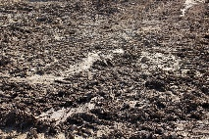  Read the story We are going on a bear hunt or you could watch it online. When you go out on your daily walk why not retell the story and act out the parts. Thick oozy mud / Swirling, whirling snowstorm.

