Alyth Primary Nursery – Home Learning - Week beginning 11th January 2021
Literacy  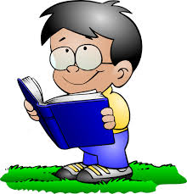  Look at information books together and discover some facts that you didn’t know. An adult could help you make a list of the new facts that you have learned. You could draw pictures to help you remember. If you do not have information books at home, you could google things that interest you, e.g a virtual tour of a building or visit one of the zoo / safari park live streams on Facebook. | Numeracy  Practise number recognition and play number games, e.g. Put the numbers in the correct order.  What number is missing from the order?  Look for and identify numbers on your daily walk.  Sequence numbers forwards and backwards.  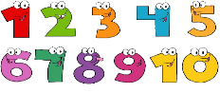  Challenge – adding numbers together. You can use items like stones to do this.  This Photo by Unknown Author is licensed under CC BY-NC | Health and Wellbeing  Set up an obstacle course to help keep you fit and healthy. Change it daily to keep it fun! The grown-ups should join in too!  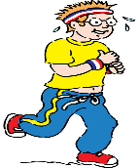
Other Curricular areas  Social Studies…  Explore the local area on your daily walk…  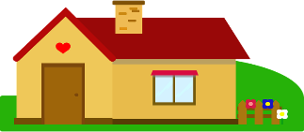  Do the houses all look the same? If not, what is different?  Can you see anyone doing their job, e.g. refuse collectors / shop keeper/ bus driver?  Can you see any shops? Chat about what they sell. | Fine Motor skills  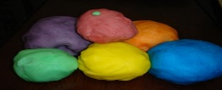  Playdough fun – e.g. roll, squeeze, squash, poke, flatten, pull, push.  There are lots of playdough recipes on-line. Why not make your own.  Use pegs or tweezers to pick up small items and put them in a jar / box. Try to use a pincer grip.  Cut out pictures from catalogues, comics, etc and glue them on to paper. | Gross Motor skills  ‘Creature moves’ – Try moving like these creatures –  crab – walk sideways with your hands and feet on the  floor  frog – put your hands and feet on the floor and jump  alligator – lie flat on the floor, then push yourself up  using your hands and feet and move about  snake – lie on the floor and slither along  gorilla – walk along with your arms swinging about  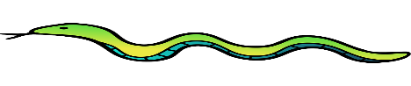  Can you think of any more to try?
Sensory  Bubbles – blow bubbles, then see how many you can burst. Remember to count them as you do! | Adventures with Alice  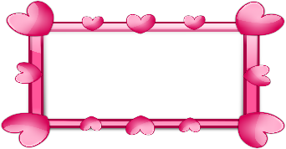  Use an old photo frame, or make one out of paper, and create your own picture using a variety of things, e.g. playdough, buttons, sticks, stones (anything you have at home). Why not take a photo of your creation and send it to someone to cheer them up!  You can make tiny frames to use when reading stories, putting the frame over part of a picture and discussing the detail you see. | Passport to Play  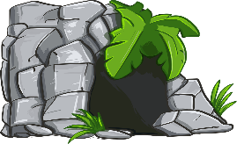  Build a den.  Materials you could use – furniture, bed sheets, curtains, picnic blankets.  Check your den is safe and give it a name.  Decide what you will do in your den. Enjoy!

