

**Bowhouse Primary School**

**Microsoft Teams – Parent and Pupil Guide**

Dear Parent/Carer,

During the upcoming school closures each child will be able to access tasks from their class teacher. They will also be able to communicate with their class teacher and classmates using Microsoft Teams. We would urge you to encourage your child to log onto their class Team each weekday while the school is closed.

* Microsoft Teams is a FREE website/app which is part of the free Microsoft suite of educational resources This can be downloaded free from either your regular app store or through Glow. (It can also be accessed through a web browser such as Internet Explorer, Google Chrome or Firefox).

The following information gives a quick guide on the basics of accessing Microsoft Teams and using its basic features.

**Accessing Microsoft Teams**

Microsoft Teams requires your child to log in (this ensures all data is kept personal and secure). This is always done using their Glow login, whether using an internet browser such as Firefox or accessing directly via the Microsoft Teams app. Your child should already have a copy of their Glow username and password.

**Accessing via a web browser:**

Search for ‘Glow login’. This should take you to the page shown below:

[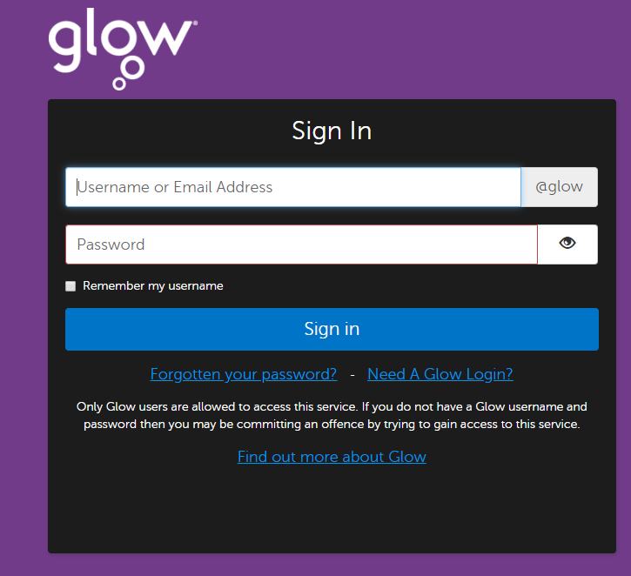](https://sts.platform.rmunify.com/account/signin/glow)

Your child should then login with their Glow username and password provided. This then takes them to their Glow ‘launch pad’. In the search bar at the top of the page, search for ‘Teams’. You should see the Microsoft Teams icon shown below:

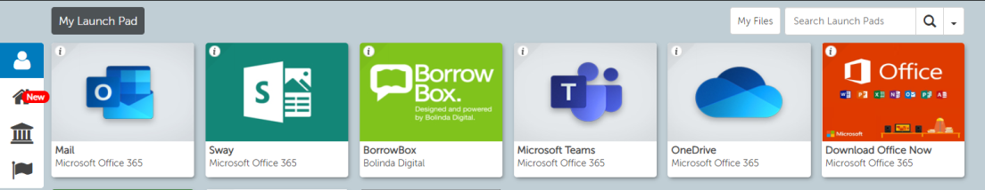

If your child cannot see this in ‘my launch pad’ then click on the symbol of a house and search ‘teams’.

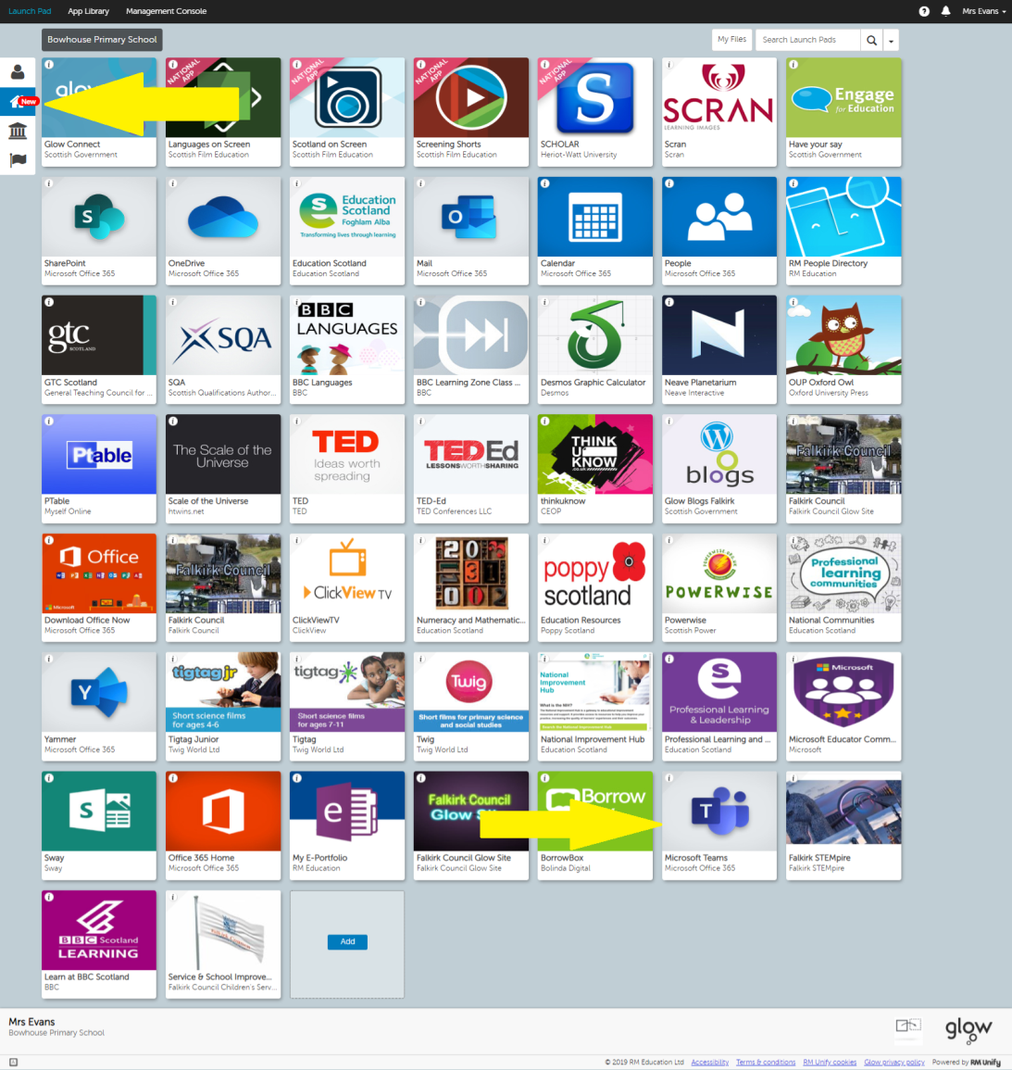

Clicking this will take you directly to Microsoft Teams. If it asks you for login details, please enter your child’s Glow username and password again.

**RECOMMENDED OPTION**

**Accessing directly via the Microsoft Teams app:**

Microsoft Teams is also available as a free download from the app store on most Apple and Android devices and can be downloaded onto both tablets and mobile phones. Search for ‘Microsoft Teams’ on your regular app store and then download directly from here.

**Using Microsoft Teams**

Once your child has logged into Microsoft Teams, they should be able to see the screen similar to below **(note they will only be able to see their own class**):

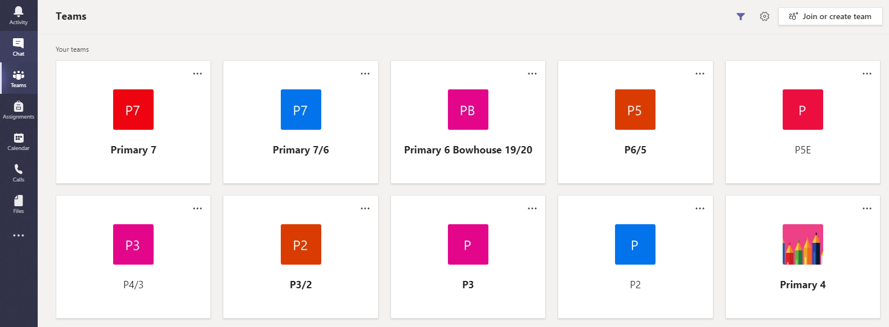

*Please note that this will look slightly different depending on whether your child is accessing from a web browser (as above) or directly via the app (the menus or tabs appear down the left-hand side on a web browser, but along the bottom of the screen on the app), however the ‘labels’ should remain the same.

**All your child has to do is click on the name of their class.**

Once in the Team, there may be different channels within the Team – this simply helps to organise information on different topics/themes. These will be shown underneath the name of the Team, as shown in the picture below:

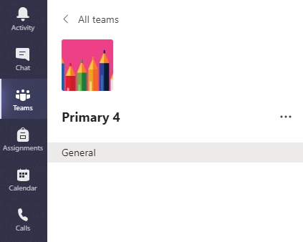

Along the top of the Team, you will see different tabs, namely ‘Posts’, ‘Files’, ‘Class Notebook’, ‘Assignments’ and ‘+’ as shown in the picture below. These are where you can access different features within the Team.



* ‘Posts’ is where general conversations regarding classwork/home learning can take place. Pupils are able to post a comment, and can also reply to others’ comments and questions. You can also upload/attach files, pictures and documents into a post.
* ‘Files’ is where your child can access Word documents, Powerpoints etc. saved by their teacher (as shown in the picture below). Files may be organised into different folders – simply click the folder to access the files within. Pupils can open a file by clicking on its name. They can also collaborate on a document – all changes made can be seen by everyone who is a member of the team – great for working together on a project or sharing questions.
* The ‘+’ icon is where your child can access other Microsoft apps (i.e. Word, Powerpoint) and where your child’s class teacher may save frequently used websites.

This covers the main features we will be using Microsoft Teams for.

**We would remind pupils of our usual online safety rules and responsibilities which should be followed at all times when using Microsoft Teams – i.e. being mindful of others’ thoughts and feelings, only posting comments and questions relating to classwork and home learning, etc.**

Many thanks

Bowhouse Primary School