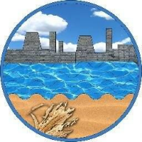

Dear Parents/Carers,

Primary 7 are holding a bake sale on Friday 15th June 2018 to raise money for Strathcarron Hospice and The Beatson Hospital.

We kindly ask if any Parents/Carers could help provide home baking donations, to be handed in on Friday morning.

This would be greatly appreciated.

[](http://www.bing.com/images/search?q=cupcake+clipart&id=4F06971E6D86013AD980ED03E7E487DBE2DCE053&FORM=IQFRBA)Kind regards,

Primary 7