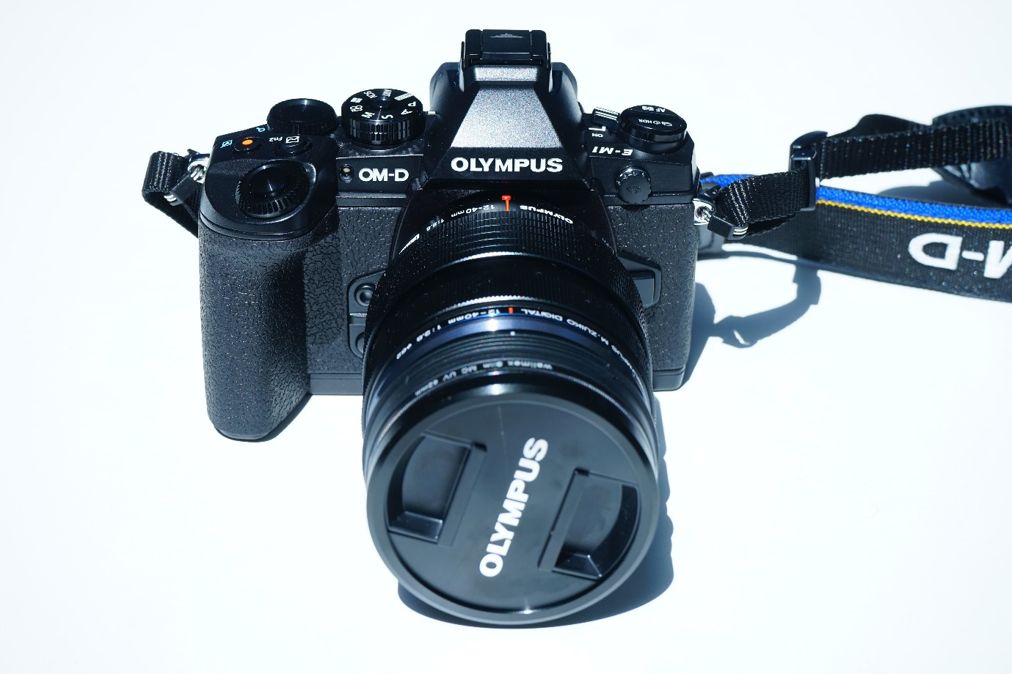
Tempest Photography shall be in school on Monday 26th January to take individual/sibling and P1 & P7 Class photographs.
Please make sure your child comes to school in full uniform. If your child is due to have PE they shall take part in their uniform.
If you would like to have a sibling photograph taken, please fill in the below form by Friday 23rd January.

Tempest Photography – Fill in form

