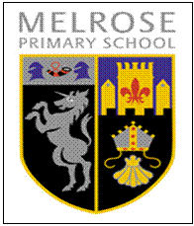
Melrose Primary School
Early Learning and Childcare (ELC)
Newsletter
Term 2
October to December 2018

We would like to share a few photos of the experiences the children have engaged in this term within our nurturing learning environment.

- Learning to be independent
- Making new friends
- Learning the routines of our ELC session
- Exploring the ELC environment indoors and outdoors
- Harvesting our garden
- Learning to problem solve and risk assess
- Beginning to work as a team
- Being creative using a variety of resources
- Using our imaginations to construct
- Visiting shops in our local community
- Child smile visit – learning about personal hygiene and the roles of people who help us take care of ourselves
- Listening in small groups

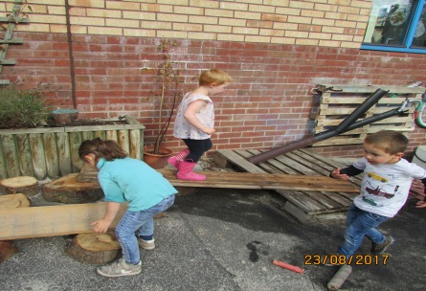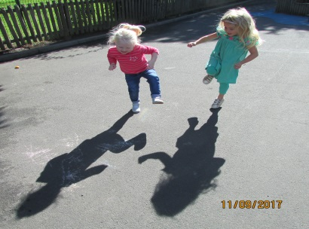

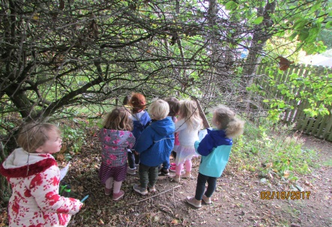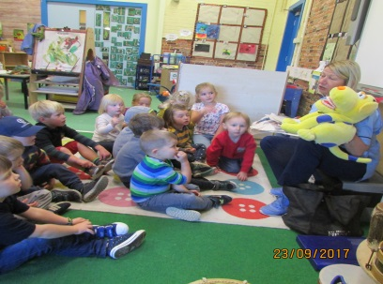

Care Plan Review
The children’s individual care plans need to be reviewed 6 monthly, therefore the children who attended ELC last year are due a review. This should only take a short discussion with your child’s keyworker. The review requires a parent/carer to read over the documents you have already submitted and update any details that may have changed or add any additional information. Your child’s keyworker will organise a time either at the beginning or end of a session that suits you to be able discuss. If you are unable to come in to ELC we will send you a copy home for you to look over, sign and hand back in to a member if staff.

Library
Each week we encourage parents/carers to help their child choose a library book from the ELC library basket. The library basket will be kept beside the book nook next to the cloakroom door. Children can change their library books as often as they like. We ask that parent/carers keep their child’s library record up to date, marking the borrowed books designated number in and out in the columns provided. The children’s library records can be found within the blue folder kept with the library basket.
Attached to this letter you will find a sheet to fill in with your child each time you share a story together. Please write in the name of the book and, after discussion with your child; exploring events, characters, likes and dislikes, please could you fill in the comment box with your child’s thoughts on the book.

Parent Helpers
On the information board in the cloakroom area we have rotas for the experiences that we require parent/carer support to enable us to provide the experience. The children visit the shops in the local community to buy our snack for the next again week. Unfortunately we are unable to provide these learning opportunities if we don’t have the correct adult/child ratio for both our walk to the shops and within the ELC. If you are available for 30/40 minutes at the beginning of a session to accompany us to the shops please write your name next to the date of availability.

Wednesday 31st October 2018
Children are invited to come dressed up in an outfit of their choice on Wednesday 31st October 2018. We will be having a sensory day, exploring a variety of experiences using our senses.

ELC Christmas Enterprise Project Parent/Carer helpers
ELC Christmas Enterprise Project
Due to the popularity of the enterprise project last year, the ELC are once again running a cookie jar enterprise project. The children will create and sell “Make Your Own Cookies” in a jar. These decorated, reusable jars will come complete with all the dry ingredients necessary for making cookies, as well as the recipe, in three varieties – gingerbread, Smartie and choc-chip. They are fun to use with your children or ideal as an unusual Christmas gift.
The money raised will be used to buy new resources for Melrose ELC setting. The jars are priced at £4.80
Please fill out an order form and give it to a member of the ELC team.
Orders to be in by Friday 26th October 2018

If you would like to help with the cookie jar enterprise please could you write your name next to any available date on the baking helpers rota situated on the information board in the cloakroom.

Thursday 13th December 2018 - Christmas Open Day Sessions
Parents/carers are invited to come in with their child for a special Christmas themed stay and play session. Morning stay and play session 8.45 – 10.00
Afternoon stay and play session 12.45 – 14.00.
You will have the opportunity to explore a variety of Christmas experiences with your child. We hope that you will join us for a festive sing-song around the log fire at the end of the stay and play session.
Morning session 10.00 and Afternoon session 14.00

Tuesday 18th December 2018 – Christmas Party
All children are invited to the Christmas party. If your child does not normally attend on a Tuesday but would like to join us please inform a member of staff. Children are invited to wear their party clothes for some party games, dancing and a festive snack.

Please arrive early for pick up to meet our ‘special guest’:-

Morning ELC parents arrive at 11.05
Afternoon ELC parents arrive at 15.05

Dates for your diary

Thursday 31st October – Dress up day
Thursday 8th November – In-service
Friday 9th November – In-service
Monday 3rd December – St Andrews Day holiday
Thursday 6th December - School Christmas Fair
Thursday 13th December – Christmas stay and play
Tuesday 18th December – Christmas party
Friday 21st December – Last day of term
Monday 7th January – School opens to pupils

