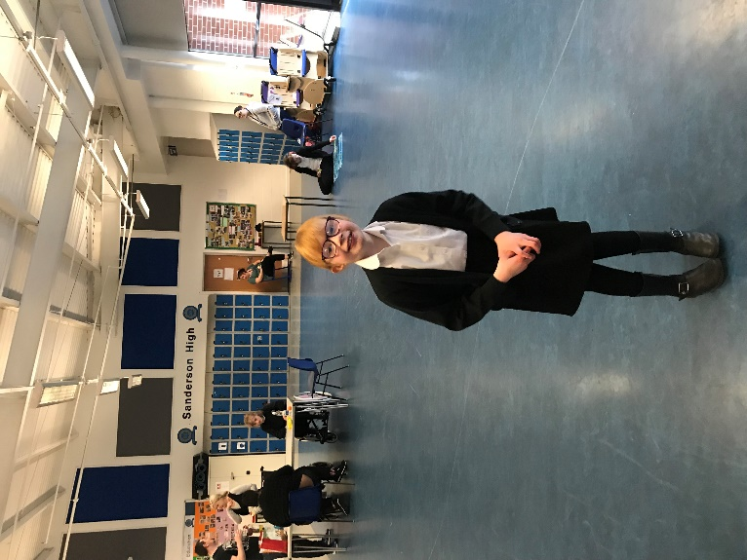

Today we went to visit Sanderson High School.

We had a good look around all of the classes.

We had a great time and saw

lots of familiar faces.

Roll on August …..