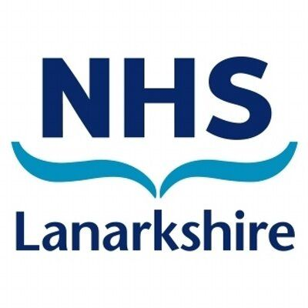

SPEECH AND LANGUAGE THERAPY
c/o Greenburn School
Calderwood Rd
East Kilbride
G74 3BQ
Tel: 01355 237278
Tuesday 6th September 2022

Speech and Language Therapy at Greenburn School
Dear Parent/Carer,
We are writing to you regarding the NHS Lanarkshire Speech and Language Therapy provision at Greenburn School. The Speech and Language Therapists at Greenburn School are Jen Storrie and Belinda Kane.
General support is provided to all the children within the school environment following collaboration with the Teachers.
If you would you like general advice or if you have any questions then please see below for the best ways to contact us:

Jen Storrie works in Greenburn School on Mondays and Tuesdays.
Email: jennifer.storrie@lanarkshire.scot.nhs.uk
Mobile: 07976 321353

Belinda Kane works in Greenburn School on Tuesdays.
Email: belinda.kane@lanarkshire.scot.nhs.uk
Mobile: 07967 330568.

Or you can call Greenburn School on 01355 237278 on the days we work.
Please don’t hesitate to contact us with any questions.
Kind regards,

Jen Storrie and Belinda Kane
Specialist Speech and Language Therapists

