**November Newsletter 2020**

As you are aware it has been a very tricky month for us with so many staff being absent. I am pleased to say that everyone will be back safe and sound from Monday. We are so happy that none of the children have been ill.

With so many new faces it has been a little unsettling for some of our pupils but our staff are so resilient and the learning and teaching has not been compromised.

Thank you so much to the supply teachers and the Early Years team for coming along to help out. It means a lot to us!

T

If you are clearing out and are looking to dispose of these items please send them in to us. Especially the jumpers, we would like to have a swap shop idea where we have a stock of jumpers for children to wear, to keep costs down. If you do not have a jumper just some tinsel or something Christmassy on the day will be fine.

A wee reminder that we are still asking for £2 per week for snack. The children are not going to the shops but they are baking much more than usual

**Christmas Events**

A flyer will come out to you very soon with all our Christmas events on it. We have not cancelled anything, we are just doing it differently. For example instead of going out for breakfast with Santa we are going to have it in school at Billy’s Den with special guest stars – 2 live reindeers. Sssh it’s a surprise for the children!

Christmas Jumper Day, Parties, Nativity will happen as usual. We are going to film the nativity and send it home for your family to share together.

In order to pay for all this, we are asking that if you would mind sending in £5 to cover ALL the Christmas expenses. (If you are able to) The school will cover the rest. We want to make it as special to the children as possible.

We will also have Christmas a raffle which will be drawn on 18th December. The classes will be in touch very soon to ask for donations for hampers. 1 hamper per class will be raffled. Any donations from family and friends will be gratefully received

**St Andrews Day **

The children can wear something tartan/checked for the occasion. We will be having a Scottish snack & Scottish dancing in the classes.

W

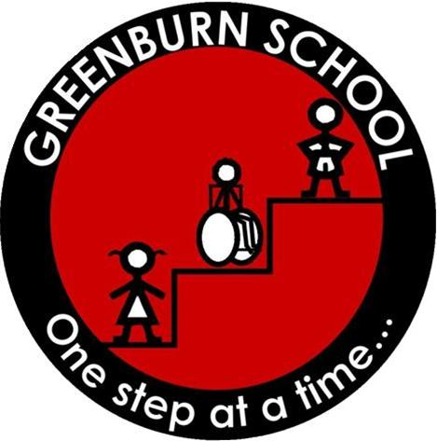

**Christmas Decorations and Christmas Jumpers**

**Celebration of Billy’s Life** 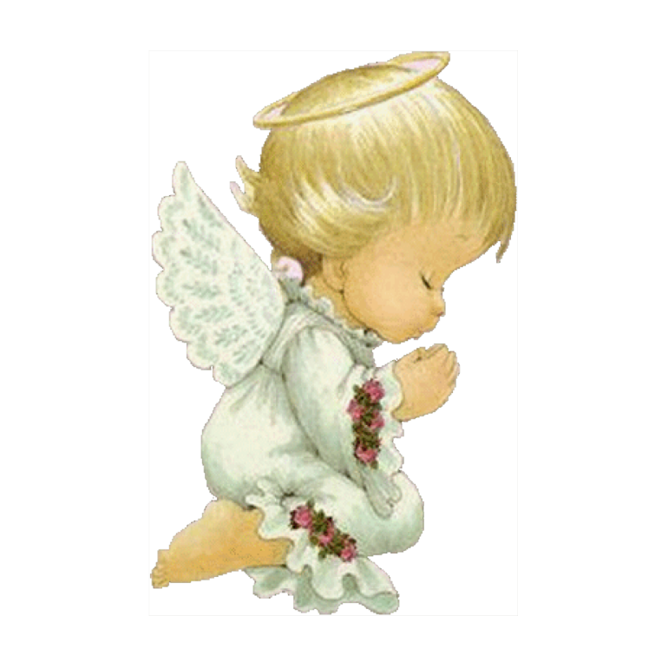

Thank you so much for taking part in the naming of our cabin which will be known as Billy’s Den. We are dedicating the den in honour of our Billy.

Next Friday at 2pm we are having a special assembly outside for Billy, his family and the school community. It is the school’s final farewell for Billy, and everyone will release some eco-friendly balloons to mark the occasion. The chaplain from CHAS who know the family well, is coming to support us and tell the pupils a story to help them understand.

I am sorry we cannot ask parents to come as COVID guidance still restricts this. The chairperson of the council will represent the parent forum.