CARLUKE HIGH SCHOOL

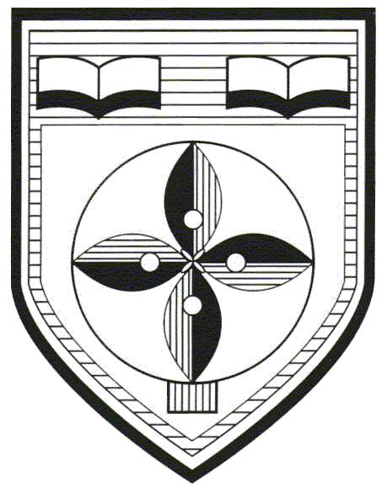

S1 Elective Programme

Pupil Choice Booklet

Important information about Electives

The S1 Elective programme will begin in the new term.

All of our pupils will have the opportunity to pick one subject as part of their curriculum before they come to Carluke High School.

Pupils will build their skills in their chosen subject throughout S1.

Each week, pupils will have 2 periods of 50 minutes to develop their skills and knowledge. This will probably be on an afternoon and will be a double period.

The curriculum choices are listed on the next page. Further details are given in subsequent pages.

No further detail is given on the sport electives as pupils will focus simply on developing skills and improving performance.

Pupils should choose their top 3 preferences in order.

Choice 1 should be their first choice, choice 2 their second choice and choice 3 their third choice.

We will try to ensure that as many pupils as possible receive their first choice. Please note that if there is insufficient uptake for a particular choice, it may not run.

Depending on numbers, there may be trials for the football elective.

P7 pupils

Read through the choices then make your selections. We would ask that you record these choices by completing a Microsoft Form which will be posted on the School App via a message.

Add your name and primary school before replying to your school.

Your choices

Name _______________________________________________

Primary school________________________________________

 | Choice | 1st, 2nd and 3rd
A | School of Rugby
B | School of Football
C | Netball
D | Net Games (badminton, volleyball, table tennis, short tennis)
E | Dance
F | Art & Design Workshop
G | Stage It: Drama
H | Music Performing & Technology
I | World of Film-Modern Languages
J | Mad Science
K | Digital Creators
L | Exploring Design and Technology
M | Ready Steady Cook

- MAKE YOUR SELECTIONS BY FRIDAY 15TH MAY

USE THE MICROSOFT FORM WHICH WILL BE POSTED ON THE SCHOOL APP. THIS WILL BE POSTED UNDER ‘MESSAGES’.

F Art & Design Workshop

Are you interested in becoming more creative and do you enjoy making things? Want to see your imagination come to life? Want to take your creations off the page and into three dimensions? Do you want to work in a creative industry as designer, artist or architect when you are older?

If the answer is yes to any one of these questions, then this course is for you.

In 2D projects pupils will get the opportunity to explore and experiment with a large range of materials to produce their own very individual pieces of work.

Pupils will also work with a variety of 3D modelling materials and learn how to create finely-detailed models and fantastical clay, plaster, textile and paper sculptures, as well as working on larger scale 3D artworks.

Pupils will also learn skills in Digital Photography and Multimedia, setting up their own photo-shoots, using professional cameras to produce their own range of art photography and develop Photoshop and Freehand skills to create posters or publish their work digitally.

G Stage It

Drama helps all students to develop skills and knowledge that will help you no matter what study or career path you eventually choose. Drama helps you become more confident, understanding and helps us to make sense of ourselves and other people. Most of all Drama is fun!

In our ‘Stage It’ elective the wonder of theatre will be brought alive through a range of practical activities and workshops. You will meet professional actors and designers - learning about their roles and responsibilities. With this knowledge you will work together with your group to create an exciting piece of theatre that will be performed for an invited audience.

You will also learn about and experience the technical roles and responsibilities within the theatre - costume, make-up, lighting, sound, set design, stage management etc., learning from industry professionals in the form of workshops, theatre visits and tutorials.

You will also learn all about the advertising/admin/front of house aspects of a theatre production.

H Music Performing & Technology

The Music Elective gives you the opportunity to learn lots of different instruments like keyboard, guitar, xylophone, ukulele and many more. You will also have many opportunities to perform on these instruments, record performances in the recording studio, write your own music and learn about other styles of music. You will develop solo performing skills and also be performing as part of a band.

At Carluke High school, we use top of the range, industry-standard equipment to learn how to record, edit, mix and produce music. You will have the opportunity to work with Logic Pro X in our iMac suite to create and produce your own music and the music of others. You will also learn how to compose music for film, how to create covers of songs, mash-ups, Vlogs and podcasts. You will get to use a variety of different microphones and learn how to set up safely and effectively to give you the best recording. At the end of the course, you will have your own folio of all the tracks you have performed and produced.

I World of Film-Modern Languages

In this elective you will enjoy watching some films and seeing the world open up through the eyes of the characters. You will explore other places, languages and cultures through the short and feature-length films we have chosen, and have the opportunity to get creative. Let your imagination take over and try creating a film trailer, using our ipads, writing an alternative ending to a film or even improvising different scenes if you’re feeling theatrical!

J Mad Science

In this course you could….
Mix chemicals together that create new unusual substances.
Attempt to create a diet coke mega-rocket.
Make slime.
Carry out lots of fun and interesting experiments.
Be involved in design projects.

You will experience a mixture of Biology, Chemistry and Physics and will learn about the world of Science and how it effects the world around us.

K Digital Creators
Digital Creators has two main themes:
- Learn to code
Learn how to write the code used to make computer games and apps. Design and develop your own app or game idea. Learn about programming with sensors. Put your problem solving skills to the test and program a Lego MindStorms robot through an assault course.

- Digital Media
Learn the basics of creating video, audio and animation using a range of software and devices. Learn about green screening techniques, how to mix audio tracks and the basics of photo editing. Go ‘manga’ and create your own graphic novel. Storyboard and produce your own live action film or animation and showcase it on the school YouTube channel.

This is an exciting collection of computer based activities that lets you explore your own creativity and turn ideas into something real.

L Exploring Design and Technology

This practical course will allow you to design and make models using manual sketching and computer software. Your designs will then be made by you in the woodwork room, using wood, metal or plastic. These completed models will then go home.

M Ready Steady Cook

This course will develop pupils’ organisational skills as well as creative skills involving a wide range of food stuffs. Pupils will develop confidence in the kitchen and will build up excellent food preparation, cooking and presentation skills.
Throughout the course, the emphasis will be on developing practical skills. A variety of themes will be explored for example, international and local cuisine, cake baking and decorating and enterprising food activities, with a link to activities within the school and the local community. These skills will begin to build the skills pupils could use in the world of work.
It is hoped that we will link with local businesses to help facilitate the delivery of aspects of the course. We hope that pupils will by the end of the course, will be able to cook a variety of food products and cakes independently and confidently to a very high standard.

