
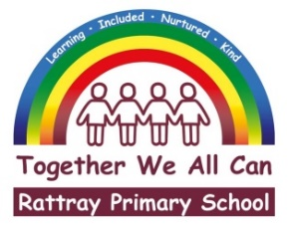

 |  | Joanna Robertson  Headteacher  Rattray Primary School,  High Street, Rattray  BLAIRGOWRIE,  PH10 7DG  01250-871980  Email: rattray@pkc.gov.uk  Date: 20 February 2026

Dear Parent/Carer,

We have been made aware of increased incidences of scabies in the local community. Scabies is a contagious skin condition caused by tiny mites that spread through close, prolonged skin-to-skin contact.

You may wish to check your child for symptoms. Common signs of scabies include intense itching (especially at night) and a raised, blotchy, or spotty rash, often appearing between the fingers, on wrists, underarms, the waist, groin, or bottom.

If you suspect your child may have scabies, please seek advice from a pharmacist, who can recommend appropriate treatment. Scabies treatment usually involves applying a cream or lotion over the whole body, with treatment repeated 7 days later. Treatment for scabies is free and available through the NHS Pharmacy First, at your local pharmacy, however treatment is only required if scabies is present in one family member.

Because scabies spreads easily, everyone in the household should be treated at the same time, even if they do not show symptoms, to prevent re‑infestation.

Further information can be found on the NHS website here:
Scabies – NHS Inform: https://www.nhsinform.scot/illnesses-and-conditions/skin/skin-injuries-bites-and-infections/scabies/

Thank you for your co‑operation in helping reduce the spread of scabies within our school community.

Yours sincerely

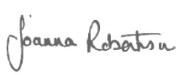

Joanna Robertson
Headteacher



