Rattray Primary School
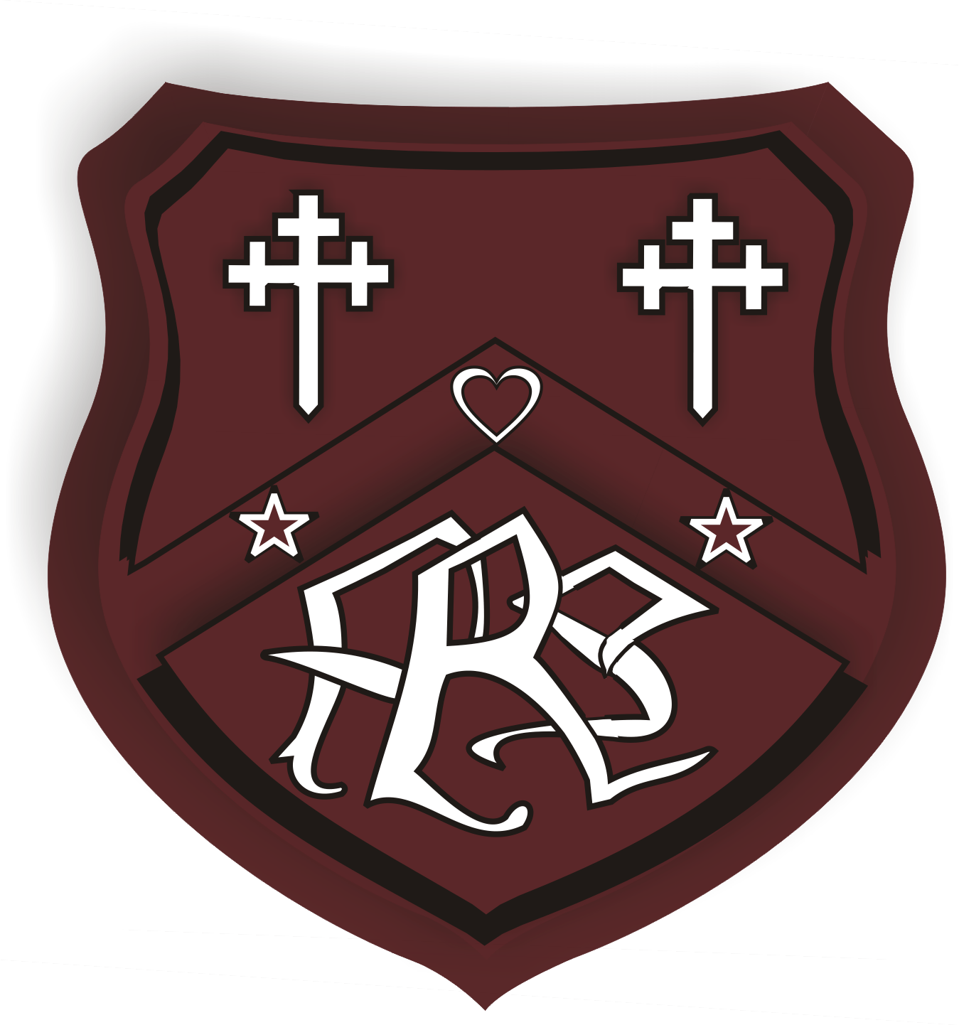
Core Procedures for Staff and Parents/ Carers
(COVID19)
From August 12th 2020 (Version 2)
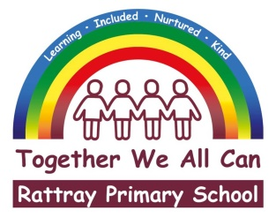
These Core Procedures will be reviewed on a weekly basis and changes will be made accordingly.

Rattray Primary School

Core Procedures (COVID19)

Who are we and what are we about? Our guiding principles have not changed!

Our school Ethos

Our vision of Together We All Can is supported by our values of
Learning, Included, Nurtured and Kind.
Our ethos is supportive, inclusive and caring.
There will be a clear focus on re-establishing relationships with peers and teachers and keeping our children safe.

School routines

Entry and Exit to school/Environment:

Journey to school/ Parking | - Please walk to school if you can  - There is still no parent access to the school car park unless you have a disabled badge  - Try to avoid parking on Honeyberry Drive and Crescent– our neighbours are concerned about blocked driveways and congestion – we are a respectful school and like to keep our neighbours happy!
Entry to school | - Nursery, P1 and P2 Rattray children (and siblings) accompanied by one designated adult per family will enter the playground via the gates on the High Street from 8.55am  - Primary 3 pupils and upwards will enter the gates from Rattray Common from 8.55am. No parents from these classes will enter the school playground, unless these children have younger siblings  - Children will enter the building via their designated entry points. This will be clearly signed on classroom doors and windows;  Nursery have their separate entrance  P1M (Ms McCulloch) will enter through the door in the small infant playground at 9.15am.  P1/2W (Ms Wigmore) will enter through the door in the small infant playground at 9.05am.  P2R (Mrs Russell) will enter through the door in the small infant playground at 9am.  P3G (Ms Gregg) will enter through the assembly hall doors in the main playground at 9.15am.  P3/4J (Miss Johnstone) will enter through the main entrance doors in the main playground at 9.05am.  P4/5 (Mrs Strachan/Mrs Case) will enter through the assembly hall doors in the main playground at 9am.  P5G (Ms Garrett) will enter through the assembly hall doors in the main playground at 9.05am.  P6M (Mr Masterton) will enter through the upper classes doors at the rear playground at 9am.  P6/7J (Mrs Johnstone) will enter through the upper classes doors at the rear playground at 9.05am.  P7M (Mrs McCarthy) will enter through the upper classes doors at the rear playground at 9.15am.  Any children travelling by bus or taxi will be collected by a member of staff and enter the building through the Fire Exit at the Assembly Hall.  - There will be no access to the school building by Parents/ Carers, all communication will be via phone call or email  - Please be prompt to help manage the number of children entering the school grounds at one time.  - A member of staff will welcome the children into school to manage the flow of children entering the building.  There will be no early entry to school due to wet weather so please ensure children have waterproof jackets with hoods.  If your child is going to be absent from school, then please follow the usual procedures and contact the school before 9:30 am.
Exiting at the end of the day | - Children will exit the building between 3:05pm or 3.20pm– however, this is subject to any transport requirements.  - Children who arrive at 9:00 am will leave at 3:05 pm; 9:05am - 3:10pm and 9.15am – 3.20pm. Lunchtimes will be shortened, and children will still have 5 hours of contact time with their teachers as is normal procedure.  Children will exit the building via their designated doors.  Nursery have their separate exit.  P1M will exit through the door in the small infant playground at 3.20pm and will be escorted by the class teacher to the gate of the small playground. Parents please do not enter the small infant playground.  P1/2W will enter through the door in the small infant playground at 3.10pm and will be escorted by the class teacher to the gate of the small playground. Parents please do not enter the small infant playground.  P2R will enter through the door in the small infant playground at 3.05pm and will be escorted by the class teacher to the gate of the small playground. Parents please do not enter the small infant playground.  P3G will enter through the assembly hall doors in the main playground at 3.20pm and will be escorted by the class teacher to the Rattray common gate.  P3/4J will enter through the main entrance doors in the main playground at 3.10pm and will be escorted by the class teacher to the Rattray common gate.  P4/5S will enter through the assembly hall doors in the main playground at 3.05pm and will be escorted by the class teacher to the Rattray common gate.  P5G will enter through the assembly hall doors in the main playground at 3.10pm and will be escorted by the class teacher to the Rattray common gate.  P6M will enter through the upper classes doors at the rear playground at 3.05pm, and will be escorted by the class teacher to the Rattray common gate.  P6/7J will exit through the upper classes doors at the rear playground at 3.10pm, and will be escorted by the class teacher to the Rattray common gate.  P7 will enter through the upper classes doors at the rear playground at 3.20pm, and will be escorted by the class teacher to the Rattray common gate.  - P1 and P2 parents can meet children (and siblings) at the designated collection point at the gate of the small playground and exit through the High Street gate.  - If collecting your child, please stand 2 metres from other families.  - Please leave the school/playground promptly  Any children travelling by taxi will stay in the assembly hall until their mode of transport arrives. This will be supervised by a Pupil Support Assistant.
Entrance to the school | - On entry to the classroom, children will hang their coats on the back of their chair and place lunchboxes/water bottles on their tables. Please encourage your child to be as independent as possible with coats etc..  - On entry to the school children will use hand sanitiser. Parents can provide moisturiser, but these must be named and not shared
School dinner choices | - Children will eat their lunch in the lunch hall following good hygiene practice  - Any leftovers from packed lunch boxes must be taken home, emptied and cleaned every night.

School routines (continued)

Bringing things to school

What will your child need? | packed lunch  Suncream/ sunhat  Waterproof jacket  Water bottle – filled every day at home  Playpiece – we love it when it is healthy!  Everything must be named and children need to be responsible for their own belongings
School uniform | School jumper/cardigan (Maroon or grey) and a white polo shirt  Trousers/leggings/joggers/shorts in the summer.
P.E | P.E will begin on Monday 17th August.  Class teachers will contact you to let you know about specific days.  Children should wear their P.E kits on P.E days until further notice.  The changing rooms will not be used until further notice.  If the weather allows, PE will take place outside so children should dress accordingly.
Toys from home | Children cannot bring anything from home unless a transition toy is essential and agreed with SMT.

Health and Safety

Handwashing

Handwashing | There will be soap and hand sanitiser in every learning space  Children and staff will wash their hands with soap and water for 20 seconds frequently and;  When re-entering the building after breaktime and lunchtime  When hands are visibly dirty  After using the toilet  After coughing and sneezing  Before eating  Before and after lunch  Younger children will be supervised where possible  Children can bring in their own moisturiser

Social Distancing (we will make every effort, but we also recognise that young children are not programmed to social distance)

In class | - Children will have their own personal resources kept in wallets. This will include; pencils, erasers, sharpeners, whiteboards and pens
Other school areas | - Changing rooms will not be used  - There will be no Assemblies

COVID19 symptoms (a new continuous cough, fever/ high temperature 37.8C or greater, loss of or change in sense and taste)

If a child or staff member becomes unwell with symptoms of COVID-19 while in school eg starts to cough | - The person will be isolated in a designated room which can be well ventilated  - They will go home as soon as possible  - Staff helping them will wear a mask, gloves and apron  - Appropriate cleaning and decontamination will be completed  - If there is a confirmed case of COVID-19 within the school Government Health Guidance will be followed. This could be a full or partial closure of the school. Test, Trace, Isolate will then come into play, but the school will not notify parents/carers as this would break GDPR guidance.  - If a child or adult displays symptoms they would be expected to self-isolate for the recommended period of 10 days and carry out a test following the Government’s procedures.  - If a child or adult has been contacted by a tracer and told to self-isolate for 14 days the person should leave school to self-isolate at home for 14 days.
If your child has symptoms | - Do not send them to school  - Anyone with symptoms over 5 years old should be tested  - Contact the NHS or arrange to be tested at 08000282816 or www.nhsinform.scot  - Everyone that tests positive for COVID-19 will be put in touch with the local contact tracing team so that other close contacts can be identified  - Parents/Carers will be informed if someone has tested positive in school

Enhanced hygiene measures

Respiratory etiquette | - Use a tissue, throw it in the bin, wash hands/ tissues will be supplied  - Use your elbow if you do not have a tissue  - If someone has sneezed on a surface, we will spray and clean the surface as soon as possible  - Bins will be emptied on a regular basis throughout the day.  - Children should try to avoid touching their faces as much as possible.
Preventing the spread of infection | - Rooms will be well ventilated
Use of PPE | - We do not need any additional PPE for general care unless we are caring for a symptomatic child  - Face coverings should not be required for most children (other than those clinically advised to wear one)  - Where adults cannot keep 2m distance and are interacting face-face for a sustained period (about 15 minutes or more), face coverings should be worn  - Anyone wishing to wear a face covering in school should be allowed to do so
Enhanced cleaning procedures | - Hard surfaces and door handles will be cleaned throughout the day and at the end of the day

Our Curriculum

Planned learning

In school learning | - Our focus will be Numeracy, Literacy, Health and Wellbeing and outdoor learning.  - A range of active approaches will still be used  - Children will be given their own “learning kit” with pencils, pens, whiteboard, number lines, multiplication square, scissors etc..  - Following the guidance from the Care Inspectorate, the Early Years classes will continue to follow principles of a play-based curriculum. This will include opportunities for parallel play and small group learning.  - Any shared resources will be wiped down at the end of the day  - Soft furnishings like cushions, soft fabrics and rugs will not be used
At home | Following the First Minster’s announcement, full time attendance will take place at school.  - Any follow-up work/homework will be sent home via Teams or Education City – this work will consolidate the Literacy and Numeracy completed in class.  - Children will move on with their learning when the teacher has observed deep learning where children can complete tasks independently and can apply what they have learned in different contexts.  - Achievement of a level will be discussed with children and parents/carer at our parents evening in November.  - Reading activities will take place in class but no books will be sent home until further notice

Communication

Communication with class teachers | - Communication via Teams and glow email
Communication with school | - Via the school email Rattray@pkc.gov.uk  - Via the school phone number 01250 871980
Communication with HT | - Via the school email Rattray@pkc.gov.uk
Communication from school and PKC | - Please follow us on Facebook to keep up-to-date with current school and information from PKC  - Information will also be sent out via Parent Pay and our school App

Daily life in school

Moving about the school

Movement will be limited | There will be no access to the school office  Children will not be sent on messages  There will be a clear movement system in operation throughout the school  Children should not be out of their classes unnecessarily.  Any movement around the school will be monitored by school staff.

Playtimes

P2, P4/5 and P6 | - Children will have a break at 10 – 10:20 am  - They will wash their hands before and after break
P1/2, P3/4, P5 and P6/7 | - Children will have a break at 10:25 – 10:45 am  - They will wash their hands before and after break
P1, P3, and P7 | - Children will have a break at 10.50 – 11.10 am  - They will wash their hands before and after break
Play activities | - Children can play alongside their friends but will be discouraged from playing contact games like tig.  - The playground areas will be sectioned off for each class.
 | - During wet playtimes children will remain in their classrooms

Lunchtimes

All children | All pupils will remain in school for lunch (No home lunch provision)  During wet lunchtimes children will remain in their classrooms  Children will wash their hands before and after lunch
P2, P4/5 and P6 | Lunch will be eaten in the lunch hall at 12:00 – 12:20pm  Play outside from 12:20 -12:45pm
P1/2, P3/4, P5 and P6/7 | Lunch will be eaten in the lunch hall at 12:35 – 12:55pm  Play outside from 12:55 -1.20pm
P1, P3, and P7 | Lunch will be eaten in the lunch hall at 12:45 – 1.10pm  Play outside from 1:10 – 1.35pm

Toilets

Communal toilet doors will be wedged open-this will not affect privacy
Number of children accessing the toilet at one time will be reduced
A toilet will be allocated for each class.
A toilet system will be in place to reduce the number of children accessing the toilet at any given time

Access to Water

Children should bring a filled water bottle to school each day. Water will be available to children, who come to school without their own water bottle.

First Aid

Staff will continue to follow current practice and PPE equipment will be worn.
Any head injuries will be assessed at the location and dealt with in accordance to Health and Safety and PKC guidelines.

Breakfast Club and After School Club
Following new guidance, these services will be available from Monday17th August.

These Core Procedures will be reviewed on a weekly basis and changes will be made accordingly.

