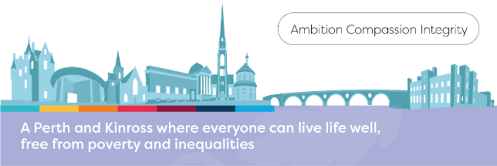

**Blairgowrie Rattray area Summer 2024 Holiday Offer**

**Blairgowrie/Rattray area free family play sessions. No need to book just come along and enjoy some family fun!** **Children must be accompanied by an adult.**

|  |  |  |
| --- | --- | --- |
| Activities include Den Building, Fire workshop, Bubble Workshop, Planting Workshop, Games, Junk Modelling, Sports, and Games. | | |
| **Venue** | **Dates** | **Time** |
| Rattray Park (next to Connect)  PH10 7D | Thursdays 4th, 11th, 18th, 25th July and 1st August and Wed 7th August | 10am to 3pm |
| Alyth  (Next to Community Centre) | Tuesday 9th July | 10am to 3pm |
| Coupar Angus (Larghan Park)  PH13 9ES | Tuesday 16th July | 10am to 3pm |

**Also - free Perth family play sessions throughout the summer. No need to book just come along and meet us at the venues below and enjoy some family fun!** **Children must be**

**accompanied by an adult.**

|  |  |  |
| --- | --- | --- |
| Activities include Den Building, Fire workshop, Bubble Workshop, Planting Workshop, Games, Junk Modelling, Sports, and Games. | | |
| **Venue** | **Dates** | **Time** |
| South Inch, Perth (grass area near  tunnels)  PH2 8BU | Mondays 1st, 8th, 15th, 22nd, 29th July and 5th August | 10am to 3pm |
| North Muirton Park (Next to shops)  PH1 3BZ | Wednesday 3rd July | 10am to 3pm |
| North Inch, Perth (grass area in front of Bells Sport Centre)  PH1 5HG | Fridays 5th, 12th,19th, 26th July and 2nd and 9th August | 10am to 3pm |

**Pre-bookable family session.** [Click here to apply for the sessions listed below](https://forms.office.com/Pages/ResponsePage.aspx?id=6dxqdyZdSUeiAvCf7-EFkHWusrVD9GBPqIel5I-VDVdUMTRCQ0xRQjA4S1VRUFRMMEVWSDIyOUkzRyQlQCN0PWcu)

|  |  |  |  |
| --- | --- | --- | --- |
| **Date** | **Time** | **Venue** | **Session** |
| Tuesday 2nd July | 10.00 – 12.30 | Rattray | Family session |

**Closing date for applications: Monday 17th June 2024**

If you require more information about the activity in the table above, please email

[Parenting@pkc.gov.uk](mailto:Parenting@pkc.gov.uk)

**Families Empowering Communities sessions as below** [**Click here to apply**](https://forms.office.com/e/QUJVC360yc)

|  |  |  |  |
| --- | --- | --- | --- |
| **Date** | **Time** | **Venue** | **Session** |
| Tuesday 9th July | 11.30 – 13.30 | Blairgowrie | Families Empowering Communities  Family Activity session |
| Tuesday 23rd July | 11.30 – 13.30 | Blairgowrie | Families Empowering Communities  Family Activity session |
| Tuesday 6th August | 11.30 – 13.30 | Blairgowrie | Families Empowering Communities  Family Activity session |

**Perth Autism Support, 14 New Row, Perth PH1 5QA** **are running the following:**

* Stay and Play sessions for preschool children who are (or maybe) autistic and their parents (or grandparents)
* Every Monday during the holidays from 10.00-11.30
* Play session in the activity space, sensory room and garden.
* Free and no need to book.
* Siblings under 8years old are welcome.
* Open to families who are not registered at PAS.
* Please email [families@perthautismsupport.org.uk](mailto:families@perthautismsupport.org.uk) or phone 01738 451081 if you would like more information.