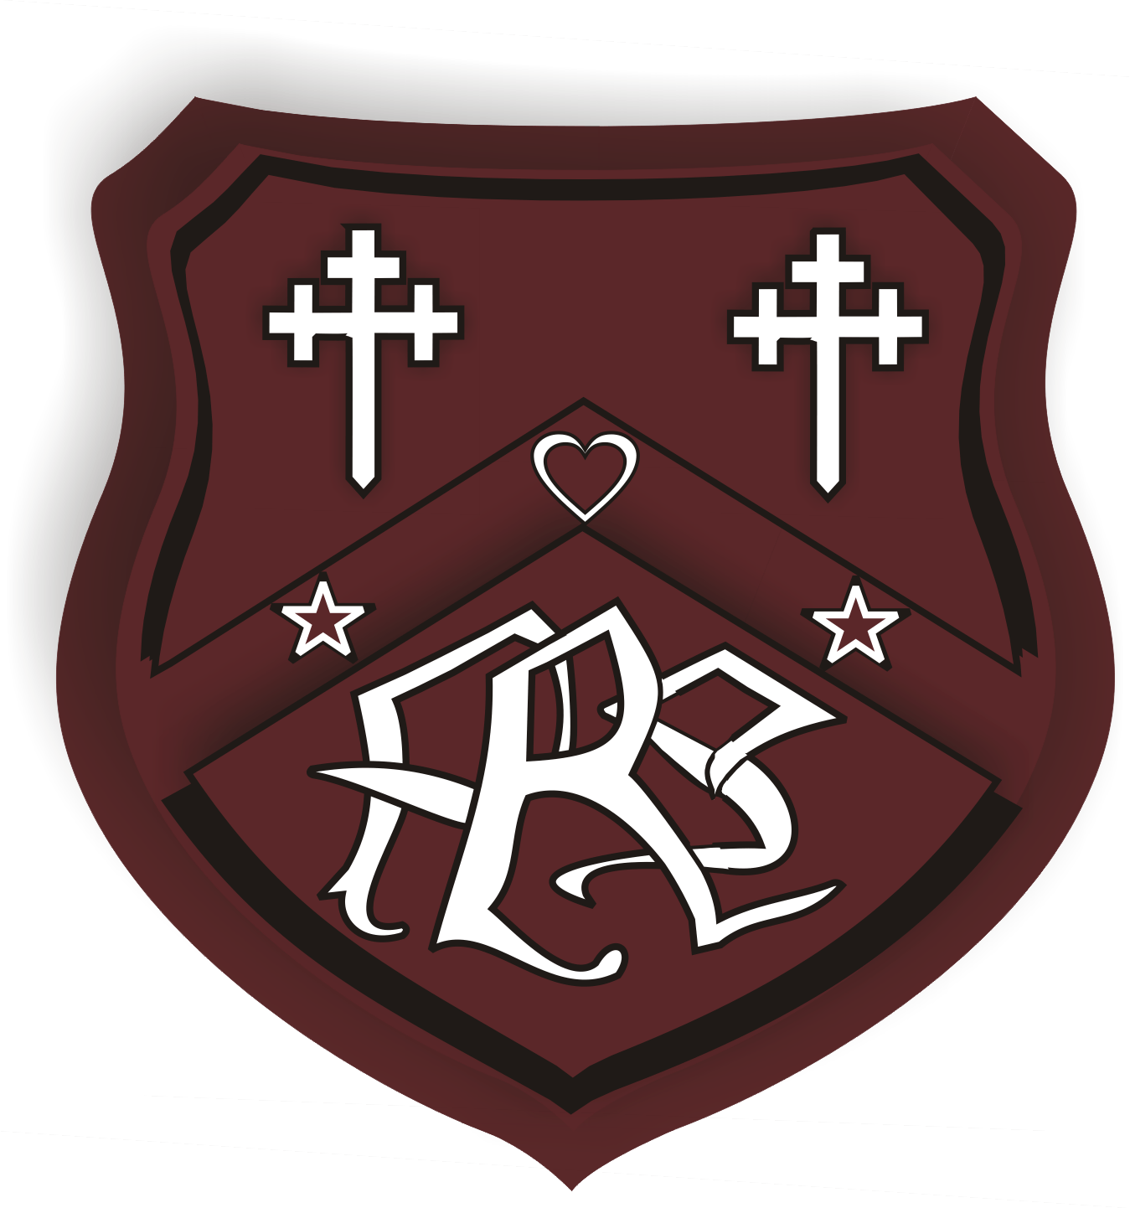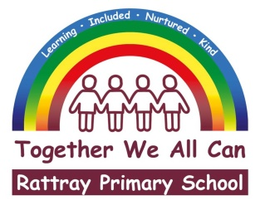

**JUNE 2022 NEWSLETTER**

It has been six weeks since our last newsletter and those weeks have been packed full of learning and events for our pupils. In this short time scale our P7s went to Lendrick Muir, we had an assembly with a piper and drummer for the new Strathmore Schools pipe band, some classes visited Dundee Botanic gardens as part of their rainforest topic, some children competed in cricket, tennis and athletics competitions, we had a bake sale and a barbeque, have celebrated the Queen’s platinum jubilee, participated in our health week where we enjoyed basketball, dance, football and potted sports, our P7s visited high school, our new P1s came to visit our school and finally two of our classes were visited by a Macaw! For the first time in over two years, it looks like we are returning to ‘normality’, and we are so pleased about this. We are now in the final weeks/days of this school session, and there are still several things planned for our school. These are listed in the section at the end of this newsletter.

All these events and activities need careful planning and organisation and wouldn’t happen without the commitment and dedication of our school team, from the office staff who make sure all these events run smoothly, to our school and nursery support staff who transport and accompany children to events and to the teaching and nursery staff who plan many of the events and activities. Before this school year draws to a close it’s important to acknowledge our Rattray staff team who go ‘above and beyond’ for our pupils. It goes without saying how much I appreciate them and would like to thank them for all they do for our pupils.

I’d also like to thank our school community, parents/carers, staff and other professionals who support our children and school daily. I feel very proud of how we, as a school community, have worked together through the trials of the last two years to ensure that our Rattray children have had the best possible education despite the obvious challenges of a global pandemic, whilst also being in the midst of an extensive school refurbishment and extension.

I hope everyone connected with our school has a relaxing and well-deserved summer break. When we return in August, we will (hopefully) be coming back to a full school session with no covid mitigations and restrictions and in a refurbished and extended school building which our pupils, staff and families deserve and can enjoy.

**Welcome to our school**

We have some new pupils join us since our last newsletter P1 Darlah Tolmie, P3 Mykola Kuzyk, P5 Artem Paliichuk, P6 Laila Coburn and P6/7 Jack Hood. We hope all our new starts will enjoy their time at Rattray Primary School.

**Successful Students**

We are always incredibly proud of our Rattray pupils, but recently several students have raised the bar which regards to their achievements recently.

A group of our P6 students won the local **cricket** festival in Meigle, which meant they progressed to the Perth and Kinross cricket finals and after being placed highly they were selected to compete at the Scottish Cricket Finals. Our Rattray pupils played exceptionally well and were placed 7th from 16 schools overall. This national event had teams from all over Scotland including the private sector. We are absolutely delighted that our school after only a few cricket coaching sessions managed to get so far in this competition. The organisers of the event singled out our pupils saying 'their enthusiasm and happy nature was infectious. A TRUE CREDIT TO YOUR SCHOOL'. Well done, Ayla, Stevie, Emily, Eva, Joey, Jack, Jacob, Aaron, Kane and Arran. Also, a huge thanks to Sian Warner and Mrs Coles for accompanying the children to the different events.

In May, some pupils from P3, P3/4 and P4/5 represented our school at a tennis tournament in Blairgowrie. They played fantastically well and one of our teams even won their section. Well done to all our budding Murrays and Raducanus, those competing were Aaron, T.J., Matias, Lacey, Max, Keane, Dominik, Marcus, Isla, Charlie, Alex and Luca.

Harris Brown, as part of a two man play by Blairgowrie Players, won the Scottish Youth Final with the play “Down Came the Rain”. The play was directed by a former Rattray PS pupil, Ciaran Low, and featured Alex Howat from Blairgowrie High School.  They qualified for the final after winning their regional and divisional rounds. They won 1st prize overall, as well as the Award for creativity and imagination - the first time a play has won both trophies being competed for. Congratulations Harris, we are all very proud of you. We expect no less than a BAFTA or an OSCAR in twenty years time.

Recently, some of our P6 and P7 pupils attended the cluster athletics event at Blairgowrie High School. Our pupils competed in 24 different events and did exceptionally well. We won two events outright but were placed in the top 3 for 12 of the events. The winners of two events were Chloe Neave (Shot Putt) and Scarlett McGougan (Discus), who will have the opportunity to compete in the county sports athletics finals next week. In 2nd place were William Forrest (Long Jump) Ayla Meikle (Long Jump), Stevie Grant (Shot Putt), Corey Clunie (800m) and Bethany Assenti (200m). Third place spots were won by Ayla Meikle (80m), Corey Clunie (80m), Jack Higgins (200m), Caleb Cummings (200m) and Maddox Patterson (Long Jump). Congratulations to those who were placed and well done to all our other competing athletes Olivia Dingwall, Joey Rooney, Murray Donaldson, Ellie Menzies, Calum Ireland, Logan Downie and Riley Brown. Lastly, thanks to all the parents who transported the children to and from the high school.

Quite a few our pupils have been particularly successful at recent football events. P6/7 pupil Corey Clunie was on the winning side at a recent cup final for Athletico Blair. P5 pupil Keegan Ferguson played on the pitch in a tournament at Aston Villa’s ground Villa Park. Rattray pupils Jude Downie, Hudson Scott, Jacob McFadden, Keane Phillips, Marcus Miezitis, Max Pirie, Dominik Maj, James Fowler, Finlay McKenzie, Riley Brown, Kane Warner and Charlie Anderson competed in the Pitlochry Fun Festival at the weekend, some of their teams even winning the fairest team award. Well done to all our footballers, hopefully future Scotland stars in the making.

**Exiting P7 Pupils**

We will be sad to say goodbye to our current ‘fabulous’ primary 7 pupils, although they enjoyed their visits to high school so much, they didn’t want to come back to primary school! We know that every one of them is capable of great things, and we wish them lots of luck and success for the future years at high school and beyond.

**Sports Day**

Our rearranged sports day will take place at Davie Park on **Wednesday 15th June** at 1.30pm. We are so pleased that once again we can hold our Sports Day with parents/carers welcome to spectate. To support our Parent Council, we are suggesting that a donation of a raffle prize is made at entrance to Davie Park.

**Open Afternoon**

We are delighted to be able to invite parents/carers into the school on the afternoon of **Thursday 16th June from 2:15pm to 3pm**. This is an opportunity for you to find out what the children have been learning, alongside letting you see how our new classrooms are looking. We really do hope you join us on this afternoon.

**End of this school year**

P7 will have their ‘Leavers Extravaganza’ on the afternoon of **Tuesday 28th June** on Rattray Common and playground, they are in the process of organising this. They opted for a more informal event rather than a Leavers Prom this year. The P7 Leavers Assembly will be on **Friday 24th June at 2.15pm,** all P7 parents are welcome to attend. Our Nursery Children have their graduation ceremony on the same morning **(Friday 24th June) at 9.30am.**

Our end of term prizegiving take place on the penultimate day of term (**Wednesday 29th June).** We have arranged both a P1 to P3 ceremony at **9.30am** and an upper school service (Primary 4 to 7) at **2pm** on the above date. Parents of those children receiving a prize, will be contacted and invited to this ceremony.

**Holiday dates**

School closes for the summer holidays on Thursday 30th June at 12 noon and reopens for pupils on Wednesday 17th August at 9am. If you require a take-away packed lunch for the last day of this school term, please get in touch with the school office. The school holiday and term dates up to June 2023 are available at the [following link.](https://www.pkc.gov.uk/article/21553/School-term-and-holiday-dates-2022-2023)

**Lost Property and Lost Uniform**

We have a considerable amount of lost property in our school, we have posted photos on Facebook, please let us know by commenting on the photo if something belongs to your child and we will return it to them. Anything clothing remaining prior to the summer break will be handed into local charity shops.

**School Handbook 2022/23**

Our school handbook for next session is available to view on the council website or in paper form from school office. Follow this link – [school handbook](https://www.pkc.gov.uk/media/32309/Rattray-Primary-School-Handbook-2021-22/pdf/Rattray_handbook_2021_-22.pdf?m=637433009665230000)

**Rattray Parent Council**

Our parent council are running a raffle in aid of funds at Blairgowrie Tesco on Friday 17th and Saturday 18th June. They urgently require donations for hampers for the raffle. Please hand in any donations to our school office or at our school sports day by Wednesday 15th June.

The most recent parent council meeting was held in school last month. Matters discussed were progress around our school improvement plan, school refurbishment, social media concerns, staffing, support with online homework, fundraising and communication protocols.

All parents and carers are welcome to attend the parent council meetings, and as a school we would urge you to think about coming along to meetings. If you want further information about our Parent Council, please visit their Facebook page. <https://www.facebook.com/Rattray-Primary-Parent-Council-1486611214939520/>

**Social Media Concerns**

I am sure that we are all aware of the many benefits that technology and phones bring to society, whilst also being aware of the risks these can pose. Unfortunately, as a school we have noticed a significant increase in the number of incidents in which social media has played a central role in causing upset and distress. Many of these incidents are beginning with initially trivial comments or events but are escalating quickly.

This term we had the police give talks to some of the upper classes about staying safe on-line, and on social media, as it is important that children and young people know the strategies, they need to stay safe, before they immerse themselves in the online world.

It is worth noting the age restrictions on many of the apps that our children are using.

|  |  |
| --- | --- |
| App | Age allowed access |
| WhatsApp | 16+ |
| Snapchat | 13+ |
| Facebook | 13+ |
| Twitter | 13+ |
| Instagram | 13+ |
| Tik Tok | 13+ |

None of the children at Rattray are old enough legally to access any of the apps where issues are arising. As these incidents are happening outside of school, and on apps children shouldn’t be accessing, the school is not able to investigate or follow up on parental requests to deal with incidents online.

The appropriate response is for you, as parents/carers is to discuss the importance of being safe on-line with your children, and if there are issues, to follow this up with your child, other parents and involve the police when necessary.

We will however continue to support children to be safe on-line, and to know both the dangers and opportunities that technology can bring.

**Communications Conduct Policy**

It is widely recognised that the more involved parents are in their child’s education, the better the pupil performs at school. It is therefore vital that parents/carers can communicate with school. In conjunction with other local schools and following PKC guidance, the school has created a communications conduct policy which provides an overview of the standard of communication parents and carers can expect of Rattray school staff and, in turn, what our staff will expect of parents/carers. This policy (which is attached to this newsletter) was shared, discussed and agreed at our most recent Parent Council meeting, changes have been made considering these discussions.

**Profiles**

This year we have been developing our pupil profiles and have switched from having children keep work over the year in a jotter, to having it OneNote. This means that parents can always access the profile, and it also allows parents/carers to share their child’s successes with us too.

A helpful guidebook (which will be sent to you shortly) will take you through

1. How to access your child’s profile
2. What you should expect to find in your child’s profile
3. How you can share your child’s successes with the school

Helpful videos can also be found on our school YouTube account.

OneNote on an iPad- <https://youtu.be/K12Kg8j8iGE>

OneNote on a laptop - <https://youtu.be/GU8qzdNPdJI>

**Free school meals and school clothing grants**

Free School Meals are offered to **ALL**pupils in P1 - P5 **without the need for parents/carers to apply**. Don't forget to apply for Free School Meals for your child when they move into P6 as they will no longer be automatically entitled to Free School Meals.

An application form must be completed if you also require a school clothing grant for your child in P1-P5. Parents/Carers in receipt of a qualifying benefit will receive an annual school clothing grant of £120 per child in primary school and £150 per child in secondary school. Please [Apply online](https://my.pkc.gov.uk/service/Free_school_meals_and_clothing_grant___apply?referrer=MyPKC_Web)

For more information regarding free meals and clothing grants please visit the PKC website. [Free school meals and school clothing grants - primary and secondary - Perth & Kinross Council (pkc.gov.uk)](https://www.pkc.gov.uk/freeschoolmeals)

**School Refurbishment and Nursery Extension**

We are delighted to announce that as of Monday 20th June, the new Rattray Early Childhood Centre will be open to all nursery pupils. We will share photos with you as soon as we can. As you know, this space will now be able to accommodate more families in local community with extended hours and weeks.

With the new nursery completed, the school project will continue over the summer holidays, and all refurbishments should be completed for our return in August.

**Annual Pupil Report and next years classes**

We are currently finalising our pupils reports and all parents/carers will receive their child’s school report by the end of this week. Contained within your child’s report will be information as to their new class and teacher for next academic session.

Please be mindful that classes are created following strict council guidance and are based on the children’s chronological age. As much as we would like, we cannot take consideration of friendship groups or other factors, whilst we are happy to discuss concerns it is highly unlikely that classes will be altered.

On behalf of all the staff I would like to thank you for your continuing support. If you have any questions or queries regarding any of the items within this newsletter, please don’t hesitate to contact the email address below.

I hope you all have a wonderful summer!

Yours faithfully

Joanna Robertson

Headteacher

[rattray@pkc.gov.uk](mailto:rattray@pkc.gov.uk) **Future Dates**

Wednesday 15th (1.30pm) – School Sports Day

Thursday 16th (5pm – 6pm) – HT- parent drop-in session

(contact school office if you would like an appointment)

Thursday 16th (6pm) – P1 parent induction session (online)

Thursday 16th (2.15pm) – Open Afternoon (all welcome)

Friday 17th – P7 bike ride to High School

Monday 20th – New Rattray Early Childhood Centre opens

Thursday 23rd (PM) – Nursery and P1 teddy bears picnic (pupils only)

Friday 24th (9.30am) – Nursery Graduation (by invitation)

Friday 24th (2.15pm) – P7 Leaver’s Assembly (by invitation)

Tuesday 28th (PM) – P7 Leaver’s Party (pupils only)

Wednesday 29th (9.30am) – Infant P1-P3 Prizegiving (by invitation)

Wednesday 29th (2pm)– Infant P4 – P7 Prizegiving (by invitation)

Thursday 30th –P7 Shirt Signing (pupils only)

Thursday 30th (12 noon) – School closes for Summer Break