COVID-19 REMINDER

As you will be aware, in the last few days there have been confirmed COVID - 19 cases in our local community. In order to keep our school community safe, can I please remind you of the following:

- We will encourage children to sanitise or wash hands upon entry to and exit from school, after using the bathroom, before and after lunch/breaks, when moving between rooms in the school. Please remind your children of the necessity of good respiratory and hand hygiene.
- Nursery, P1 and P2 Rattray children (and siblings) accompanied by one designated adult per family can enter the playground via the gates on the High Street. Do not congregate in areas of the playground.
- Primary 3 pupils and upwards can enter the school from Rattray Common. No parents from these classes should enter the school playground, unless these children have younger siblings.
- If entering the school playground, please stand 2 metres from other families, on exiting the playground please leave promptly.
- Limit items that your child brings from home.
- Pupils should keep socially distanced from all adults.
- Encourage your children to maintain distance where possible, particularly indoors, as an added precaution – it is recommended that they should not be crowding together, touching or hugging their peers.
Please DO NOT send your child to school if they are displaying any of the following symptoms:
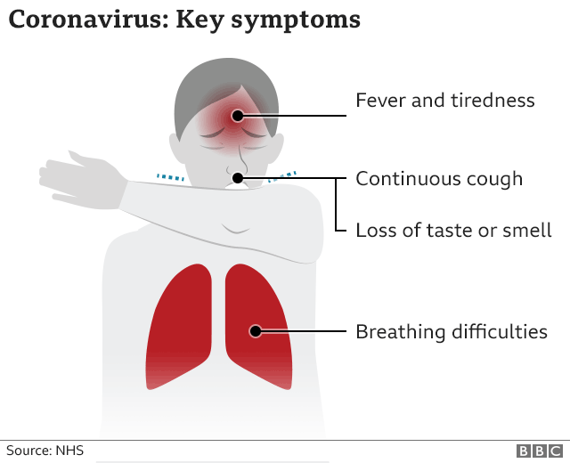
- a high temperature – this means you feel hot to touch on your chest or back (you do not need to measure your temperature)
- a new, continuous cough – this means coughing a lot for more than an hour, or 3 or more coughing episodes in 24 hours
- a loss or change to your sense of smell or taste – this means you've noticed you cannot smell or taste anything, or things smell or taste different to normal

If ANYONE in your household is showing any of the above symptoms, then the person who has symptoms should stay at home for 10 days from the day their symptoms started. Anyone else who lives with you who doesn’t have symptoms should isolate for 14 days from the date your symptoms started. THIS INCLUDES CHILDREN WHO ATTEND OUR SCHOOL. If others develop symptoms within the 14 days, they need to stay at home for 10 days from the day their symptoms started. They should do this even if it takes them over the 14-day isolation period.

Anyone with symptoms of coronavirus should be tested. The test is only reliable if you have coronavirus symptoms. You should get tested in the first 3 days of symptoms appearing. You can book a test for:
• yourself
• someone you care for
• a child in your care

You can access a test online at: https://www.nhsinform.scot/illnesses-and-conditions/infections-and-poisoning/coronavirus-covid-19/test-and-protect/coronavirus-covid-19-testing or phone 0800 028 2816

More information can be found at https://www.nhsinform.scot/illnesses-and-conditions/infections-and-poisoning/coronavirus-covid-19/test-and-protect/coronavirus-covid-19-guidance-for-households-with-possible-coronavirus-infection

