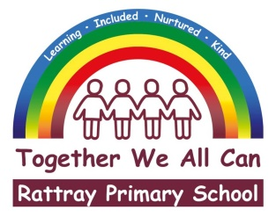

**OCTOBER 2021 NEWSLETTER**

Dear pupils, parents/carers and friends of Rattray

I hope you have all been able to enjoy some rest and relaxation over our October holidays. It has been lovely having our pupils back in school, however we are saddened that we are not able to have parents, carers and families return to visit our school yet. This year we will again miss out on our annual parent council Halloween disco, we do love seeing all the fantastic costumes and crazy dances at this fun-filled event. However, the school and parent council hope we can offer some dress up fun for the children this coming Friday 29th (see below). At the moment, we are hoping that our Christmas celebrations are not hampered by pandemic restrictions again, however if they are, similar to last year we will endeavour to be as creative as possible.

This newsletter contains many of our usual ‘housekeeping’ items, apologies if they are repetitive. At the end of this letter there will be a number of dates (some provisional) which I hope will be of assistance in planning busy family routines. Please take the time to read this lengthy newsletter and as always, if you have any queries or concerns (no matter how trivial) please get in touch via our school office 01250 871980 or [rattray@pkc.gov.uk](mailto:rattray@pkc.gov.uk)

Please be mindful that our school procedures will be adapted and updated in line with changes in government and council guidance around Covid. We will continue to keep you updated in our usual ways – Parentpay, school app, text messaging and our school Facebook page. **Therefore, please ensure your Parentpay account, email address and your mobile phone numbers are all up to date.**

Although the return to school this year has been very different, I am proud to say that

our pupils have shown courage, resilience and positivity in the first few weeks of term.

Young people seem to be very good at taking changes in their stride and I a

**Welcome to our school**

We have had several new pupils join us this session Perrie Watson – P2, Harriet Crich – P3, Estella Cronshaw – P3

Harris Low – P3/4, Isla Low P3/4, Faith Crich – P4/5, Chloe Carmichael – P5, Andrei Hunea-Anania – P5 and Finley McArthur – P5. We hope all our new starts will enjoy their time at Rattray Primary School.

**Staffing Update**

Recently, there have been some staffing changes to share with you. Miss Jenni Gregg (pupil support assistant) was successfully in a recent interview and has been appointed to her post until next August. Ms Maria Johnson joins us one day a week in her role as pupil support teacher.

In our Early Childhood Centre, Mrs Una Robertson was successfully appointed to our Senior ECP post on a temporary basis. Mrs Lynne Michael (ECP) and Mrs Louise Cameron (PSA) will be joining the nursery team temporarily. We have some nursery vacancies which we are in the process of interviewing for, we will update you with any further staffing changes as they occur. Lastly, Janine Whyte begins her maternity leave on the 8th of November, we wish her and her baby much health and happiness.

The Scottish Government has funded several temporary covid recovery posts within our local schools, and we will be given a share of some these new roles. Joining our school team temporarily this school year are Ms Fiona Shaw (Community Learning Assistant), who will be joining our school team two days a week, her role will be to support attendance and wellbeing for our children and families. Mrs Miriam Laing (Early Childhood Practitioner) will move temporarily from the nursery to our P1 classes to support our pupils three days a week to learn through play. Our Covid Recovery Teachers Miss Lucy Thomson (3 days) and Miss Julia Moore (1 days) will support children’s learning during the period of Covid-19 recovery.

**School Refurbishment and Extension**

Our extensive school refurbishment continues, and many parts of the school are already looking fantastic. Our office areas and all classrooms from P3 to P7 have been fully decorated, recarpeted, refloored and refurnished. We recently shared photos on our school Facebook page of the newly refurbished areas.

Our P2 class are currently in one of our decant classrooms, whilst their room and the library are being refurbished, thereafter P1 and P1/2 will spend four weeks in the decant classrooms. Unfortunately, this means that during the school year we will still have to change the playground entry and exit points for classes.

This project will last until Summer 2022. The school and nursery will look very different when the works have been completed, and we do hope that you will be able to visit our school to see the ongoing works very soon.

**School Prefects**

All our P7s are school prefects this academic session, and they are now all in possession of new Rattray prefect hoodie, which they are delighted with. These hoodies were partly funded by our Parent Council, for which I am very grateful. There are several responsibilities and expectations which come with the prefect role, and I am sure that our P7 prefects can be wonderful role models for our younger pupils.

**House Captains**

Our house captains have been selected this year; each captain completed an application form and participated in an interview to gain selection. All P7 pupils who applied should be very proud of themselves, regardless of selection or not. Ideally it would have been lovely if we could have given all our applicants a captaincy role. This year’s house captains are

Glasclune – Mackenzie Brown, Maisie MacKenzie, Ellie Menzies and Chloe Neave.

Glen Ericht – Lo Brierly, Harris Brown, Murray Donaldson and Calum Ireland

Parkhill – Connor Anderson, Bethany Assenti, Logan Downie and Lia McNair.

Strathmore – William Forrest, Bethany Graham, Alexander Harris and Caitlyn Leighton.

Our Captains have signed their duties and responsibilities contract, I am certain they will be a great asset to the school this year.

**Pupil Council**

All classes were asked to nominate and select pupils to represent them on our Pupil Council. Congratulations to these children. The new class representatives are as follows

P1 – Macy Cunningham

P1/2 – Grace Pick

P2 – Josh Ireland

P3 – Jacob McFadden

P3/4 – Shaih Kempton

P4/5 – Amelia Robertson

P5 – Lewis Fyfe

P6 – Charlotte Findlay

P6/7 – Rory Scotland and Abigail Coventry

P7 – Finlay Ferrie and Andrew Scullion

Last term the Pupil Council wanted to find out about relationships in our school. They graded how good they thought we are in different aspects, and then from this thought of questions they would like to ask pupils. A survey was created and carried out from P4. It is clear from this there are many positive relationships throughout the school, and children feel safe here too. This term the Pupil Council will be thinking about “Feedback that helps me in my learning” and again capturing what different classes find helps them.

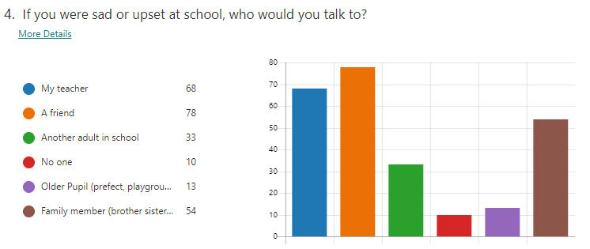

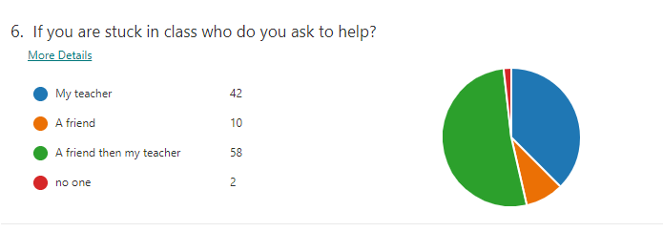

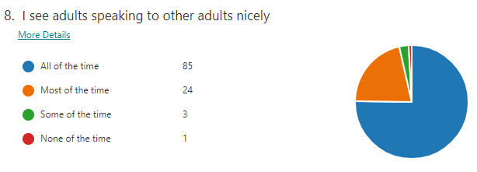

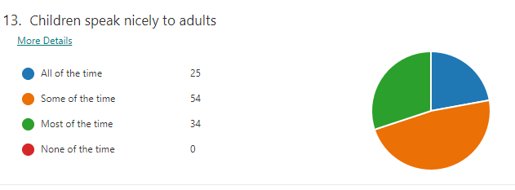

**Parent Survey**

As a school we are keen to find out from you how you feel about our school. Can we please ask that an adult from every family please complete this very short survey related to your experiences as a parent at Rattray, following this link – [Parent Survey – Relationships](https://forms.office.com/Pages/ResponsePage.aspx?id=oyzTzM4Wj0KVQTctawUZKWRgx6-lUEBMl4VSA2lTbcVUOTdaSktUMFFGNDQzQzFNWVNYUDJOM0xERC4u). Thank you in advance of completion.

**Flu Immunisation Programme**

Tayside Health Board nurses will be in school on **Wednesday 27th October (this week)** to carry out the flu prevention programme for all children from Primary 1 to 7. Again, this will be in the form of a nasal spray.

Although the return to school this year has been very different, I am proud to say that

our pupils have shown courage, resilience and positivity in the first few weeks of term.

Young people seem to be very good at taking changes in their stride and I a

**Parents’ Evening 9th & 10th November 2021 - Online Appointment Booking**

Our online booking system will be opening soon, please look out for a letter in your parentpay account, explaining how to book an appointment with your child’s class teacher.

**Inset Days - Thursday 11th and Friday 12th November.**

A reminder that school will be closed for to pupils for INSET training next month, on **Thursday 11th and Friday 12th November.**

**Parent Council Dress Up/Dress Down Day – Friday 29th October**

All children (and staff) are invited to dress up (costumes) or dress down (play clothes) this coming Friday. This day will help raise funds for our Parent Council, and we ask that all families donate £1 or more (if they can) to support this fundraiser. Children should come to school with money. **NO SCARY MASKS PLEASE**, this frightens some of our younger children!

**Home Learning**

As some of you may be aware, each class teacher from P3 upwards, has set up a Microsoft Team and some classes used it last term to communicate homework.This term more of our classes will be putting activities and tasks on their Teams page so please make sure you have access to it and check it regularly. All pupils should have been added to their class team however you will find the Teams codes for each class below:

P3 – **4h0ebbg**

P3/4 – **50n0ni0**

P4/5 – **mdkpdlz**

P5 – **s2ra133**

P6 – **xq0ks2a**

P6/7 – **k00d76c**

P7 – **3xbm2cl**

**School Uniform and Lost Property**

It is lovely to see the children at school so smart in their school uniform, thank you for making this effort. However, we have already accumulated a large amount of lost property, which are largely grey jumpers/cardigans. It would be helpful if your child’s name or initials could please be written on the labels of school clothing, this will also aid teachers when it comes to gym time too. Thanks for your co-operation.

Whilst there is no expectation to buy branded school clothing these can be purchased from <https://www.grandtullylogos.com/school/rattray-primary/> . This company also sells our schoolbook bags, should you wish to replace any missing or lost items. School ties can be purchased from Doigs on Blairgowrie High Street.

**Appropriate clothing for the weather**

Please can we ask that your child comes to school each day with a coat and appropriate footwear. Currently due to Covid 19 restrictions, there is less movement around school which means the children are spending longer periods of time in their classrooms. It is important that our pupils get plenty of exercise and fresh air, so children will be outdoors for break and lunchtimes in all weathers (except torrential rain and high winds).

**PE Times and Kit**

All our classes have at least two sessions of PE each week. The attached table indicates the days that your child will have their PE lesson. Until further notice, children should come to school without uniform and wearing suitable sportswear on these days. Current advice is that changing rooms cannot be used. Please note that on these days, jewellery should not be worn, and long hair should also be tied back.

**Pupil Absence and Lateness**

Absent - If your child requires to be absent from the school for any reason, please contact the school (01250 871980) as soon as possible on the morning of the absence and before 9.30am. **If the phone is not answered by a staff member, please do leave a message on our voicemail system.** If there has been no parental contact by 9.30am staff will send a text message to enquire as to your child’s absence. This is normal procedure across Scotland. Your support in this is much appreciated.

Sickness/Diarrhoea - NHS advise that they should not attend school for at least 48 hours after the last bout. This helps stop the spread of infection. Please also see your local GP for advice.

Cold-like symptoms - If child does not have symptoms of COVID-19 but has other cold-like symptoms, such as a runny nose, they do not need to be tested and they and you do not need to self-isolate. Your child can come to school or nursery if fit to do so.

COVID-19 Symptoms - The main symptoms to be aware of are:

* new continuous cough
* fever/high temperature
* loss of, or change in, sense of smell or taste

If a young person or a child in your care develops any of the above symptoms, they should self-isolate and you should book them a test as soon as possible at <https://www.nhsinform.scot/test-and-protect>, or by calling 0800 028 2816.

It is recommended that testing is only for those with a continuous cough, fever, or loss of or change in the sense of taste or smell.

Lateness - If your child is going to be late, please call us to let us know their lunch choice for that day as we must report to the kitchen by no later than 10.15am. Late lunch choices may not be accommodated after this time, due to kitchen deadlines. This also includes children who may change their mind midway through the morning.

**Communication with teaching staff**

We appreciate that given the current COVID led situation we find ourselves in, it can be difficult for parents to have face to face contact with school staff. Teaching staff are available at the end of the school day on most days to discuss any general matters or concerns you have. If you are concerned about your child’s education or welfare at any time, please do not hesitate to contact the school office as soon as possible. Currently, whilst school is open school staff are not accessing their glow email addresses on a regular basis. If you need to contact your child’s class teacher or a member of the school management team this should be done through our school email [rattray@pkc.gov.uk](mailto:rattray@pkc.gov.uk) or by telephoning our school office during the hours of 8.30am to 3.15pm.

**Assessing Children’s Progress**

As you may be award National Standardised Assessments have been introduced across all schools in Scotland, and each year pupils in Primaries One, Four and Seven are assessed in schools locally and nationally. This is part of the Scottish Governments commitment to raising standards across Scottish Education. Testing of our P4 pupils will take place this term. Further details can be found at the web link below. <https://www.education.gov.scot/parentzone/Documents/parent-leaflet-assessing-progress.pdf>

**Rattray Numeracy and Maths Trail**

Over the October holidays we were delighted to see photos from some of our pupils taking part in the Numeracy and Maths Trail. We were so pleased to see that the Trail had proved popular and that lots of answer sheets were handed in. Well done to everyone who took part. ALL ANSWER SHEETS SHOULD BE RETURNED TO THE SCHOOL BY THE END OF THIS WEEK, for pupils to be included in the prize draw.

Thank you to the following local businesses who supported our Maths and Numeracy Trail by displaying our questions. Our pupils had a fabulous time trying to find them all and answer all the questions!

Coupars Subway The Wee Coffee Shop Wetherspoons Boots

The Cancer Research Shop Mitchell’s Newsagents The Cateran Café Goodfellows

The Blairgowrie Cookshop Semi Chem Sainsbury’s M and Co Pet’s Pantry

Something Special The Two Bells The Dome Davidson’s Adventure into Books

**Ski Trip**

A reminder that on Parent Pay, we have added the Ski Trip as an item for you to start saving for. Putting money in at this stage will not commit you to the trip, and I am organising a meeting with Cally Gordon to share with you, on the key things you need to know about the trip. Last year I recorded a meeting between Cally and myself and then shared this on the different Class Teams pages, and I imagine this is what I will do this year too. If you have any questions, you would like me to ask Cally please contact the school.

As a reminder, the trip is non-residential, with pupils travelling from Rattray to Glenshee daily. The cost is approximately £210, which includes transport, tuition, ski pass and equipment hire. Children do not have to have any skiing experience, and indeed usually this is the first time for most children skiing.

If you have any questions or queries regarding any of the items within this newsletter, please don’t hesitate to contact the school office or the email address below.

On behalf of all the staff I would like to thank you for your continuing support.

Yours faithfully



Joanna Robertson

Headteacher

[rattray@pkc.gov.uk](mailto:rattray@pkc.gov.uk)

01250 871980

Rattray Primary School Key Dates

**Please note these dates are provisional and may be subject to change**

**Other dates will also be added**

**October 2021**

Wednesday 27th – Flu Immunisations

Friday 29th – Dress down/Dress up day

**November 2021**

Tuesday 9th - Parent Contact 1 (4pm to 6.30pm)

Wednesday 10th – Parent Contact 2 (5pm to 7.30pm)

**Thursday 11th – Inset Day school closed to pupils**

**Friday 12th – Inset Day school closed to pupils**

Monday 15th - Odd socks day (anti-bullying)

Wednesday 24th (5.30pm – 6.30pm) – HT- parent drop-in session

**December 2021**

Thursday 2nd - Winter Fayre (6pm)

Tuesday 14th - Infant Nativity (9.30am and 1.30pm)

Tuesday 14th - (PM) in Hub- Nursery PM Party

Friday 17th - (AM) in Hub - Nursery AM Party

Friday 17th - Carols in the Playground (3pm)

Monday 20th – Whole School Christmas Party Day

Tuesday 21st - Christmas Jumper Day and Christmas Lunch

Tuesday 21st - Nursery Christmas Activity Day and Songs

Wednesday 22nd - End of term service (10.30am)

Wednesday 22nd (noon) – School closes for Winter Break

**January 2022**

Thursday 6th - Back to School

Tuesday 25th (5.30pm – 6.30pm) – HT- parent drop-in session

Friday 28th – Upper School Burns Assembly (PM)

**February 2022**

**Wednesday 16th – Inset Day school closed to pupils**

**Thursday 17th – Public Holiday school closed to all**

**Friday 18th - Public Holiday school closed to all**

**March 2022**

Tuesday 1st - Parent Contact 3 (4pm to 6.30pm)

Wednesday 2nd – Parent Contact 4 (5pm to 7.30pm)

Wednesday 23rd (5.30pm – 6.30pm) – HT- parent drop-in session

Thursday 24th – Open Afternoon (2.30pm)

Tuesday 29th – Upper School Show (afternoon and evening performances)

Thursday 31st – Easter Service (2pm)

**April 2022**

Friday 1st – School closes for Spring holiday

Tuesday 19th - Back to School

**May 2022**

**Monday 2nd –** **Public Holiday school closed to all**

Tuesday 10th (5.30pm – 6.30pm) – HT- parent drop-in session

w/b 16th – P7 residential week Lendrick Muir

**June 2022**

Wb 6th June – Health Week

Thursday 9th – Nursery Sports Day

Wednesday 8th – Sports day (Upper School AM/Infant school PM)

9th/ 10th – P7 Transition Days

Wednesday 15th (5.30pm – 6.30pm) – HT- parent drop-in session

Thursday 16th – Open Afternoon (2.30pm)

Monday 20th – Nursery Graduation

Thursday23rd – P7 Prom

Friday 24th – P7 Leaver Assembly

Wednesday 29th– Prizegiving (Upper School AM/Infant school PM)

Thursday 30th – School closes for Summer Break (12 noon)