 |  | Joanna Robertson  Headteacher  Rattray Primary School,  High Street, Rattray  BLAIRGOWRIE,  PH10 7DG  01250-871980  Email: rattray@pkc.gov.uk  Date: 12 March 2026

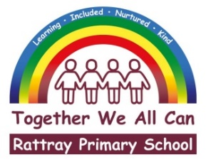
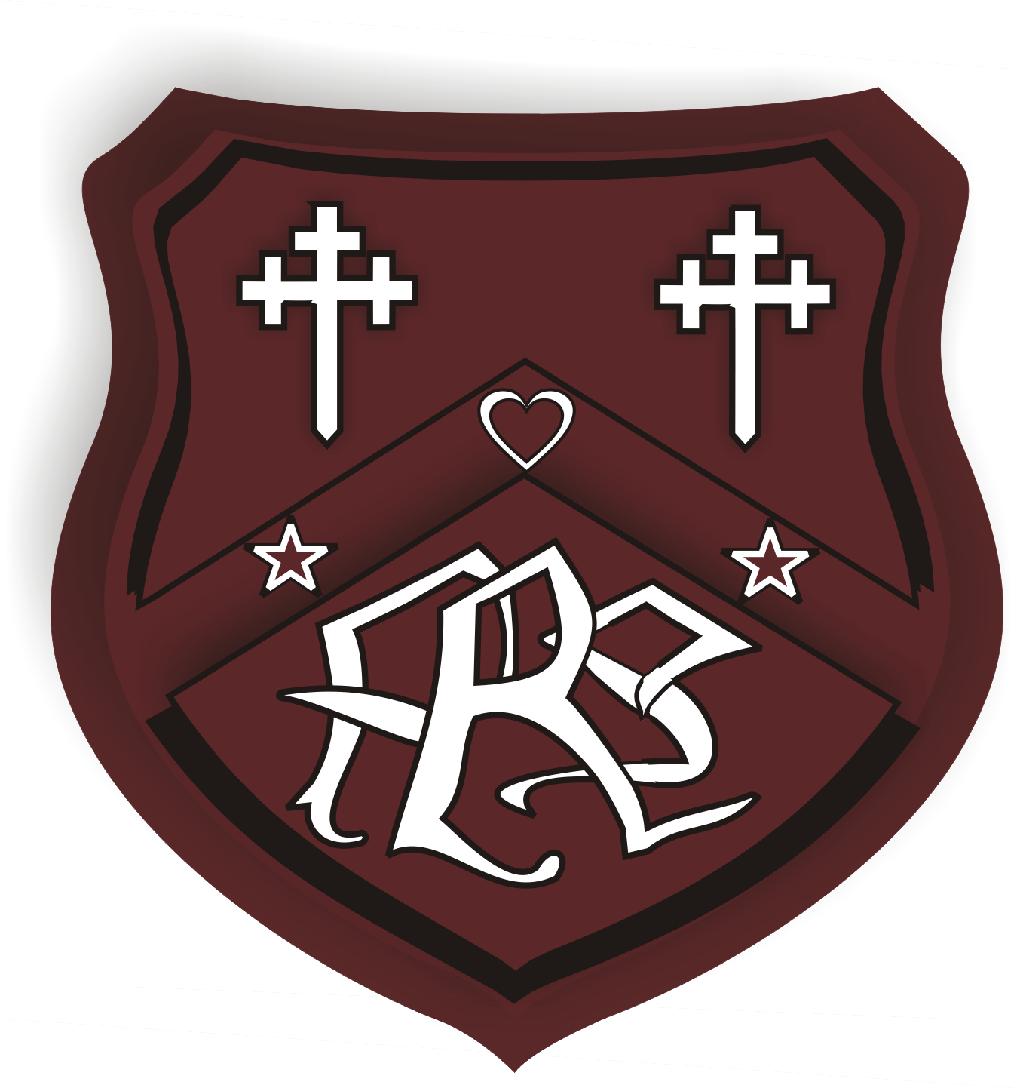

Dear Parent/Carer,

Industrial Action – Thursday 19 March 2026

I am writing to update you on the impact of the planned industrial action on Thursday 19 March. As previously advised this action involves members of the EIS union and is part of a national dispute relating to Reduction in Class Contact Time (RCCT) and the failure to agree on the nature and timescales of reducing teachers’ class contact time to 21 hours per week. Negotiations are continuing at a national level. However, it is important that we prepare for the possibility of industrial action going ahead.

As with all decisions of this kind, the safety and wellbeing of children and young people is our priority. Following a careful risk assessment of our school’s circumstances – including expected staffing levels and our ability to operate safely - I can confirm that:

- The school will be open for all nursery aged children
- The school will be closed to all primary school aged children (Primary 1 to Primary 7)

Lunches will operate as normal for our nursery children. No meal service will be available for primary school aged children, however, for pupils who are eligible for free school meals, payments will be made directly to parents/carers. Breakfast club will not operate on Thursday 19th March.

We know that uncertainty around national industrial action can be challenging for families. We are sharing this information early to support your planning, but please note that arrangements may need to change if new information becomes available. If this happens, we will update you as soon as possible.

Please note that the arrangements for 19 March do not confirm arrangements for the further proposed strike day on Wednesday 25 March. Learning from 19 March will inform local planning for that date and we will update you nearer the time.

We will keep you informed through our usual methods of communication. You can also follow Perth and Kinross Council’s updates on Facebook or check www.pkc.gov.uk/schoolclosures for the latest information.

Yours faithfully,
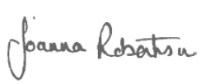

Joanna Robertson

Headteacher

