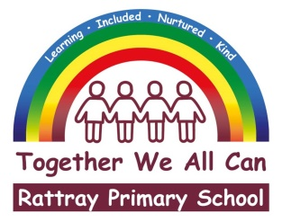 |  | Joanna Robertson  Headteacher  Rattray Primary School,  High Street, Rattray  BLAIRGOWRIE,  PH10 7DG  01250-871980  Email: rattray@pkc.gov.uk  www.pkc.gov.uk
 |  |  | 27 February 2024

Dear Parent/Carer

Parents’ Evening Wednesday 6th and Thursday 7th March 2024 - Online Appointment Booking

I would like to invite you to participate in our Parents’ Evening on Wednesday 6th March (5pm to 7pm) and Thursday 7th March (4pm to 5.30pm).

This term, it would be preferred if you could come into the school to talk to your child’s class teacher face to face. However, I appreciate that for some families a conversation over the telephone is better suited, and this can also be arranged.

The school uses an easy-to-use online appointment booking system. This allows you to choose your own ten-minute appointment with teachers. On selection of your appointment time, you will be prompted with a message box, please leave a short note if there is anything specific you would like to discuss at the appointment time. After booking you will receive an email confirming your appointments.

Appointments can be made from Tuesday 27th February 3pm until Monday 4th March 11.55pm. Should you wish to make any changes after this date please contact the school office.

Please visit https://rattray.parentseveningsystem.co.uk to book your appointments. (A short guide on how to add appointments is included with this letter.)

IF YOU WOULD LIKE A TELEPHONE APPOINTMENT, PLEASE CONTACT THE SCHOOL OFFICE BY EMAIL OR PHONE.

If you do not have access to the internet or are having any difficulties booking an appointment, please contact the school office who will be happy to add appointments on your behalf.

Yours sincerely

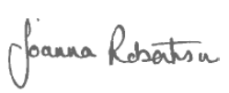

Joanna Robertson
Headteacher

