Accessing on a PC or laptop
- Search for ‘Glow RM Unify’
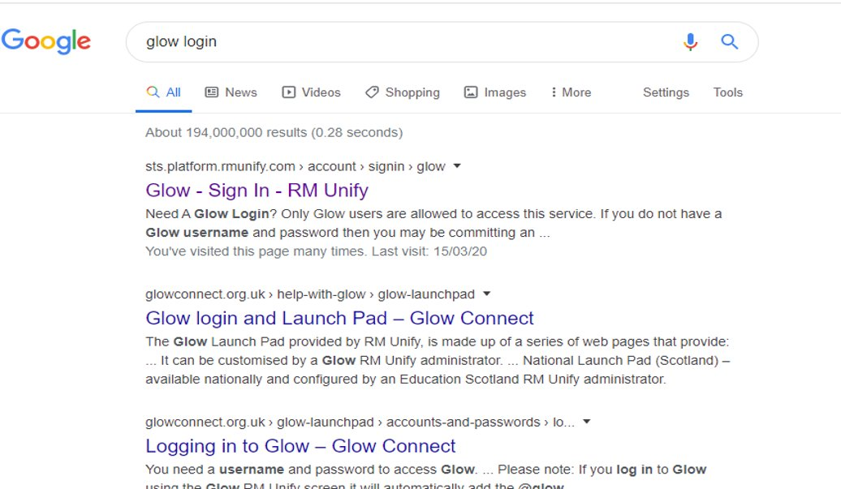
- Enter Glow username and password
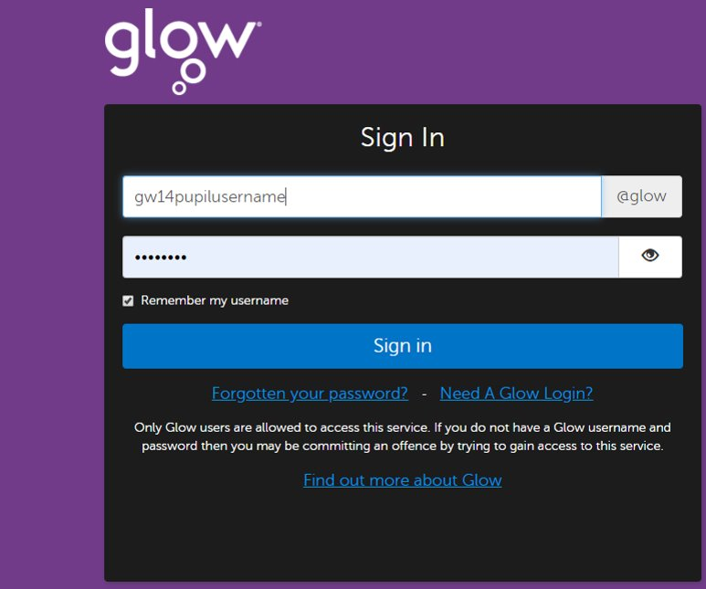
- It may be you are asked to re set your password​. If you do, it also possible that when you click “log in using new password” an error message will show. Just close down the internet window and log in again from the start of the process, using the new password

- On the Glow Launch Pad click on Office 364
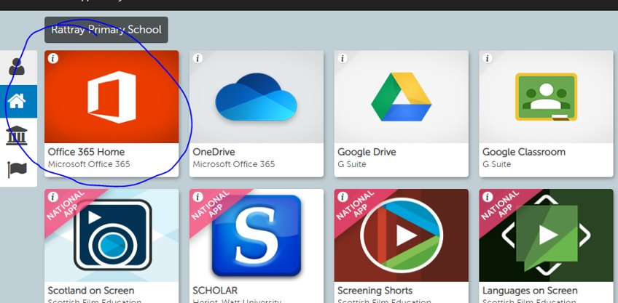

- Select Microsoft Teams
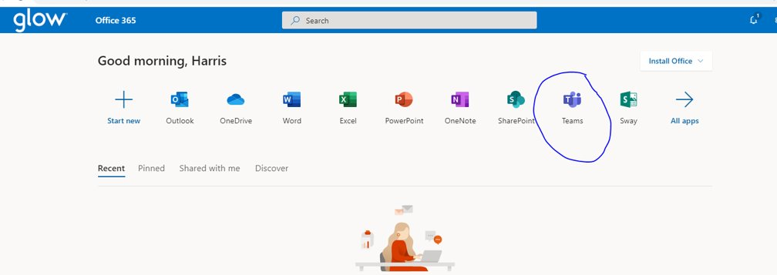
- You may get this help page when you open​
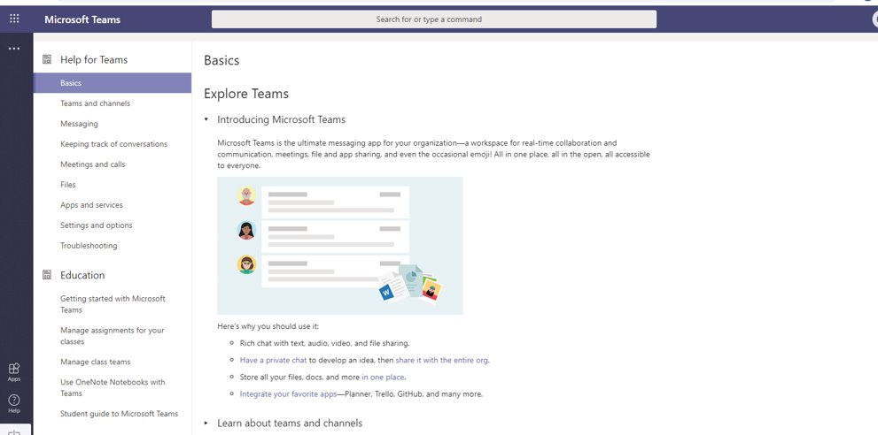
If so try opening settings
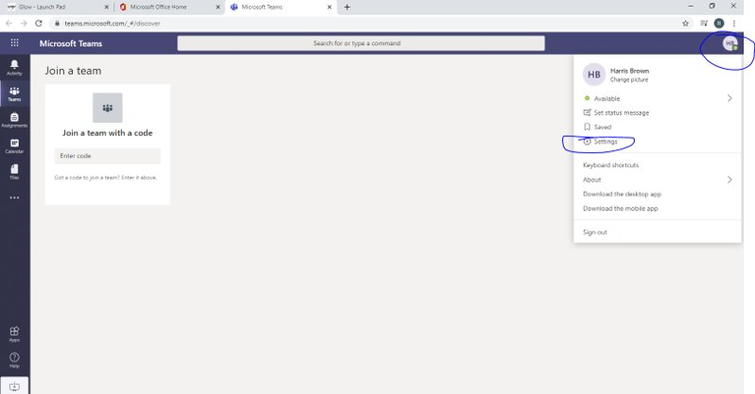

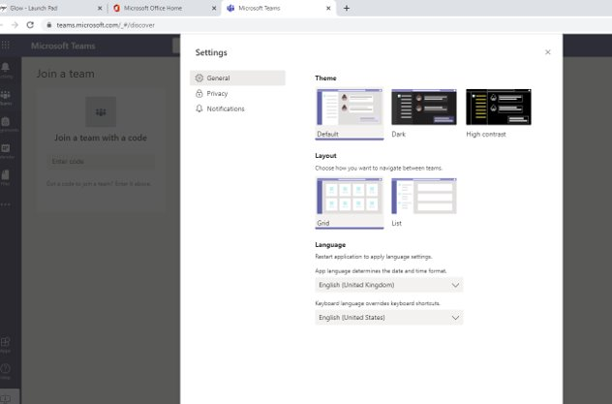
And select Grid. If this doesn’t work, it may be that Microsoft need 5-10 mins for the user profile to update

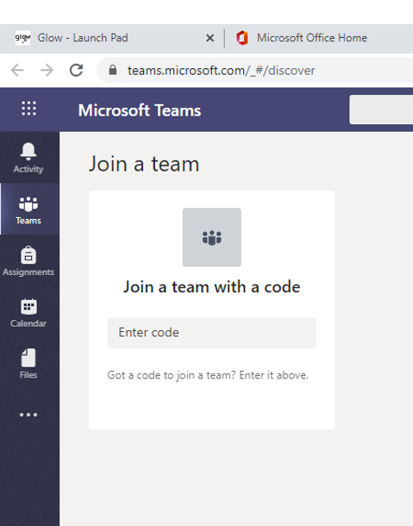
- Enter team code​ -You should now see​ your class as a team​ you are part

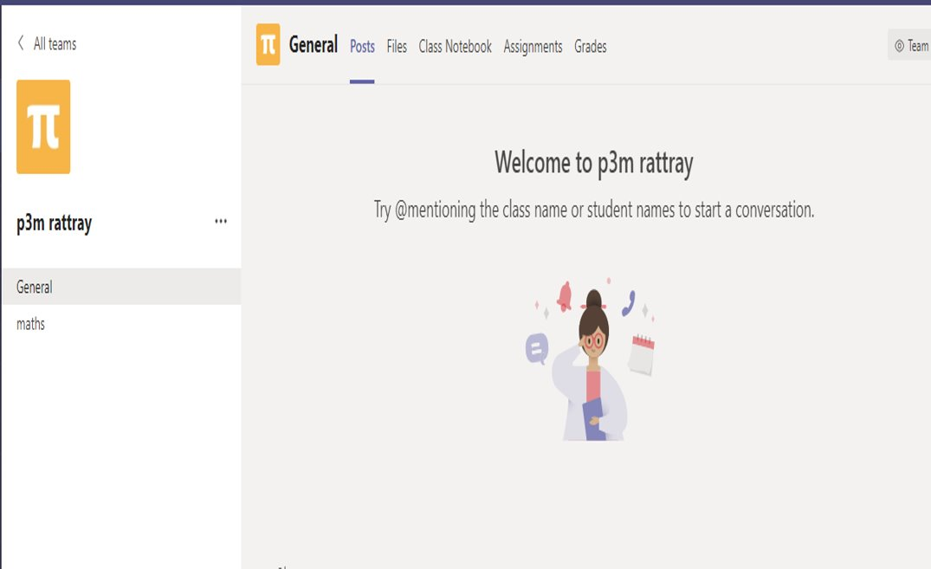

ON PHONE OR TABLET
- Use Appstore to search and download Microsoft teams. This app is free and has been rigorously checked for safety and GDPR compliance.

- Enter your Glow email address – similar to gw##surnamefirstname@glow.sch.uk
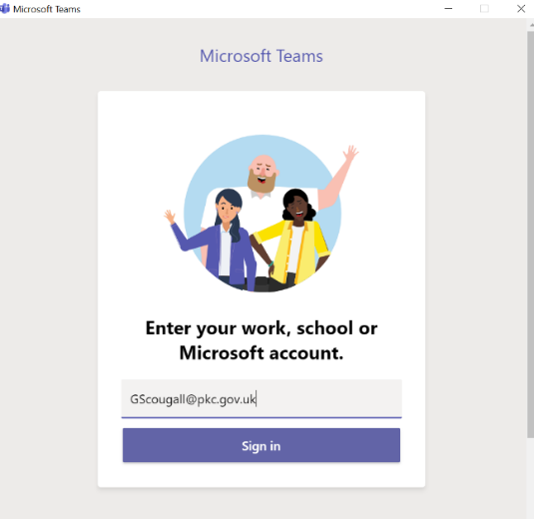

- Enter Glow username and password

Each app will default to an email address used on the computer or phone. Make sure you when logging in you delete this address and enter your glow email -gw##surnamefirstname@glow.sch.uk
Microsoft Teams
MS Teams is a social network for classes and groups. On this teachers and pupils can upload files and engage in chat. Pupils are aware that this is not an open forum for general chit chat and must only be based around home learning or questions they have related to school.
*teachers will be notified with every new conversation but may not reply after school hours.

