OFFICE 365 HOME ACCESS/SAVING/SHARING

- Log into Glow on the internet. The school Launch Pad should load automatically, click on Launch Pad ( icon) to load your own Launch Pad.

- Search for Office 365 – tiles similar to the ones display below should appear, if they don’t you can search by entering the exact name of the tile you are looking for.

REMEMBER, you can download Office to your home computer by clicking the Download Office Now Tile and following the instructions – please ask permission from your parent/carer before doing so.

- Click on Office 365 Home. The following should appear:
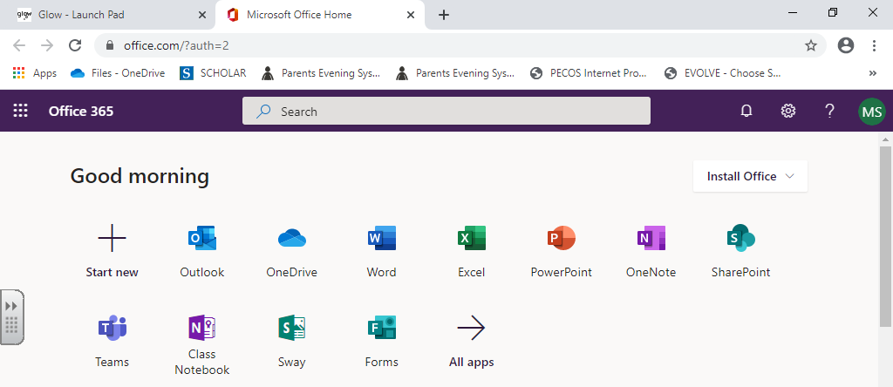

You can now load Word, Excel, PowerPoint etc from your home computer.

- To save a document, click on:

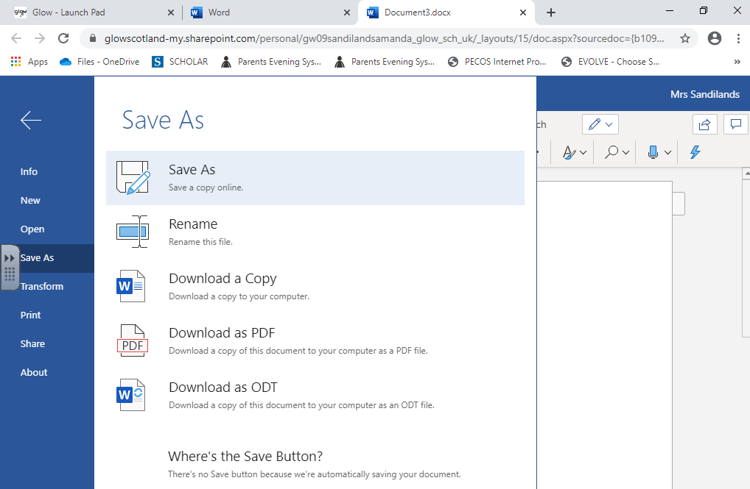

This will automatically save the file to your OneDrive.

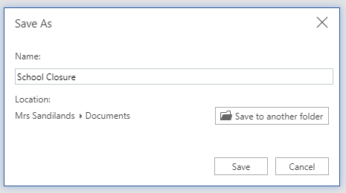

Enter your document Name.

Click on Save.

TO SHARE AN OFFICE 365 DOCUMENT WITH YOUR CLASS TEACHER:

- Open the document you wish to share.

- Click on Share.

- Enter your Class Teacher’s Glow Username eg gw09sandilandsamanda (if you have already shared a document with them – their name will be displayed as below).

There may be multiple people with the same name in Scotland – for example there are over 6 Amanda Sandilands’s – please check you have the correct username before sharing!
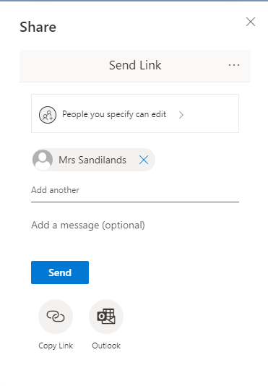

- Click Send – your teacher can now access your document.

