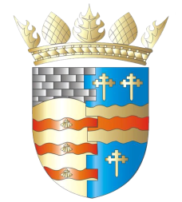**BLAIRGOWRIE AND RATTRAY COMMUNITY COUNCIL\***

**Contact us now:** [**sec@brcommunitycouncil.org.uk**](mailto:sec@brcommunitycouncil.org.uk)

WANTED: Babies born in 2024!

**for our project ‘Rooted in Rattray & Blairgowrie -**

**A fruit tree planted for each baby born in the town’**

*Our inspiration: ‘One birth, one tree’ project in our twin town, Brebières, France*

In Brebières a tree is planted in a local park for each baby born in the town.  Here in Blairgowrie & Rattray, BRCC would like to plant a range of site-appropriate food-bearing trees for babies born in 2024. Doing so helps with many issues affecting our town: resilience, engagement, biodiversity, food growing, cost savings, climate change, social benefits, air quality, local wildlife. You supply the baby – we supply the tree!

***While welcoming our newest residents, the planting of food-bearing trees will result in free food for the whole community!***

**Interested in a tree commemorating the birth of your baby?**

**Planting starts soon!!** Contact us now: [sec@brcommunitycouncil.org.uk](mailto:sec@brcommunitycouncil.org.uk)

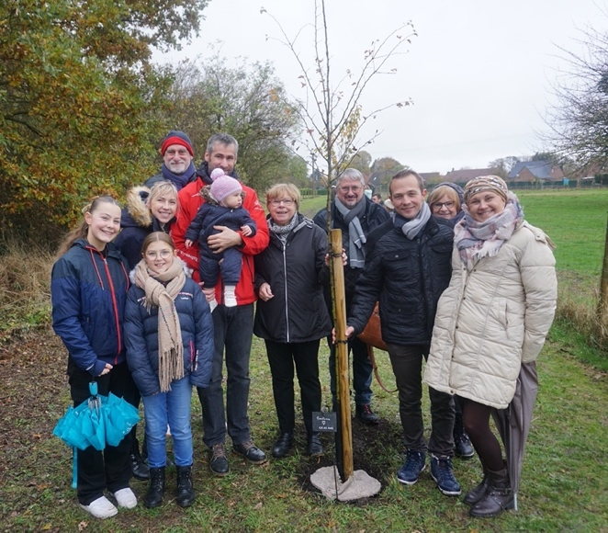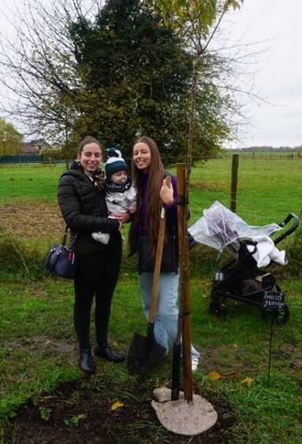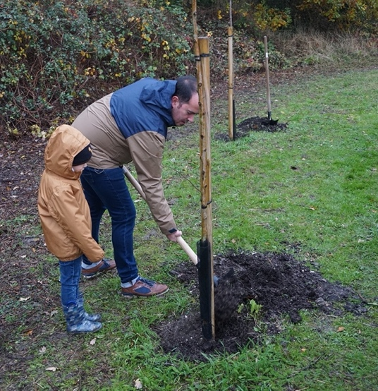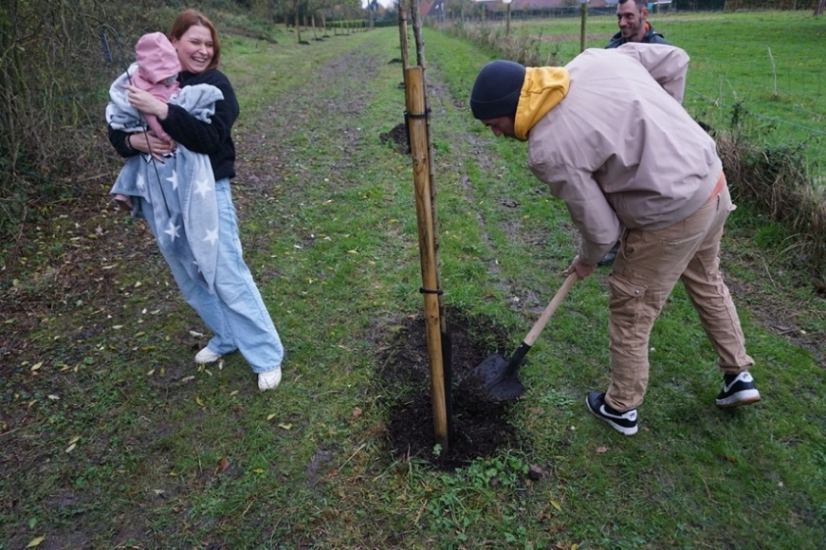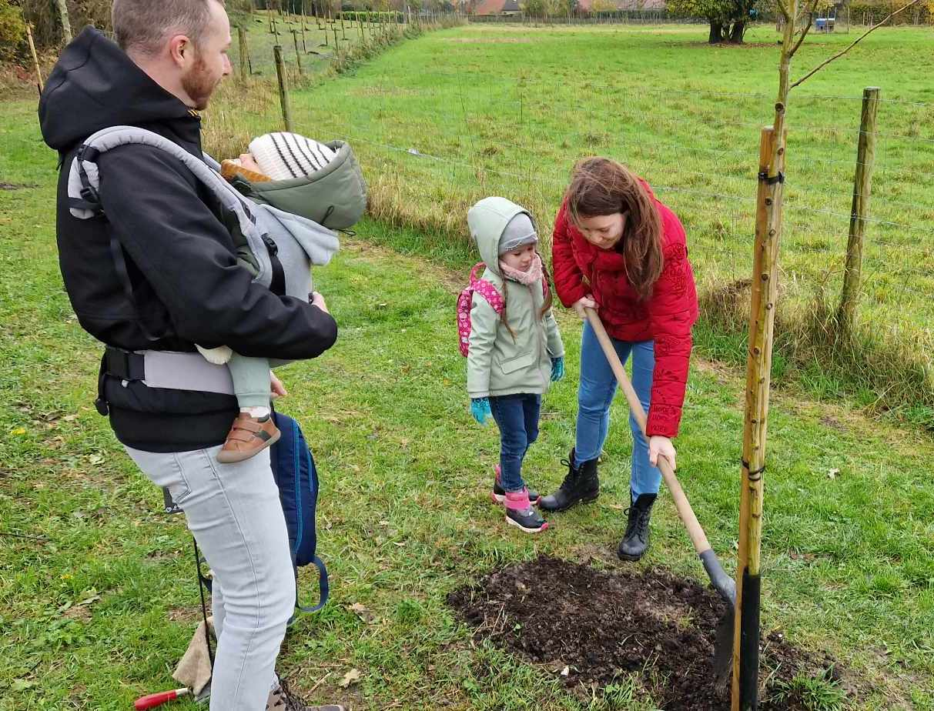

Families planting trees in our French twin town, Brebières.

**\*Working with Biodiversity Blair, Blairgowrie Climate Café & Soroptimists International Perth**