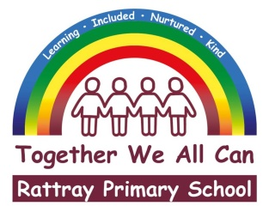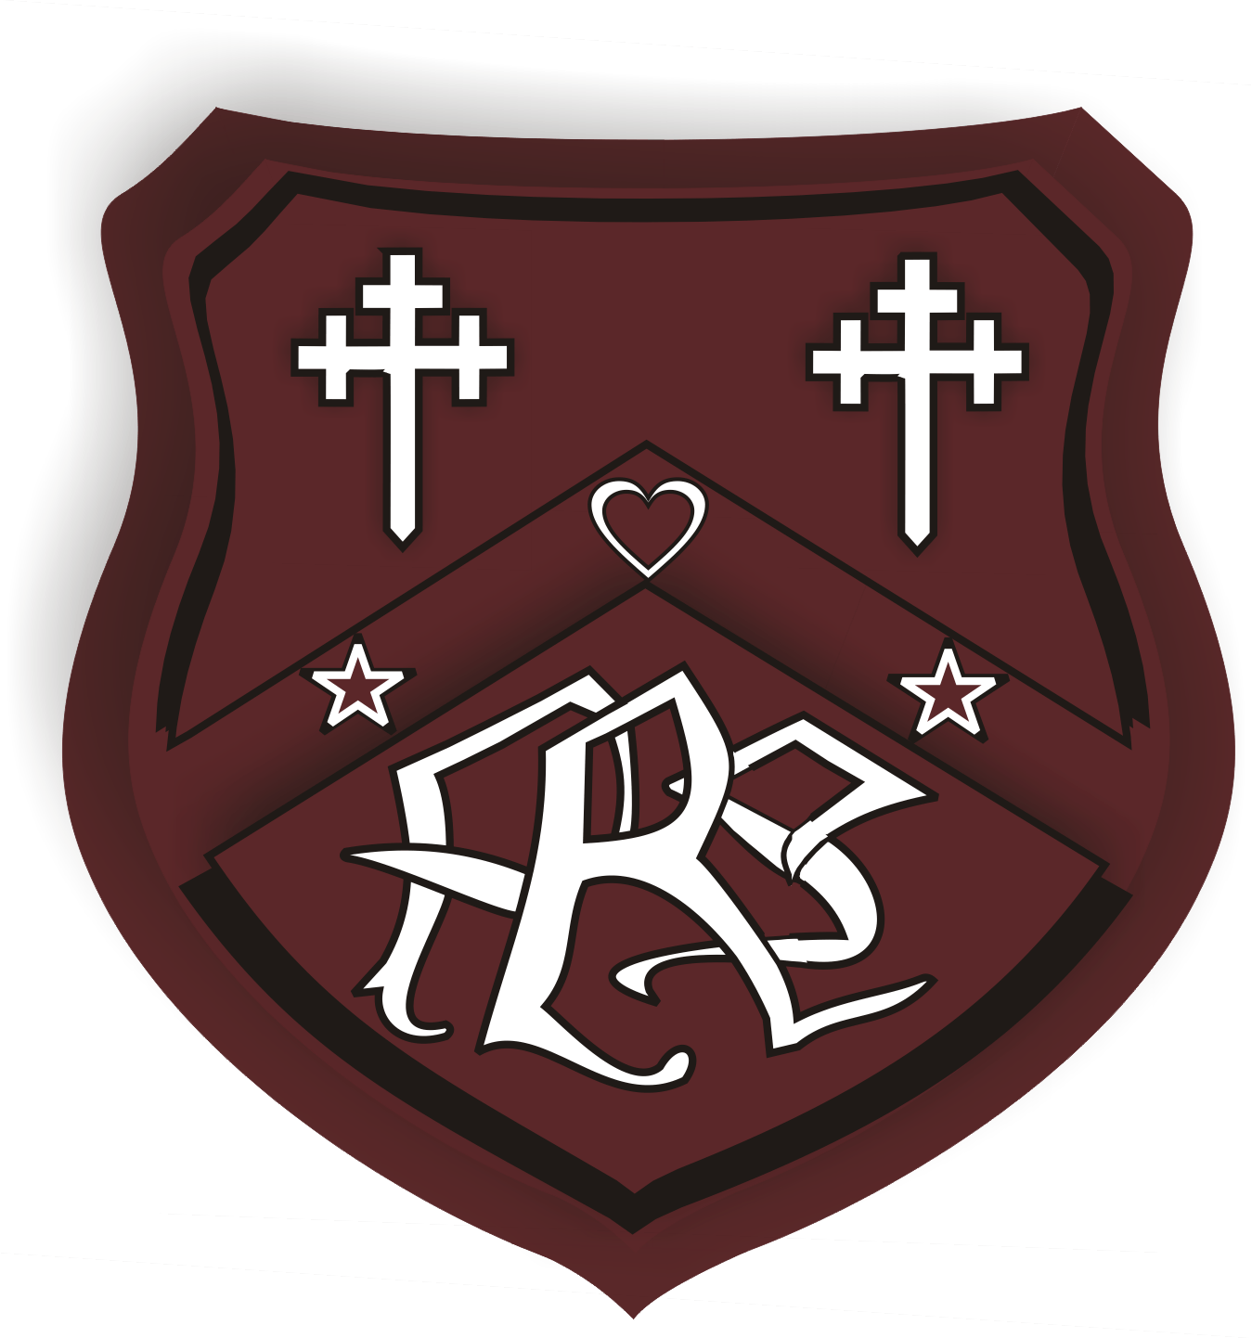**RATTRAY PRIMARY SCHOOL**

**Remote Learning due to ongoing Strike Action**

**Remote learning has been offered to all our pupils, including a live lesson every day. Learning packs are available from our school office for all nursery and school pupils. Packs will contain activities which can be undertaken at home alongside login details for our digital platforms Sumdog and Education City (links below).**

[**https://www.sumdog.com/user/sign_in**](https://www.sumdog.com/user/sign_in)

[**https://go.educationcity.com/**](https://go.educationcity.com/)

**These packs will also include a glow login which will allow your child to access our live learning offer on teams. Teams can be accessed through Glow logins.**

All school and nursery pupil’s passwords for glow/teams(with the exception of Mrs Strachan’s P7 class) are **Rattray1**

**Please click the Link below to watch a youtube video which explains how to use glow and Microsoft teams.**

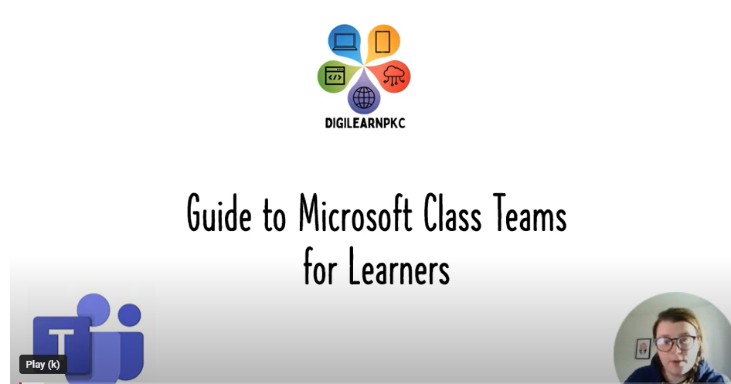

[**https://youtu.be/oISy_FrNrXw**](https://youtu.be/oISy_FrNrXw)

**Over the coming days, class teachers will provide live learning experiences through Microsoft teams. Teams will also give children the facility to engage directly with their class teachers through the chat facility or video calls if required.**

**Learning undertaken at home can be completed on paper and/or uploaded to teams dependent on the request of class teacher. The class teacher will provide home learning instructions through Teams too.**

**If you have any queries regarding home learning and accessing digital platforms, please do not hesitate to get in touch via our school email address** [**rattray@pkc.gov.uk**](mailto:rattray@pkc.gov.uk) **or our school number 01250 871980.**

**Thank you for your support.**