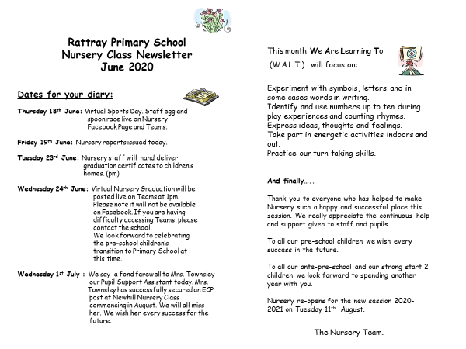

We also wish Ms. Harrison all the very best in her new secondment opportunity as area support teacher in the Blairgowrie cluster of schools.