
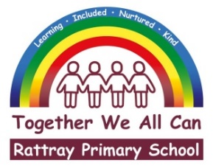

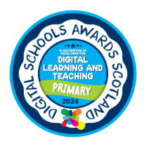 |  | Joanna Robertson  Headteacher  Rattray Primary School,  High Street, Rattray  BLAIRGOWRIE,  PH10 7DG  01250-871980  Email: rattray@pkc.gov.uk  Date: 22 April 2026
Dear Parents and Carers,

I am writing to remind all families of the school’s communication procedures. To ensure you receive all important information, ParentPay is the school’s primary and official method of communication for letters, updates and essential notices. All parents and carers are expected to access and monitor information shared through this platform.

Please ensure that you check your ParentPay account regularly and that your contact details are kept up to date. Messages sent via ParentPay are delivered to you by email notification, and it is the responsibility of each parent and carer to ensure these communications are received and read.

Please note that our school app will no longer be in use from the summer break, as the company that operated the app has dissolved. We are already beginning to scale back communication on this platform, and it should no longer be relied upon for school information.

Just2Easy is the platform used by teachers and staff to share your child’s learning and communicate messages related to their class. Moving forward, we will also use Just2Easy at times to share whole school information. It is therefore strongly expected that parents and carers have access to Just2Easy, as this will ensure you remain informed about your child’s learning, classroom messages and key developments across the school.

While we may occasionally post reminders on our school Facebook page, this is supplementary only. Facebook should not be relied upon for official school communication, as all important information will always be shared through ParentPay and, where appropriate, Just2Easy.

If you require support accessing ParentPay or Just2Easy, please contact the school office without delay, and we will be happy to assist.

Kind regards,
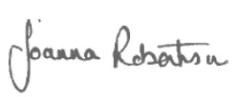
Joanna Robertson
Head Teacher
Rattray Primary School and Early Childhood Centre

