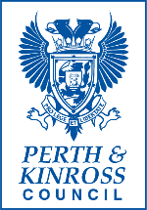

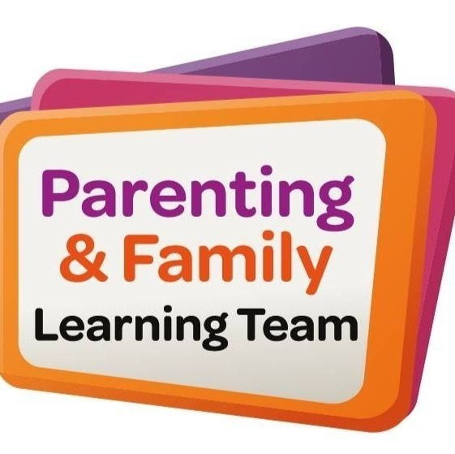
Education and Learning
Summer 2026 Holiday Offer

Pre-bookable free family sessions!
Closing Date - Thursday 25th June Summer Family Activities 2026 – Click to apply

Date | Time | Venue | Session Theme
Monday 6th July | 10.30am-12.00pm | Kinross Primary nature garden | Den Building
Tuesday 7^{th ,14th & 21st July} | 10.00am-11.00am | Kinross Primary | Play on Pedals (Block of sessions)
Friday 10th July | 10.30am-12.00pm | Loch Leven Community Campus Library | Book Bugs and Crafts
Monday 13th July 2026 | 10am - 12pm | Glenearn Community Campus | Crafts & Sports
Tuesday 14th, 21st, 28th July | 10.00-11.30 am | Perth Venue TBC | Eat well Play Well (Block of sessions)
Thursday 16th July 2026 | 10am - 12pm | Loch Leven Campus | Crafts & Sports
Thursday 16th , 23rd, 30th July | 10am-11pm | Riverside | Play on Pedals (Block of sessions)
Wednesday 29th July 2026 | 10am - 12pm | Breadalbane Campus | Crafts & Sports
Thursday 06th August 2026 | 10am - 12pm | Alyth Community Centre | Crafts & Sports
Friday 14th August 2026 | 10.30am-12.00pm | Loch Leven Community Campus Library | Book Bugs and Crafts

If you require more information about any of the activities in the table above, please email Parenting@pkc.gov.uk

A Perth and Kinross where everyone can live life well, free from poverty and inequality

