Prefect Learning Newsletter

March 2020

**Dear pupils, parent/carers and friends of Rattray,**

**All the classes have been very busy since our last newsletter. We have put together a snapshot of some of the things they have been up to.**

**P2R**

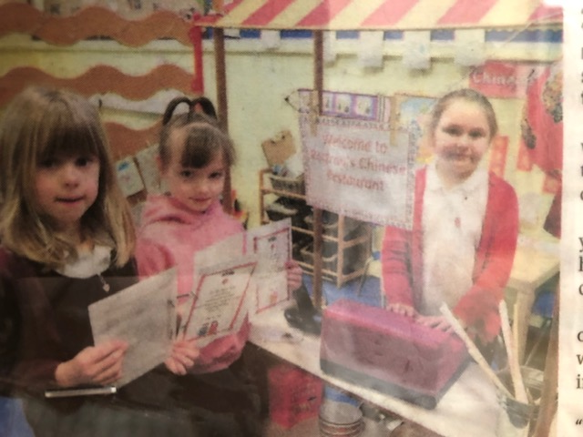

This term P2R have been learning about ‘Around the World in 30 days.’ The children have really enjoyed this topic and have decided where they want to find out about. So far, we have explored Scotland, Arctic, China, Poland, Russia, Australia, Antarctica and now we are exploring Africa. The children have been

learning lots of new facts and have taken a keen interest in global warming and how we can save our planet.

**P3M**

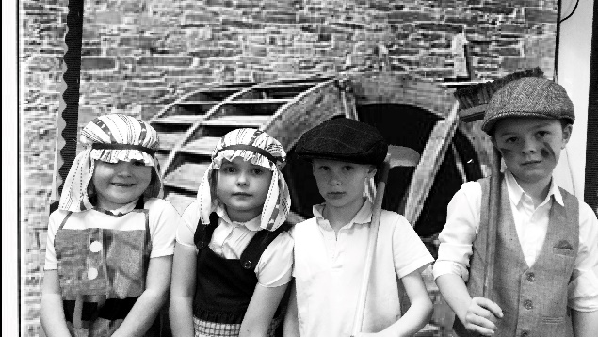

P3M have been learning about the conditions of working in the mills in Blairgowrie and Rattray in the 1800’s, and about how The Factory Act of 1833 improved laws around working hours and working age. They have been learning technology skills – green-screening and grey-scaling to change the background and make the images black and white respectively.

**P4/5 and P5**

Primary 4/5 and Primary 5 are learning all about the Early Scots.  We will be using technology, polishing up on our presenting skills, creating jewellery, note taking and designing tattoos in the style of the warriors.   We will be researching the Celts and

Picts and teaching each other all about them.   We will listen and take notes from the other class as they teach us about the Picts/ Celts.   We will be learning how to label a map with the main cities in Scotland now and explain where the Early Scots settled.

**P7J**

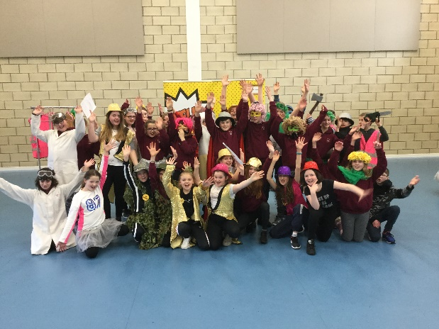

This term primary 7 took part in an NHS smoking workshop. They spent the day learning about the dangers of smoking and the effect it can have on your health. They then used this information to put together a show for their parents/carers and primary 6. The show was fun, entertaining and factual. Everyone in the audience learned lots.

P7J then took this learning further by creating factual posters and sharing them with other classes.

**P6M**

P6M have been enjoying working collaboratively to become ‘experts’ in a specific area of our Europe topic.  Each week we have visited a different European country, investigating such things as climate, rivers and mountains, food and drink and various European artists.  So far, we have visited Germany, France and Spain; however we are excited to find out about other European countries such as Poland, Italy and Norway.  We have found by working collaboratively we can come and report back to other groups to share our findings and increase our knowledge!

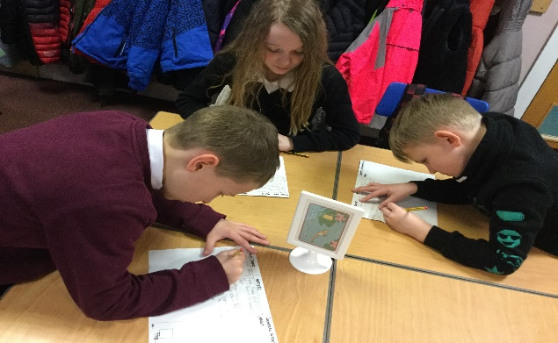

**P1W**

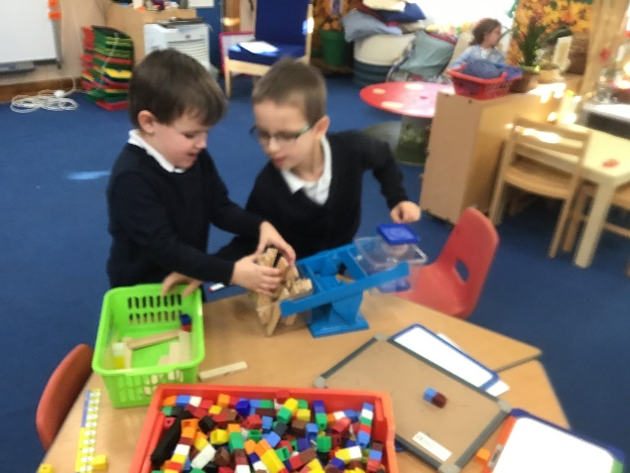

We have been learning about different weights and measures. Here the children were challenged to find items from around the setting and try and balance them. They were told they could choose anything they wanted but they couldn’t mix the items on any one side.

**P3/4**

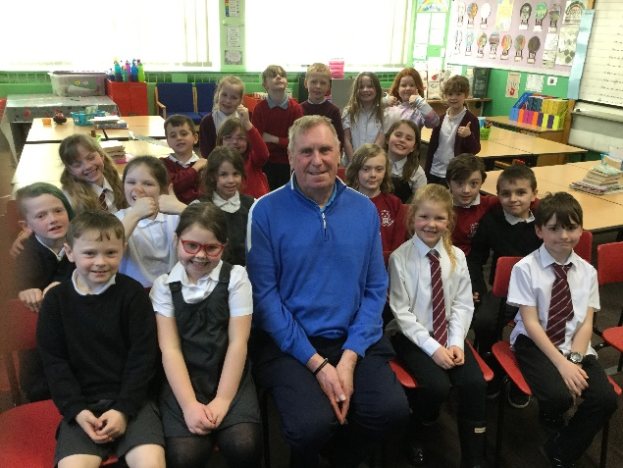

This term P3/4 have been studying the novel, Charlotte’s Web, and as part of our topic we have been learning all about different types of farming in Scotland.  To help us to learn more

about pig farming we invited Pig Farmer Dave (who also used to be the school Janitor) to spend the afternoon with us and answer all our questions. Next week we are lucky enough to be visiting Stewart Tower Dairy Farm to see some of the farm animals up close.

**P1/2**

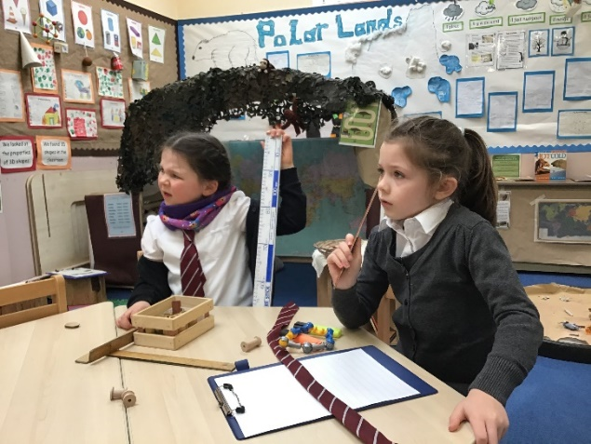

P1/2G have started a new topic in maths – Measurement.

We put items in order of their size and measured items around the classroom.

**P6/7**

We have studied two different topics this term. Scotland and Europe. For Scotland we looked at Robbie Burns and recited To a Mouse at the Scottish afternoon. We designed our own Celtic

knots. We researched Scottish inventors and made a poster or power point which we presented to the class.

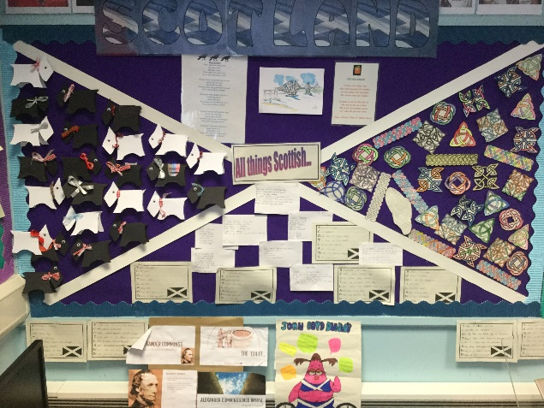

**Nursery**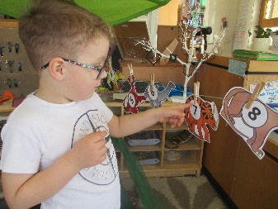

Nursery children have been learning to retell a familiar story or rhyme, count forwards and backwards within 10, match and sort by colour and pattern and use a range of tools accurately including writing tools.

**Thanks to all the classes and teachers for contributing to our learning newsletter.**

**We hope you have enjoyed reading it as much as we have enjoyed creating it.**

**The Rattray P7 Prefects**