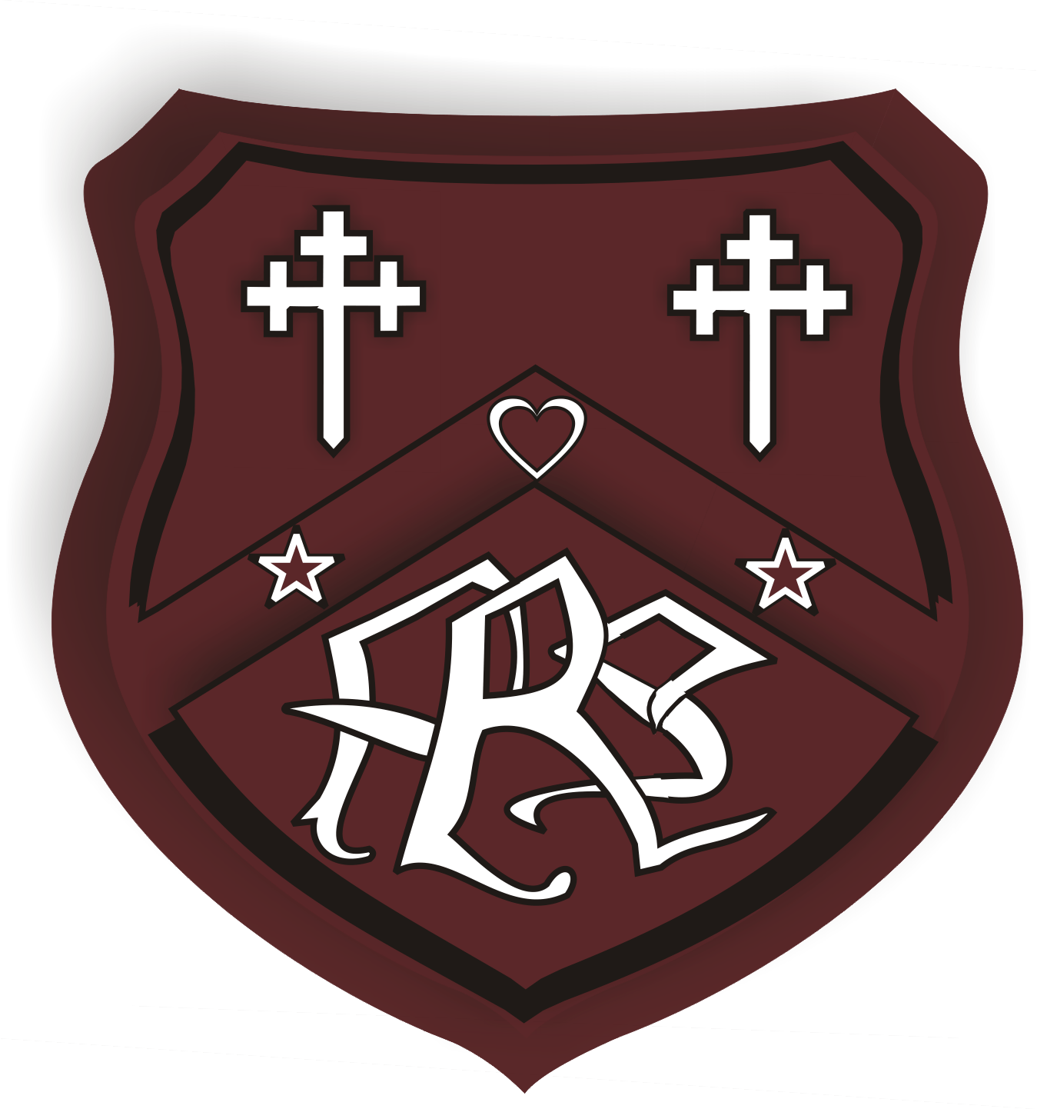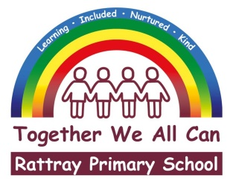

**JUNE 2020 NEWSLETTER**

Dear pupils, parents/carers and friends of Rattray

I am writing firstly, again with a huge thank you from all at Rattray Primary School. Thank you for your continued support and engagement with home learning. I personally, am very proud of how we, as a school community, are working through these challenging times together.

I wanted to reiterate what I had stated in the May newsletter, that as a school staff we are aware that within our school community there will be many families experiencing different challenges from the norm. We really do appreciate that some families are juggling working from home, home learning, caring for relatives alongside the huge stressors related to the economic challenges that are being encountered by many during this difficult period. It is important to us that you know our school and staff are here to support in whatever way we can. Whilst we encourage and would hope our pupils continue with their learning at home, we also understand that this can be difficult. Be reassured that our expectations are adjusted to suit the current situation and staff are mindful that on some days home learning will be a chore for families. Please start each day afresh as we do not want any child (or their families) to be worrying or feeling pressure about learning at home.

**Recovery Planning and School Building Reopening**

There is still a lot going on in the background in relation to the reopening of our school building in August 2020 and I can share some information with you.

In line with PKC guidance, we are taking a measured approach to our return to school, and our recovery planning will ensure we give due regard to all health and safety, hygiene, public health and Scottish Government advice. Individual primary schools have been considering attendance pattern for schools which will support the safe return of pupils whilst also considering the context of their own building capacities. Following carefully considered consultation with all stakeholders, it is now agreed that all Blairgowrie High School cluster primary schools will follow a blended learning model where up to 50% of pupils are able to be accommodated in school on a 50/50 basis. The pattern of attendance will be as follows:

Monday, Tuesday – group one

Wednesday – support for home learning, support for vulnerable children

Thursday, Friday – group two

Please be assured that children from the same families will be accommodated on the same days.  Every class will be in attendance on each day in order to ensure that class teachers work with their own classes wherever possible e.g. P2 group A on Monday and Tuesday, P2 group B Thursday and Friday.  It will not be possible to have friendship groups in school at the same time given the many factors which we have to consider. Ensuring family groups are in on the same day will be our priority.

Your child’s class and attendance pattern will be communicated to you no later than Monday 22nd June. Please note that some staff may not be able to return to work for a variety of reasons so there may be temporary changes to staffing, however each child will be allocated a main class teacher as before.

The end of term remains Wednesday 1st July at 12 noon and our return to school will be Monday 10th August for staff and Tuesday 11th August for some pupils (dependant on their group allocation).

At Rattray are all working very hard behind the scenes on a recovery plan that meets the requirements of the guidance we are given but suits our school.  This week we have been preparing to re-open the building for staff access next week.  Over the coming weeks staff will be working separately in their respective classrooms to prepare them for return, being mindful of the room capacity whilst respecting distancing guidance.

I would also advise that you start having early conversations with your child about their return to school and prepare them that they will be in school less often and may not always have their friends around.  If we can help you with that in anyway, please get in touch.  I know that you all know we have the best interests of your child at heart and although we need to do what is right, it will feel happy, safe and welcoming for everyone when we get back.

**Teacher’s Online Presence**

Staff will be beginning the process of returning to the building to undertake key tasks that can only be undertaken in the building. Over the coming weeks staff will begin to spend some time in school in preparation for August with regard to classroom set up and planning for blended learning and consideration of their new class. The complexity and scale of the work they will be involved in is huge, therefore feedback in relation to home learning tasks may be reduced. There may also be a slightly different version of activities developed to allow staff to also attend work in the building.

For most staff this will be the first time back in the building after leaving it in March. There is lots to do just in relation to tidying up where we left off! Our priority is to ensure we create a nurturing space for our pupils to return to and plan for their reconnection to our school which will be very different for them. We ask for patience and support from you at this time.

**Health Week and Sports Day – 15th to 19th June**

We could not let our annual health week go unnoticed this year, therefore the nursery and teaching staff have created an array of creative and motivating health and sports activities for next week. All the activities are around the themes of physical activity, healthy eating and wellbeing. Similar as to what would happen when in school, the focus next week will be around health and wellbeing therefore there will be no learning planned for other curricular areas.

As usual learning will be provided on class and nursery teams pages, but information will also be sent out via ParentPay, our school app and shared on Facebook. A virtual sports day for school and nursery has also been planned for Thursday 18th June, and information will be sent regarding this too. We look forward to you sharing your photos and videos with us during our health week.

**Active Schools June Challenge**

Active Schools are working with Live Active Leisure on a June challenge. They are hoping to clock up enough miles to travel around the world and would like to invite everyone to join in! Families can walk, run, skip, dance etc. If you are interested, please follow the link <https://www.liveactive.co.uk/travel-the-world>

**New P1 and Nursery Pupils**

I am delighted to say that we are looking forward to welcoming 33 new P1 children and 7 new families to the nursery in August.  The infant and nursery staff are working hard to ensure that these pupils have a smooth transition into our school. We will be very shortly be sending out a presentation to our new pupils and their parents, which will give the pupils a chance to see their new teacher and nursery staff, alongside providing parents with much needed information.

The current Scottish Government advice regarding social distancing and close contact with other families make it really difficult for our school to provide our normal transition experience for our new pupils, we are considering ways and taking guidance around whether our new pupils can meet their new teacher and nursery staff, and visit their new class and the nursery room prior to the summer break. Be assured that if we can facilitate this, we will let you know as soon as we can.

**Exiting P7 Pupils**

We are extremely saddened that our current ‘fabulous’ primary 7 pupils had their final year in school cut short so suddenly. Many of them wore their prefect hoodies with such great pride and were wonderful role models to our younger pupils. We want to give them a well deserved ‘send-off’ and Mrs Johnstone, Miss Robertson and other class teachers are pulling together something special for them, as they say, ‘watch this space’. It will certainly be our intention to invite these pupils back to school whenever it is feasible to give them a proper goodbye from the younger school pupils and staff. Until then, I would like to wish all our exiting pupils or ‘lockdown leavers’ as they have called themselves the greatest success at secondary school. You will always be welcome at Rattray and we look forward to hearing from you very soon.

**Nursery Graduation - Wednesday 24th June 1pm**

Nursery staff are currently working hard to prepare a virtual graduation celebration for all children transitioning to P1 in August. The celebration will be shown on GLOW Teams Wednesday 24th June at 1pm. Nursery staff will endeavour to hand deliver children’s certificates to individual children’s homes on Tuesday 23rd June in the afternoon so that they have their certificate prior to the celebration. We would like to extend a welcome to all nursery children and families to participate in this very important part of the transition to school process.

**Virtual Prizegiving – Monday 29th June**

During these strange times, it is especially important the we carry on with our Rattray traditions, and there are none so important as our prizegiving. On Friday 19th June, we will inform our class prize and school trophy winners of their success. The recipients of awards will be given an opportunity to collect or receive their award prior to the end of the term. On Monday 29th June our virtual prizegiving and end of year celebration will be released online. We will provide you with further information nearer the time.

**Annual Pupil Report**

We are currently finalising our pupils reports and all parents/carers will receive their child’s school report by email next week. We will provide a paper copy when we return to school in August, but should you require prior to this please get in touch with the school via our main email account.

**Class Information**

Our staffing and pupil numbers are being finalised too, and alongside your child’s school report, next week, you will receive information regarding your child’s class and teacher for the new academic session. Teachers are already sharing handover notes and planning for their new classes.

Please be mindful that classes are created following strict council guidance and are based on the children’s chronological age. As much as we would like, we cannot take consideration of friendship groups or other factors, whilst we are happy to discuss concerns it is highly unlikely that classes will be altered.

**Parent /Carer Communication**

We are working hard to ensure our communication in this current situation is clear, relevant and timely. We will continue to post regular updates from PKC with links to documents for our families through ParentPay (specific and personal communication), our school app (general and generic communication) and our Facebook page (general and generic communication). Can we please ask that any day to day communication with the school is still made through the school email address [rattray@pkc.gov.uk](mailto:rattray@pkc.gov.uk). This email address in checked regularly and any issues/queries can easily be relayed to the relevant person. If you require a call back from the school, please leave a phone number on which we can contact you too.

**Home Learning Engagement**

At Rattray, we do check all our pupil’s engagement with online learning and their submission of learning activities, and we will be contacting some families as we want to ensure that all our families can access Teams if they choose too. Therefore, if you are experiencing any difficulties in being able to engage and access our online learning materials please get in touch via the school office [rattray@pkc.gov.uk](mailto:rattray@pkc.gov.uk) As we may have solutions which can support your child’s learning.

Please remember that Microsoft Teams can, and should, be accessed through pupil GLOW accounts. Please also note that Office 365 is available free of charge, also through GLOW to download onto home devices. If you have lost the details for your child’s login, please contact the school email address too.

**Learning Equipment**

A supply of jotters and stationery have been dropped off at the community larder outside Rattray Community Connect (The Hub) and Bowls of Help (Blairgowrie Bowling Club). Please take what you need but take sparingly.

**Personal Belongings - Clothing/gym kit etc...**

As we left school suddenly in March, many of the children’s personal belongings were left in situ. These include pencil case, lunch boxes, jackets, PE kits. If you have personal items which you require to be returned to your child, please get in touch with the school office and we can arrange for you to come and collect.

**Transport Applications for P1 and S1 Pupils**

**As you may be aware, all transport application forms for the new school year commencing in August must be returned to Education & Children's Services no later than 10 May 2019 for new P1 pupils and P7 pupils moving to secondary school for new transport to be organised from August.  As transport planning for August is now underway, it is critical that all new pupils expecting to use school transport in August have applied and are known to us.    Any parents of new P1 or P7 pupils moving to secondary school who are entitled to transport must submit their transport applications as a matter of urgency if they have not done so. The online application is below:**

<https://www.pkc.gov.uk/article/17284/Schools-transport-and-trips>

**Free school transport is only available to pupils attending their catchment school and living more than 2 miles (primary) or 3 miles (secondary) from the school measured by the shortest available walking route.**

**Funded Early Learning and Childcare/Nursery hours – message from Perth and Kinross Council**

From August 2020, additional funded Early Learning and Childcare (ELC)/nursery hours were to be on offer to all 3 and 4 years and eligible 2-year olds across Perth and Kinross. Perth & Kinross Council (PKC) were making very good progress with the roll-out of these additional hours and were set to offer access after the summer holidays to this extended provision in council-run nursery, private and not for profit nurseries and childminders to all nursery aged children across Perth and Kinross.

Due to the global pandemic of COVID-19, consideration is currently being given to what all areas of education provision will look like from August onwards. As part of this process of planning, we aim to keep the safety of the children and our staff at the heart of what we do.

We are considering the appropriate social distancing measures to ensure the safety and well-being of the children and staff. This will depend on the space available within each setting and the number of staff required to allow children to return safely. To ensure that children can access ELC safely, this means there is the possibility of a delayed or staggered return, as well as initially a reduced number of hours compared to those originally offered. In terms of returning to ELC and school provision, where possible we will offer family groups access to the school and nursery at the same time.

The ELC offer available in schools will be planned around room capacity, the space needed to ensure health guidance, and available staff. This will be carefully considered at school level so that the ELC plan fits with the wider school plan and continued childcare provision for key workers and vulnerable families.

As a school we are not yet able to provide a model for our nursery return in August, as we are awaiting further guidance from the Scottish Government and local authority, as soon as we can provide information regarding the return to school for nursery pupils at Rattray, rest assured we will do so.

**Children’s Activity Centres**

Children’s Activity Centres look after the children of key workers who have no other means of childcare. Key workers involved in the response to the Coronavirus (COVID-19) outbreak can [submit applications](https://bit.ly/pkc-covid-support) for places at Children's Activity Centres by visiting the following link <https://www.pkc.gov.uk/coronavirus/schools?fbclid=IwAR2I9TrT5qvI6nJ1m3WVqkpqDTKocEbuM8uwuie9r387d5l9fe2XAfK5MDI> Additionally, key workers whose partners work in food production, agriculture, postal and delivery services or in the agriculture/food haulage sectors can apply for places if they cannot care for their children at home.

Several our staff have been supporting this activity centre and other centres too over the past few weeks. My thanks go to all our staff who have been involved in this.

**PKC Remote Learning Hub**

This site has been created for parents, pupils and staff to access key information and guidance whilst working and learning from home during school closures. Specific sections have been created to allow for ease of use and to ensure you can access the information that is most appropriate for you. This site will be updated regularly with the latest information and added to ensure the content and messages are current. We hope you find the site, and information within it, useful: <https://sites.google.com/pk.glow.…/pkcdigitalschoolshub/home>

**School meal provision**

While schools remain closed, school meals cannot be provided in school buildings.  PKC will provide direct payments to families entitled to free school meals with the first payment being made week commencing 23 March 2020. Payments will be made to parents fortnightly.

If you have not made an application for free school meals previously because of automatic entitlement (likely to be Primary 1 to Primary 3 pupils) parents should email [ecsschools@pkc.gov.uk](mailto:ecsschools@pkc.gov.uk) or call 0345 30 111 00 to let PKC know bank details to process payment.

If you are now in a position where financially you need to apply for free school meals. An application can be made by completing an online application and providing evidence of qualifying benefit criteria, by following this link <https://www.pkc.gov.uk/article/17410/Free-school-meals-and-school-clothing-grants-primary-and-secondary> If a family has a tax credit letter or a universal credits statement, pictures of this can be sent as proof. If an application is completed quickly together with proofs of benefits, families can be processed for free school meals within a matter of days.

In light of current school closures, any prepaid school meal funds will remain in pupil accounts until schools reopen. Alternatively, parents/carers can request a refund of any prepaid school meals funds by emailing [SchoolMealRefunds@pkc.gov.uk](mailto:SchoolMealRefunds@pkc.gov.uk) stating each pupil's name, class and school.

**School Handbook 2019/20**

Our school handbook for next session is available to view on the council website or in paper form from school office. Visit

<https://www.pkc.gov.uk/media/32309/Rattray-Primary-School-Handbook-2020-21/pdf/Rattray_handbook_2020-21.pdf?m=637110714968230000>

I would like to finish with a personal thanks to everyone who send messages of congratulations on my permanent appointment as Rattray Head Teacher, or who liked and added comments to our school Facebook post. It means a great deal to me that I have been welcomed so openly into your school community. I am absolutely delighted that I am able to stay with you at Rattray, and so pleased that the staff, families, community, education authority and of course our wonderful pupils have put their trust in me to lead Rattray forward. It is with a heavy heart that I leave behind both my previous schools Kettins and Meigle, as I have had a long, successful and happy connection with both these schools. I believe Rattray Primary School has a bright future, with staff who care deeply about your children and the local community, and I feel very privileged to be able to lead this wonderful school team and play a part in the continued success of the school. I look forward to meeting you all again and working with you to support your children and the local community.

On behalf of all the staff I would like to thank you for your continuing support. If you have any questions or queries regarding any of the items within this newsletter, please don’t hesitate to contact the email address below.

Please stay safe, take care and do stay in touch with the school in whatever way you can.

Yours faithfully



Joanna Robertson

Headteacher

[rattray@pkc.gov.uk](mailto:rattray@pkc.gov.uk)

**Future Dates**

**June 2020**

15th to 19th June – Nursery and School Health Week

Thursday 18th June – Virtual Sports day for nursery and school

Wednesday 24th June 1pm – Virtual Nursery Graduation

Monday 29th June – Virtual Prize giving

**July 2020**

Wednesday 1st – School closes for Summer Break (12 noon)