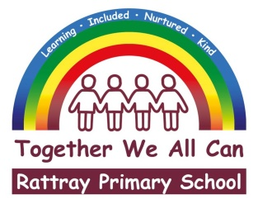 |  | Joanna Robertson  Headteacher  Rattray Primary School,  High Street, Rattray  BLAIRGOWRIE,  PH10 7DG  01250-871980  Email: rattray@pkc.gov.uk  www.pkc.gov.uk
 |  |  | 9 September 2020

Dear Parent/Carer

This letter is to raise your awareness of a recent social media concern and to share the advice below and attached.

You may be aware of the recent press coverage regarding a video which has been circulating on social media platforms of a man dying by suicide. The video begins by showing a man with long hair and a beard on the phone sitting at a desk. The clip originated on Facebook Live and was then uploaded onto Tiktok over the weekend. It then began to appear in user recommendations. In addition, some Tiktok users have now spliced sections of the video into unrelated clips so that other people may view the recording without intending to do so.

The attached document contains advice published in the last couple of days by Netsafe.

https://oursaferschools.co.uk/2020/09/08/tiktokalert/?utm_content=139347131&utm_medium=social&utm_source=twitter&hss_channel=tw-939101937588371456

The safety messages that we as a school, and you as parents give to pupils regarding watching distressing content, privacy settings, who they communicate with online and what to do if they receive unpleasant messages, would obviously apply in this situation and you as a parent may choose to use this opportunity to reinforce these messages once more.

Additional support and advice for individual pupils who are distressed by viewing this content can be provided by our link Educational Psychology staff. If you feel that you may need access to this support please make contact with the school.

Kind regards,
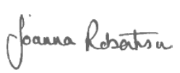

Joanna Robertson
Headteacher

