What’s on at Rattray Primary School
Below is a list of after school clubs we are currently offering across the school in Term 3
Club Name | For Who? | Staff Member/Coach | When | Cost | Where
Glee | P4-7 pupils | Miss Arnold and Ms McCulloch | Monday 3.10-4.10 | Free | P2 Classroom
HomeWork Club | P5-P7 | Miss Johnstone | Tuesday 3.10-4.10pm | Free | P6 Classroom
Running Club | P5-P7 | Mrs Newlands | Tuesday night 3.10-4.10pm | Free | Meet in GP Room
Story Writers Club | P3-P7 pupils | Ms Gregg | Monday night 3.10-4.10pm | Free | P3/4 class
Ukulele | All P6 and P7 pupils | Mr Masterton | Tuesday 3.10-4.00 | Free | P6/7 Classroom
Drama | All P4-P6 | Mrs Wilks | Monday 3.10-4.10pm | Free | P4-6
P5-P7 Boys Football | P5-P7 Boys | Active Schools | Monday 3.10pm-4.10pm | Free | Playground
P5-P7 Girls Football | P5-P7 Girls | Active Schools | Thursday 3.10pm-4.10pm | Free | Playground
Lego Club | P1-P3 pupils | Ms McCulloch | Tuesday 3.10pm-3.45pm | Free | P1 Classroom
Basketball | P3-P5 | Sporty Jack | Friday 3.10pm-4.10pm | Free | Meet in GP Room

- Numbers will be limited and will be run on a first come basis. If you have not been given a space the school will contact you

- All clubs will start the week beginning 7th March, except GLEE, which will hold auditions during the school day. Non-football clubs will run until the week beginning 25th April. After this a new set of clubs will be offered to pupils.

- Football club sign up is on a form sent earlier - https://forms.office.com/r/GCEbhn7wtp

- All other clubs sign up is via the MS Form link below

https://forms.office.com/Pages/ResponsePage.aspx?id=oyzTzM4Wj0KVQTctawUZKWRgx6-lUEBMl4VSA2lTbcVUQUs0TUc2RVFTNlAxQlQ4M1FKWDRGOE4zSS4u

Club description
Lego Group
Lego-based therapy provides children with the opportunity to develop the social communication skills. The children work in small groups to build a piece of Lego through undertaking different roles, an engineer, a builder and a supplier. The concept encourages children to develop a range of skills through sharing, turn-taking, following rules, communication and problem solving.
Lego-based therapy is a great way to develop all of these skills whilst enjoying creating something new. Children of all ages enjoy playing with Lego, this group takes this enjoyment and harnesses an opportunity to develop important life skills both for school and beyond.

Basketball Club

Come learn how to play and enjoy basketball with Sporty Jack! He’ll teach you everything you need to take part in this fantastic sport!

Story Writers Club
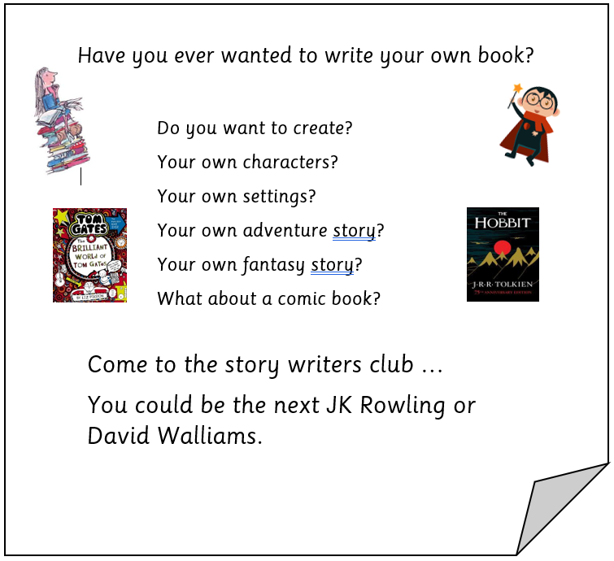
Mr M’s Ukulele Club
Do you want to be a rock star? Have you ever wanted to play an instrument like guitar? Are you in P6 or P7? Why not give Ukulele club a go?
A weekly club where you can learn how to play cool rock and pop songs with your friends in our awesome Rattray Ukulele Band. Starting Term 3 after the mid-term break, on a Tuesday after school (3.10-4.00).
If you are interested, grab a form from outside Mr M’s classroom (P6/7) and hand in to your teacher. Hope to see you there!
Homework Club
Do you find it hard to finish your homework on time? Do you need help with IT to get your homework completed? If so, come to Miss Johsntone’s Homework Club, where IT will be provided, and pupils will be helped, to complete their homework!

Glee Club
The Scottish Primary School

Challenge is back for 2022!
If you can sing and dance
we want YOU to come and audition for
Rattray Primary’s Glee Club!

Auditions will be held at lunchtimes starting in February and after school club will be Mondays from 3.10-4.10 in P2 Classroom.

Drama Club Running Club

