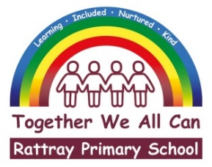

|  |  |  |
| --- | --- | --- |
|  |  | **Joanna Robertson**  *Headteacher*  Rattray Primary School,  High Street, Rattray  BLAIRGOWRIE,  PH10 7DG  01250-871980  Email: [rattray@pkc.gov.uk](mailto:rattray@pkc.gov.uk)  Date: |

Dear Parent/Carer

We have the following after school clubs available for term four.

**Board Games (P5-P7)**This club will continue, and there is no need to sign up again if you are already signed up, but new people also welcome to join  
  
**Basketball (P5-P7)  This**club will continue, and there is no need to sign up again if you are already signed up, but new people also welcome to join  
  
**Scripture Union (SU) (P5-P7)** This club will be led by some local volunteers. The SU Group is a safe space for children and young people to have fun, play games, eat snacks, chat and explore some amazing things about the Bible. All are welcome, and will be made to feel like they belong and respected.”  
  
**Coding Club (P5-P7)** In this club we will use Programming tools like Scratch and also Micro Bits, by learning how to code. Beginners welcome, as are more experienced coders.  
  
**Tennis (P3-P5)** Miss Salmond will be leading this, where you will have the chance to learn and improve your tennis skills.

Clubs will start week commencing 28th of April and will finish the week beginning 2nd of June.

Please follow the link <https://forms.office.com/e/kYfUdbsbam>

or scan the QR code to sign your child up for some term 4 after school clubs.



Yours sincerely

Joanna Robertson

