How to book a Parents’ Eve Appointment

- Click the link https://outlook.office365.com/book/Bookings-ParentsevetrialFeb@pkc.gov.uk/
- The below website will show
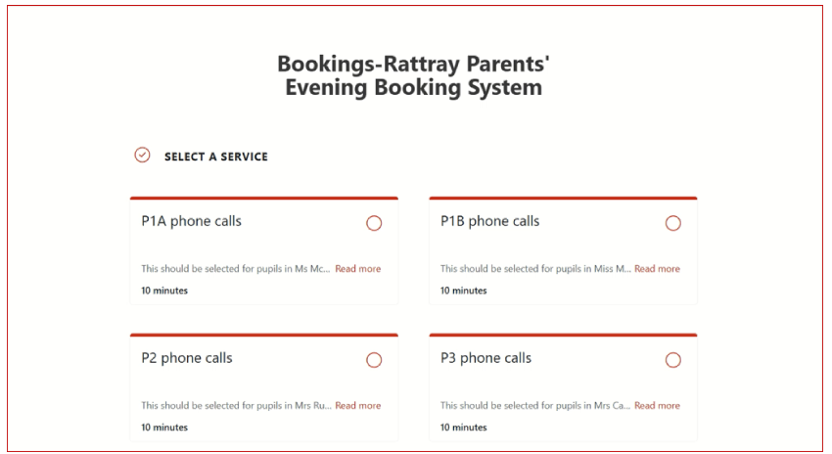
- To see all options click “show more services”
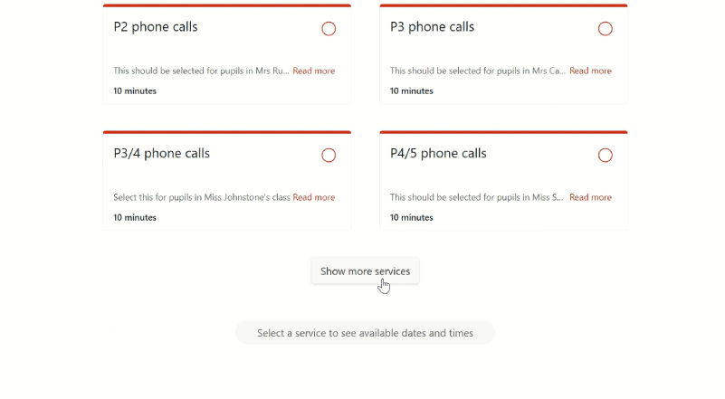
- You can book either an in person appointment, or a phone appointment. When you have located the appointment you want, click the red circle
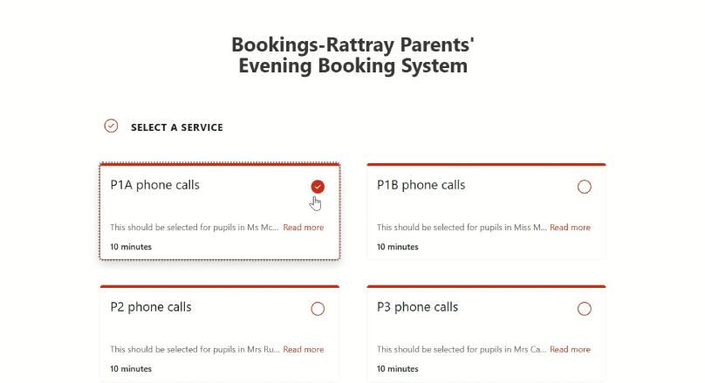
- Now scroll to the bottom and navigate through the calendar to the dates of the parents’ evening (5th and 6th of March this year). Click on your preferred date and the available times will be shown
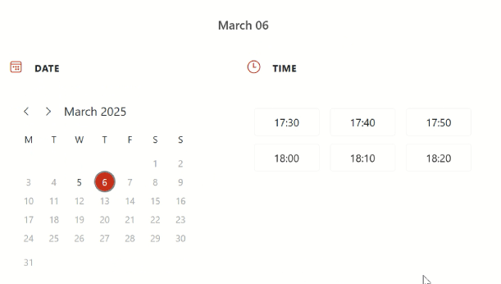

- Click the time you would like to book. Now scroll to the bottom and fill in the relevant details. For First and surname, please write the child’s name. For email, please enter your email address.
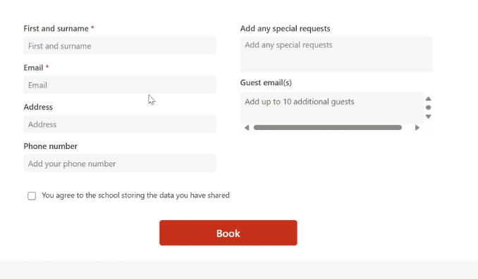

- If you have selected a telephone appointment time, please enter the phone number you wish to be called on
- You should receive a confirmation email, with the date and time of your appointment

