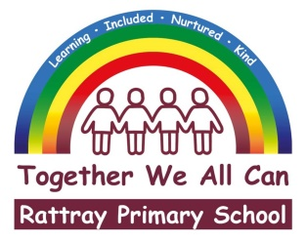 | 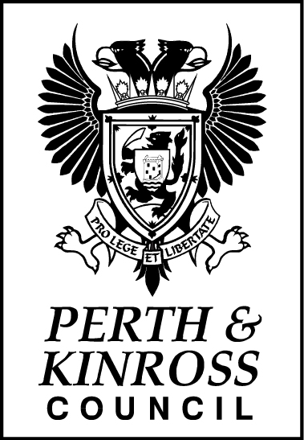 | Joanna Robertson  Headteacher  Rattray Primary School, High Street, Rattray  BLAIRGOWRIE, PH10 7DG  01250-871980  Email: rattray@pkc.gov.uk  www.pkc.gov.uk
 |  | Date: | 27 August 2020
Dear Parent/Carer

New National Guidance on the Use of Face Coverings

Following an announcement by the Deputy First Minister on Tuesday 25 August 2020, the national guidance for the return to schools has been updated and now recommends the use of face coverings in secondary schools for pupils and staff with effect from Monday 31 August 2020.

In relation to Rattray Primary School from this date, face coverings should be worn by staff and pupils when:

- adults and children and young people aged 5 and over are travelling on dedicated school transport.
In our school alongside other primary and nursery schools, both adults and children are permitted to wear face coverings should they wish.

If wearing a face covering staff and pupils should ensure they:

- bring their own face coverings to school;
- store these safely in a washable, sealable bag or container when not in use;
- wash reusable face coverings in hot water at the end of each day; and
- safely and hygienically dispose of disposable face coverings after use.
Please remember that a face covering can be as simple as a scarf, snood or other piece of cloth which covers the nose and mouth.

Further information on face coverings is available on the Scottish Government’s website as follows:
https://www.gov.scot/publications/coronavirus-covid-19-phase-3-staying-safe-and-protecting-others/pages/face-coverings/

The full return to school guidance, including the updated guidance on face coverings is also available on the Scottish Government’s website as follows:
http://www.gov.scot/publications/coronavirus-covid-19-guidance-preparing-start-new-school-term-august-2020-version-2/

Thank you for continuing to support our school to keep it safe and open.

Kind regards,
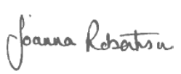

Joanna Robertson
Headteacher

