HEALTH WEEK – Together We All Can!
Whole School
5th June – 9th June

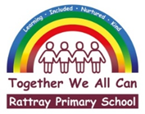
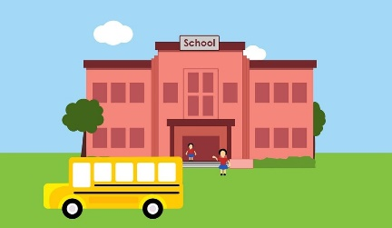

Sport  Dancing  Just Danceathon  15-minute time slots for each class so we are dancing all day!  Article 13 | Sport  Rattray’s Got Talent  Preliminary rounds – select two from your class with a talent.  One pupil vote.  One teacher pick.  Article 13 | Sport  Potted Sports  Wednesday potted sports.  See plan.  Article 31 | Sport  Yoga  Partner yoga.  Led by Ms Byrne (tbc – on P7 transition days)  Article 31 | Sport  Team Building  Try some of the below team building activities…  13 Team Building Games, Activities & Ideas for Kids in 2023  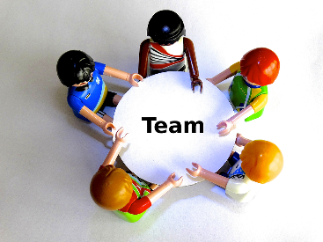
H + W / Craft  Design a team player!  Design a perfect team player. Think of the characteristics that makes a team player, draw a poster to show what we’re looking for.  LINK – PP for elements of a game. | H + W / Craft  Design a Playground Game  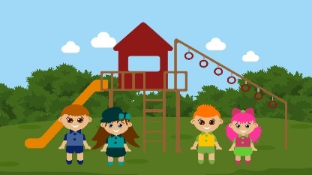  Design and write the rules for a playground game and then get your friends to try it out.  LINK – PP for elements of a game. | H + W / Craft  Child Led Idea  `  Let your class come up with an idea to fill this part of the grid!  What would you like to do? | H + W / Craft  Mindfulness activities  Have a go at some mindfulness activities!  Set the tone in class with dimmed lights, relaxing music or even take your class outside.  Mindfulness Hub - BBC Children in Need | H + W / Craft  Healthy eating  Fruit frenzy  Fruit will be provided, do what you wish with it.  E.g.- kebabs, tasting, smoothies…  Article 24
Additional activities

Lawrie’s football taster sessions, daily mile, rounders, songs in the playground, Reading Trail.

Article 13- Freedom of expression
Article 24- The right to clean water and nutritious food.
Article 31- The right to play.

