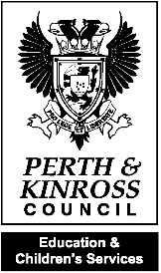
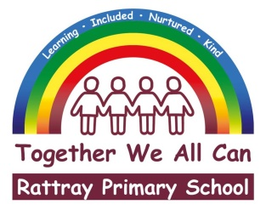
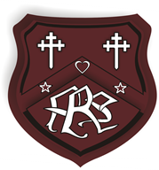

Prefects Learning Newsletter
March 2023

We wanted to share the fantastic learning that has been happening across the school this school term, which has been full of hard work, progress and fun. We have asked each class to provide us with some information about what has been going on in their classrooms. We hope you enjoy this newsletter.
P4/5 (Mrs Case/Mrs Murray)
This term, as part of Numeracy, P4/5 have been learning about different multiplication strategies – arrays, repeated addition, grouping and skip counting.

We have also been learning about patterns and how to work out the area of a rectangle, square and a triangle.

P4/5 have been learning about mountains for our IDL this term. The children have enjoyed creating PowerPoints about Mount Everest.
In PE, we have been developing our fitness and ball skills through different sport specific circuits such as rugby and hockey.
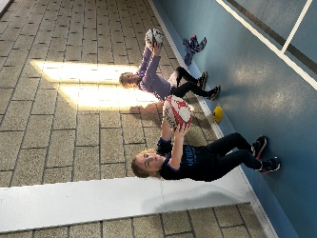
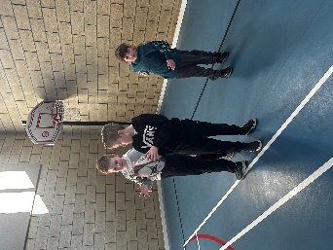
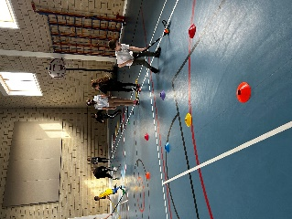

P4 (Ms Gregg)
P4 topic this term was Tourism in Scotland. We focussed on the journey from Blairgowrie to Glenshee. How the area has changed and how the Glenshee area is now used for Skiing and hill walking.

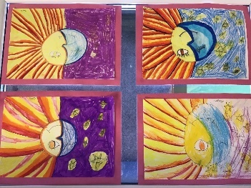
In Art, we have focussed on warm and cold colours, we worked on a piece entitled ‘Sun and Moon’.
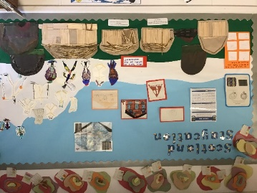
Our class especially enjoy playing chess. This is helping our maths, literacy and social skills.
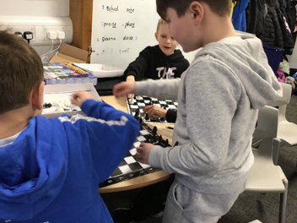

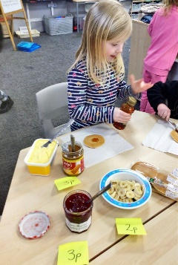
P1 (Miss McAlpine)
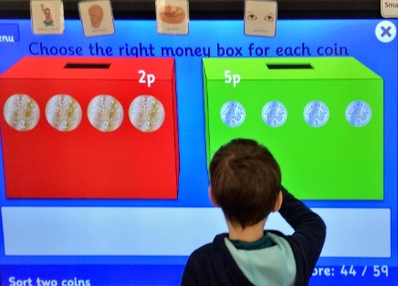

Primary 1 have been learning about money this term. We have been learning to identify coins up the value of £2 and have used coins to pay for items in our role play café. The children wanted to set up their own pancake shop in class and each child had 10p to spend on toppings. We applied addition skills to help us count the cost.
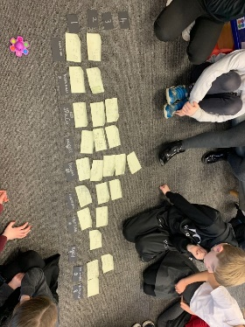
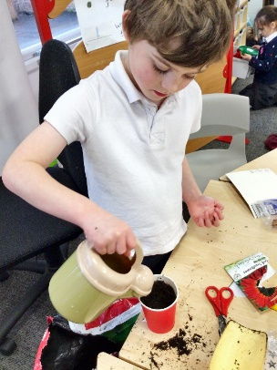
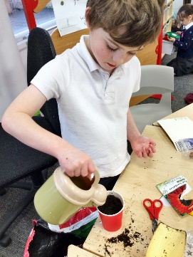
We have also been learning about Spring this term and have identified the changes that happen during this Season. As part of our learning, we identified some flowers that grow during Spring e.g. snowdrops and daffodils and produced some fantastic flower paintings. We have been exploring how to look after plants and had a go at planting our own sunflower seeds. We can’t wait to see how tall they grow!
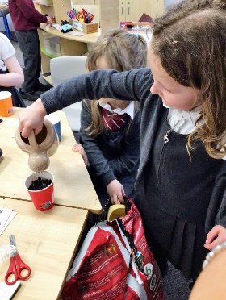

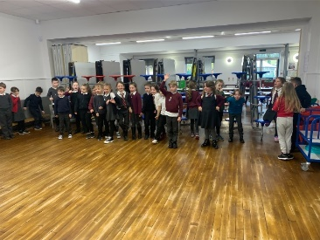
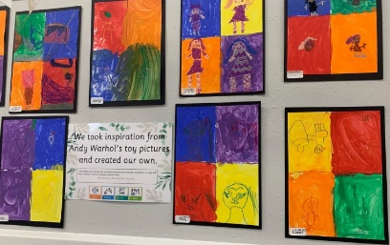
P2/3 (Mrs Russell)

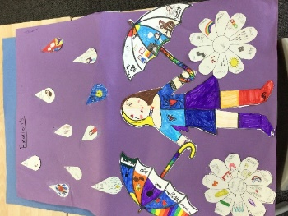
We have been very busy this term in P2/3. The children decided they wanted to find out about old toys. This included observational drawings of old toys and making a class non-fiction book. We really enjoyed using the old toys and exploring forces – ‘pushing and pulling’. We made our own ball and cup toy and had lots of fun pushing and pulling it to make it work. We also had fun finding out about the artist ‘Andy Warhol’ and creating our own toy pictures.
In Numeracy we have been learning about volume – we explored full/ empty/half full and looked at ml and l. We have been practising recall of our number bonds to 10 and we made a kite and a rainbow cloud to help us remember. We had a fun gym lesson learning about rounding numbers to the nearest 10. We had lots of exercise running to the cones to round the number up or down.
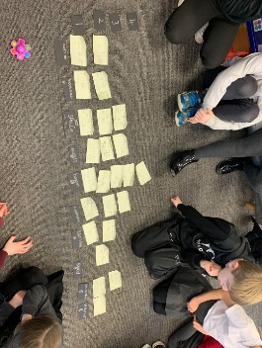
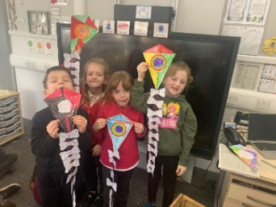
After our toys topic we all looked at ‘I wonder …’ questions to help decide our next topic. We then decided to categorise all our topics, this included – the body, dinosaurs, houses, technology etc. We used this opportunity to put our information together to make a graph.

P5 (Mrs Newlands)
This term p5 have been learning about landscapes and how they are formed. We started our topic by looking at our own communities. They created their own maps Blairgowrie and Rattray, including key features and relevant facts. The children were able to share the information gathered to the class. We have been developing our knowledge of Nepal and Everest. We were able to research, organise and present key information through use of PowerPoint.
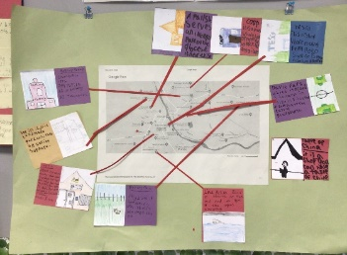

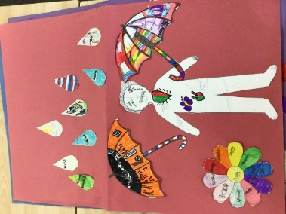
As part of Health and Wellbeing this term we have been exploring and developing strategies to cope with our emotions. We worked in groups to create our posters which included raindrops for our challenging emotions, flowers for our positive emotions and umbrellas to symbolise the strategies we can use to cope. We also explored how emotions affect the inside and outside of our bodies.

Nursery (Ms McCulloch)
Nursery have been very busy again learning a range of skills. We have all enjoyed reading at some traditional stories, such as Goldilocks and the Three Bears and the Three Little Pigs. We have talked about the characters and predicting what happens next. We have also been using the outdoor space to practise our ball and balancing skills.

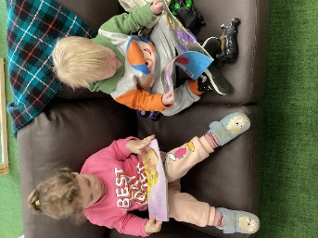
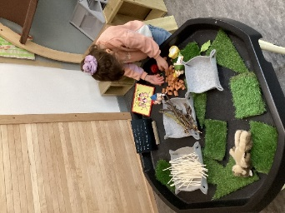
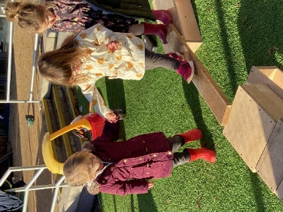

P6/7 (Miss Byrne)
P6/7 have been very busy lately, we have been learning all about Australia as our topic this term, and have learnt that aboriginal markings were part of storytelling. We took our learning outside and were creating stories through art and sharing these verbally. This approach is just like our new talk for writing learning scheme, where we have been sharing stories verbally before we start writing! With our literacy, we have been working on our inference skills, and drawing pictures based on a text we have read and then comparing what we have imagined. We then had some great discussions on the details that were not in the text that lots of the boys and girls included in their pictures.

We have also taken our numeracy outside and were learning the links between compass points and angles, and created some wonderful maps of the playground, you can see one here that shows our compass points on the map. We have a big focus on positive relationships at the minute with P6/7, and one of the ways we are working on this is through holding each other up! Learning all about using cues to help us balance. We have also been working hard on some presentations for our topic that we are planning on sharing with the other classes as we have all been learning about different aspects of Australian life! Our P7 contingent have had some transition time and had a very well received workshop all about the dangers of smoking with special guest appearances from Nicotiney Minaj among others!
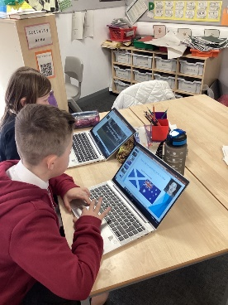
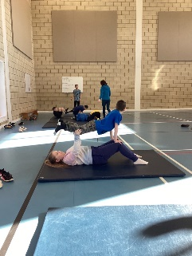
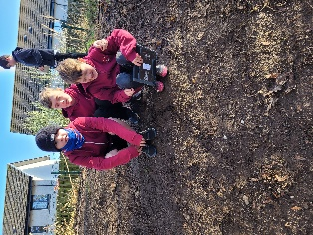

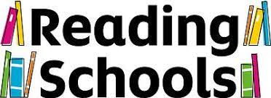
We are applying for the Reading Schools Award and for this we would like to recommend a few books that we have been reading.

P4 – The Minpins

‘It is so good to read.’ Max Pirie
‘It is an imaginative story, I really like the Minpin characters.’ Lewis Donaldson

P6 – Why the Whales Came

‘There is a mysterious character.’ Demi Mullen
‘I find it interesting.’ Alexia Burghenau
‘I like the boats on the beach.’ Reuben Brown

P2/3 - The Boy, the mole, the fox and the horse

‘It is very nice and all about feelings.’ Sara Ferguson.

If you would like to recommend a book that you enjoyed as a child, please discuss it at home with your child or perhaps send in a note so your child can share with their class.

P7 (Ms Garrett)
P7M have been busy learning about Australia especially focussing on Australian animals and aspects of the Outback. We have made individual Tourist Information booklets and created Aboriginal arts.
We enjoyed a talk from Ms Garrett’s daughter Emma who spent two years working and living in Australia and was able to further inform our knowledge and understanding of Australia.
Some class members, in the past few weeks, have been travelling up to Dunkeld for outdoor learning. They have so far been trekking and zip lining across a waterfall.
Local organisation SCYD have been visiting out class to deliver activities related to Substance Abuse.
Most members of the P7 classes participated in a whole day workshop run by Dundee based company called “Shaper Caper.” We learnt all about the dangers of smoking to our bodies and to the environment. As a finale we invited the remainder of the upper classes to watch a performance we created highlighting what we had learnt about smoking throughout the day.
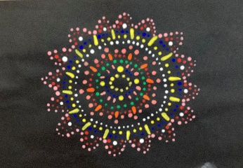

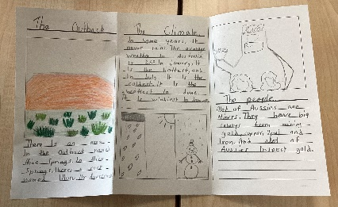

P6 (Miss Johnstone)
This term P6 have enjoyed improving our creative writing skills by exploring the text ‘The Canal’. We created our own characters, described different settings, and then wrote our own warning stories.

For our topic we have been learning all about Australia. Our favourite things have been learning about the different native animals and sea creatures, and making some delicious Australian cakes (Anzac biscuits and Lamingtons).
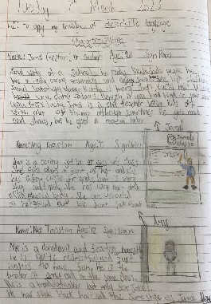
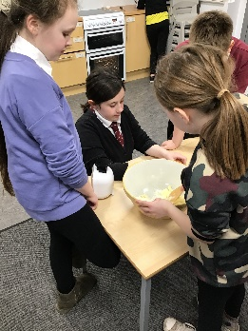
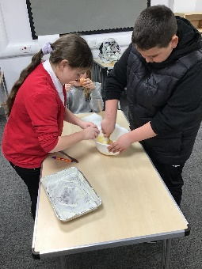

P3 (Miss Gunn)
This term, primary 3 have been learning about fractions. We have been learning how to find halves and quarters of shapes. We designed our own pizzas and then cut them up into quarters. Some of us have even found thirds and eighths!
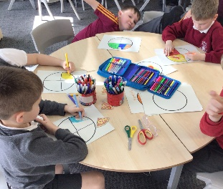
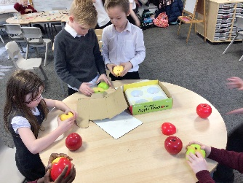
We have also been using fractions when learning how to measure volume. We have identified litres, half of a litre and quarters of a litre.

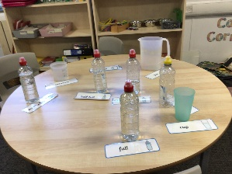

P1/2 (Miss Wigmore)
P1/2 have been very busy this term, we have learned about Chinese New Year, measuring, using 100 squares and Numicon for adding and subtraction. As a school we have started Talk 4 Writing and P1/2 are really enjoying this way of writing. We have started with warning stories and most recently the children have begun making story maps to retell a story. We have also been learning about spring, the children originally planted a bean in a clear bag as part of a science experiment, we have been monitoring them over the past 4 weeks to see what happens when the seed grows in the ground. This week we planted them in soil to continue growing at home.
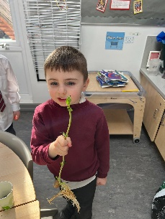
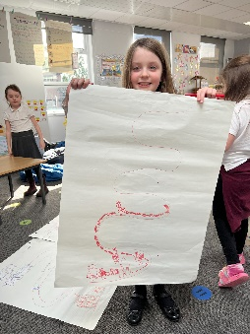
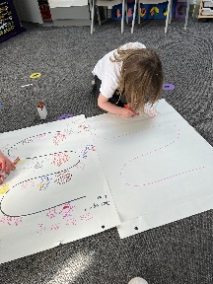
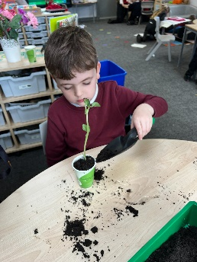
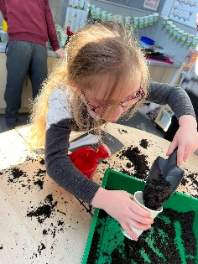

Thanks to all the classes and teachers for contributing to our learning newsletter.

