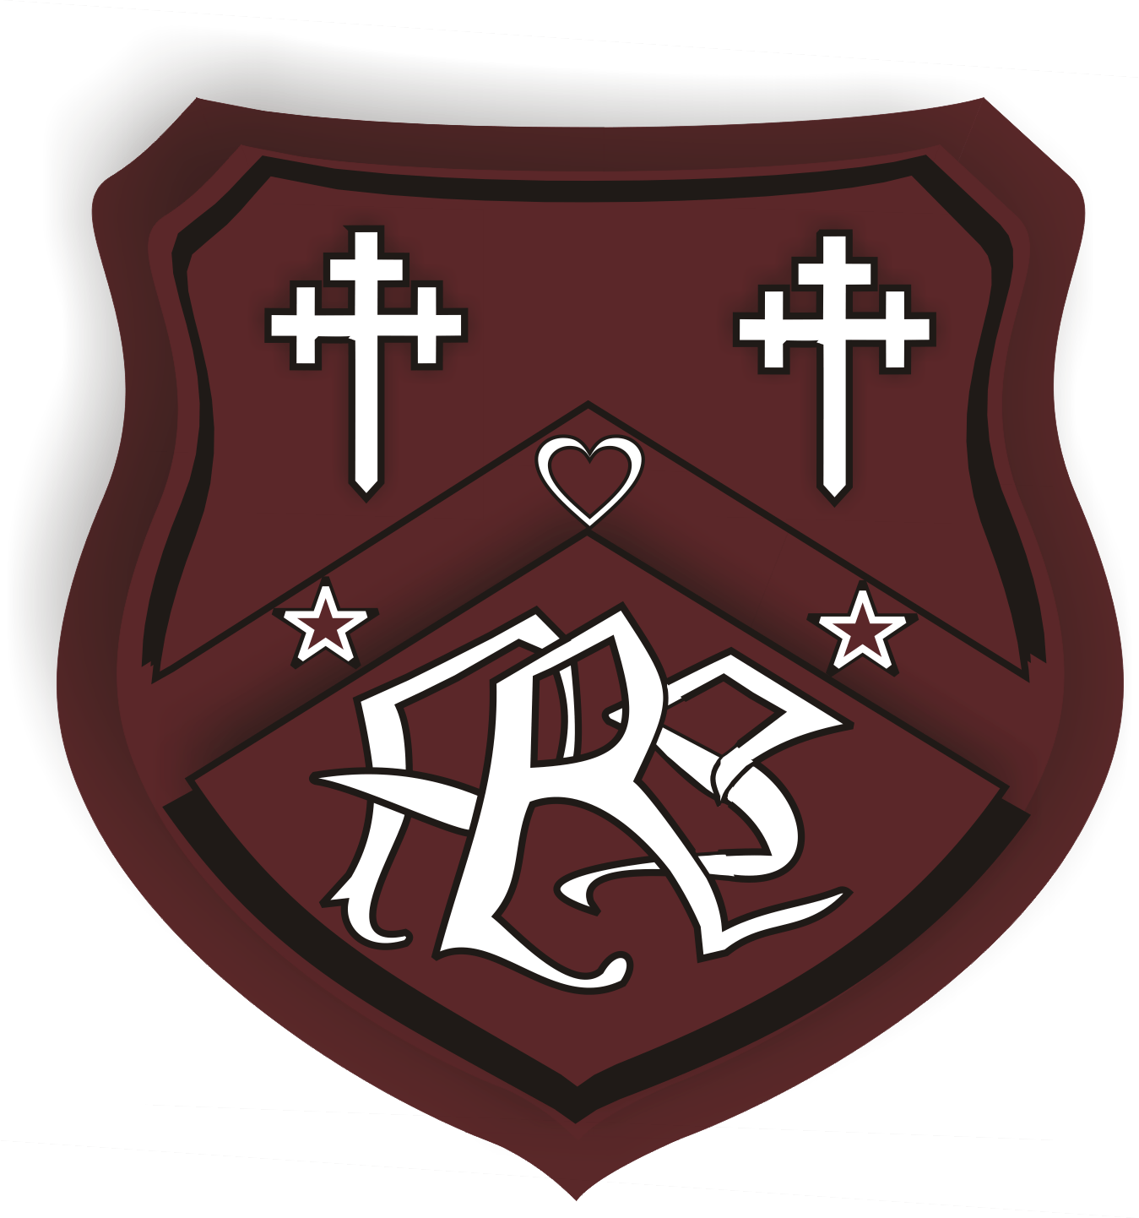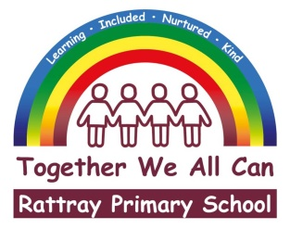

**CHRISTMAS 2024 ARRANGEMENTS**

It's that wonderful (some say stressful) time of year again, as Christmas is just around the corner here at Rattray! As we decorate our classrooms and spread holiday cheer throughout the school, the excitement of the festive season is already in the air in our school corridors and classrooms! Our dedicated staff have been working hard to make this a joyful and memorable time for all our pupils and their families, and I’d like to express my gratitude for their efforts.

We are very mindful that the rising cost of living may pose challenges for some families during this season. To ensure everyone can participate without added financial pressure, we’ve made our events free or low-cost. Despite these considerations, we’ve again managed to organise a fantastic lineup of festive activities for our children and our families to enjoy.

**Rattray Christmas Tree**

We are very fortunate again this year to be offered another Christmas Tree for our dining hall donated by the Miezitis Family. We expect to receive our tree later this week, and who knows it may even be delivered by the Grinch again! Our pupils are already hard at work making the decorations for our school tree

**Rattray Lights Switch-On at Rattray Cross – Saturday 30th November 4pm**

Our school has been approached by Rattray Community Council to participate in the re-established ‘Rattray Lights Switch-on’. Many of you who are ex-pupils or have older children in the school will recall that this was a Rattray community Christmas tradition for many a long year. Our P3 to P5 classes have been rehearsing with Ms Gregg some Christmas tunes to sing at Rattray Cross prior to the lights switch on. From these classes two lucky children (still to be chosen) will switch on the Rattray Christmas tree lights outside Rattray Church.

Following on with the tradition, after the Rattray lights are switched on there will be a procession from Rattray Cross to The Wellmeadow. The procession will arrive prior to the Blairgowrie Lights Switch-on.

Rattray Community Council are really keen to restore this Christmas tradition and would like to invite all our Rattray Families to participate in the event on Saturday 30th November at 4pm. Please note that whilst some staff will be in attendance, children must be accompanied by parents/carers or family members and staff members cannot supervise children at this community event. However, we do echo Rattray Community Council and urge you to attend this worthwhile and welcome event.

**Infant Nativity - Tuesday 10th December**

This year’s infant Nativity ‘A Midwife Crisis’ will be performed on Tuesday 10th December, at the times of 9.30am and 1.30pm. This year P1-3 will be leading the nativity, and you can expect to see the usual high standard of show you have become accustomed to. Entry to the event is a ‘food donation’ which will be used for our Christmas Hampers. Any surplus items will be donated to The Trussell Trust Foodbank. Tickets can be booked through the following links.

9.30am performance - <https://forms.office.com/e/4DFdtHD3k5>

1.30pm performance - <https://forms.office.com/e/z7d1YPx0SR>

Numbers are capped initially at 2 tickets per family. If there are further tickets available, these will be released in time. Before the morning performance and after the afternoon performance tea/coffee, mince pies and shortie will be available for everyone attending in our school GP room.

**Local Care Homes**

Once again, our older classes will be making Christmas cards and writing a personal letter to the residents of all Blairgowrie care homes. This will hopefully brighten up someone’s Christmas! Alongside this we have arranged for our P3/4 class to visit Stormont Care Home to sing to the residents on the afternoon of Wednesday 11th December.

**Nursery Christmas Parties – Wednesday 11th and Thursday 12th December**

On the above dates, our nursery Christmas parties will take place. Children can wear party dress to nursery on the above dates.

**Christmas Disco – Thursday 12th December**

All children (and staff) are invited to attend a disco on Thursday 12th December. This will take place in the school assembly hall from 6pm to 6.45pm for P1 to P3 pupils, and from 7pm to 8pm for P4-7 pupils. Entry is £2 per child and all proceeds will go to school funds. Party clothes or casual clothes can be worn. **Parent helpers are most definitely welcome!**

**Christmas Jumper Day - Friday 13th December**

On Friday 13th December we would like to invite everyone (pupils and staff) to dress up in a Christmas jumper or outfit or Dress down in casual clothes for Christmas jumper day.

**Christmas at the ‘Hub’ - Friday 13th December 2pm**

All the classes will join together in singing some festive favourites in the Rattray Community Connect building (The Hub) from. This will be held on Friday 13th December at 2:15pm. Entry to the event is a ‘food donation’ which will be used for our Christmas Hampers. Any surplus items will be donated to The Trussell Trust Foodbank. Christmas jumpers/clothing are a must! Tickets can be booked through the following link.

Christmas at the Hub - <https://forms.office.com/e/v18rkNkQRH>

Numbers are capped initially at 2 tickets per family If there are further tickets available, these will be released in time. After the performance tea/coffee, mince pies and shortie will be available for everyone attending in our school GP room.

**Santa Run – Monday 16th December**

On the above date we will be hosting our second Rattray Santa Run. All children from P1 – P7 will participate in a run or walk around the common followed by a fun outdoor disco during school hours. Children can wear a Santa hat or other festive head gear on this day to help with the festive feel!

**Class Christmas Parties – Tuesday 17th December**

On Tuesday 17th December we are going to be holding a whole school Pyjama Day. This will double as a Christmas party day for all our classes. We invite all children to wear pyjamas, onesies, or anything else festive. This will be worn outside during break and lunch time so needs to be weather appropriate! Please do not go to the expense of buying new clothing for this event. Each class is likely to watch a movie on this date, we will update as to what that is nearer the time.

**School Christmas Lunch – Tuesday 17th December**

School Cook Elaine and her wonderful team will be serving up Christmas Lunch on Christmas party day. That can be paid for, as usual, through parent pay.

**Pupil Festive Fun Day – Wednesday 18th and Thursday 19th December**

On these days pupils will be able to enjoy a variety of Christmas themed stalls such as Pin the Nose on Rudolph, Christmas Ping-Pong, Bouncy Castle, Festive Hot Chocolate, Higher and Lower and lots more. Children will be given two tokens to use on the stalls as a gift from the school and parents will have the opportunity to purchase additional tokens through Parent Pay for their children to use. One token will equal 50p.

Supporting this event supports our school, as any income gained contributes to all our Christmas activities.

**Nursery Christmas Activity and Song Day – Thursday 19th December (1.20 to 2.50pm)**

All nursery families are invited to attend the above event which will be held in our Early Childhood Centre. At 2.45pm there will be a celebration of next steps too.

**Christmas Hampers**

This year we are asking for donations towards our Christmas hampers which will be raffled through tickets bought on Parent Pay. Please send any donations to school with your child or pass them into the school office. The draw will take place on Thursday 19th December. All proceeds will be used to support school events, including this year’s Christmas activities. Thank you in advance for all your support.

**Last day of term**

Our school and early childhood centre closes for our Winter break at **12 noon** on **Friday 20th December**.

Thank you in advance for the support we will receive to make this a festive period to remember! If you have any questions or queries regarding any of the items within this newsletter, please don’t hesitate to contact the school office or the email address below.

Yours faithfully



Headteacher

[rattray@pkc.gov.uk](mailto:rattray@pkc.gov.uk)

01250 871980

|  |  |  |  |
| --- | --- | --- | --- |
| When | What | Who for | Anything else |
| Saturday 30th November  (4pm) | Rattray Christmas Lights Switch-On followed by Christmas procession to The Wellmeadow. | Primary School and Nursery pupils, staff, families and guests | Christmas Spirit and singing voices! |
| Tuesday 10th December  (9.30am and 1.30pm) | Infant Nativity | P1-3 families and guests | Book a ticket  Bring a food bank/hamper item |
| Wednesday 11th December (PM) | Nursery PM children Christmas Party | Nursery PM children | Wear party clothes |
| Thursday 12th December (AM) | Nursery AM children Christmas Party | Nursery AM children | Wear party clothes |
| Thursday 12th December | Christmas Disco | P1-3 pupils – 6 – 6.45pm  P4-7 pupils - 7 to 8pm | Wear party or casual clothes  £2 on the door |
| Friday 13th December | Christmas Jumper Day | Primary School and Nursery staff and pupils | Dress up with a Christmas jumper or outfit  Dress down in casual clothes |
| Friday 13th December | Carols in the Hub  (2pm) | Primary School and Nursery families and guests | Book a ticket  Bring a food bank/hamper item  Wear something Christmassy!! |
| Monday 16th December  2pm | Rattray Santa Run | Primary School and Nursery staff and pupils | Wear a Santa Hat or Christmas Headgear |
| Tuesday 17th December  (all day) | Christmas Party Day | Primary school pupils | Wear PJs or something relaxed |
| Tuesday 17th December | Christmas Lunch | Primary School and Nursery staff and pupils | Payment via ParentPay |
| Wednesday 18th and Thursday 19th December | Pupil Festive Fun day  (in -school event) | Primary school pupils | Buy tokens via ParentPay |
| Thursday 19th December | Christmas Hamper Draw | Primary School and Nursery staff and parents | Buy tickets via ParentPay |
| Thursday 19th December  (1.20 to 2.50pm) | Nursery Christmas Activity and Song Day | Nursery pupils and parents | x |