Prefect Learning Newsletter

December 2020

**Dear pupils, parent/carers and friends of Rattray,**

**It has been a great year for learning so far. Everyone in school has been discovering new ways of working due to living during a pandemic.**

**]**

**We, the Rattray Senior Prefects, have worked together to create this newsletter to share work from all our classes.**

**We hope you enjoying reading it.**

**P1M**

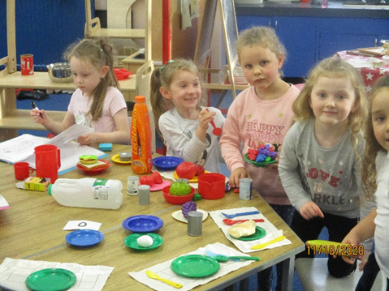P1M have been working hard this term.  Our topic has been about people who help us and the class have enjoyed looking at photos of Blairgowrie Fire Station.  In the classroom a café has been set up and this is a big hit!  The class enjoy pretending to cook food, setting tables, serving food and having tea parties.  Within maths the class have begun to look at adding small numbers and some are getting confident with adding to 5, while others have been learning to add 1 more to a number; everyone has enjoyed using lots of different items in the classroom to help their understanding.  Finally, P1M have been learning our new sounds and this is helping them to begin to blend some words together and helping with their reading.

**P5G**

This term has been very busy, learning all about different Scottish Inventors. We have created Fact Files and compiled individual booklets containing information about John Logie Baird, Charles McIntosh, Henry Faulds, Alexander Fleming and James Watt to mention just a few. As part of our homework we were asked to design then make our own invention to share in class. The ideas have been varied and amazing. There are many potential inventors in our midst!

We enjoyed our session orienteering and now have a better understanding of simple mapping.

In art, we drew some awesome poppies for Remembrance Day and observed the two-minute silence.

As the festive season fast approaches, we will be engaged in creating and filming a dance, making decorations for the school Christmas tree and enjoying the warmth, friendship and learning that takes place within our classroom.

**P3G**

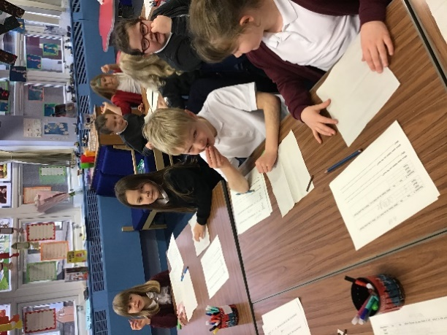

In P3G we have been exploring the world of Charlie and the Chocolate Factory.  We are reading the story and soon we will be planning and writing our own version.  We have investigated how chocolate is made and how Fairtrade can be important.

In Maths we are working with money, buying and giving change, recognising coins and making amounts.

P3 will also be starring in the school Nativity this year – Ready, Camel, Action.

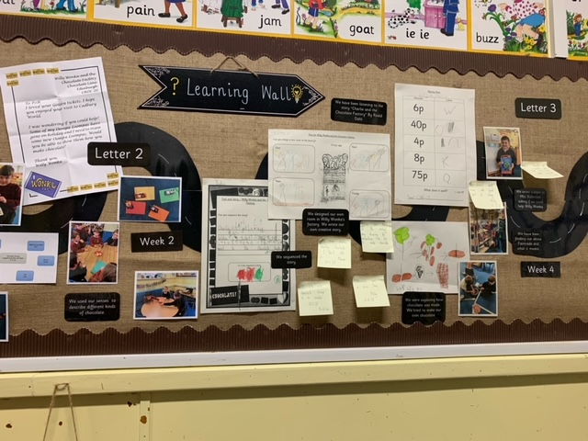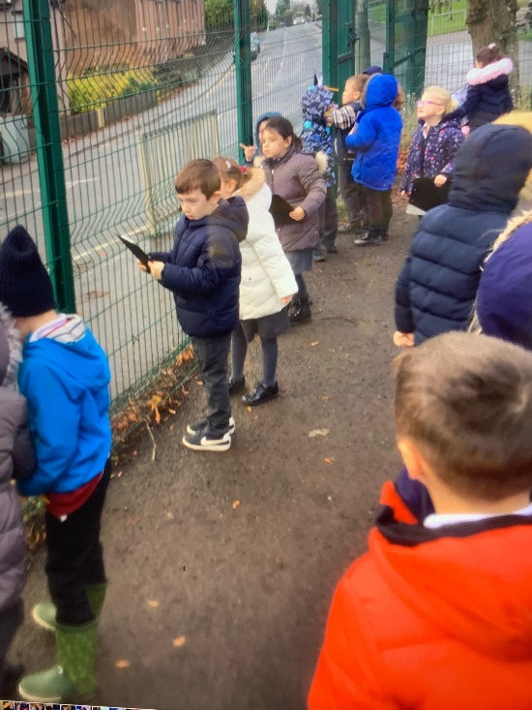**P1/2**

We have been learning about data collection and sorting. We went outside and counted cars. We sorted them into colours and then represented the data using tally marks.

We have also been learning about winter. In science we had balls of ice with an animal in each, we discussed how we thought they would melt and if we could use anything to make it melt faster. We used sand, salt, sugar, water and heat. We found that warm water was the quickest.

**P2R**

P2R have been learning about Charlie and the Chocolate factory. We received Letters from Willy Wonka asking if we could help him make new sweets/chocolates. We wrote a letter to Mrs Robertson asking if we could and she replied saying yes but only if she could be our official chocolate taster. We now have our own sweetie groups, we have called them Candy floss, Candy Cane, Fizz sweet and Fizzy Fudge. We are going to do some Enterprise

and sell them to our grown-ups. We have been preparing and learning a lot about money. This has been a busy term where we have also been creating our own Firework paintings and finding out about Remembrance day.

**P4/5**

We have been learning about Scottish Inventors and what they invented.   We have been creating instructions and made sandwiches to see if our instructions were correct.  It was such good fun!

In Maths we have been focusing on number work and are now working on multiplication and linking it to division.

We loved our glow stick dance that we did at Halloween.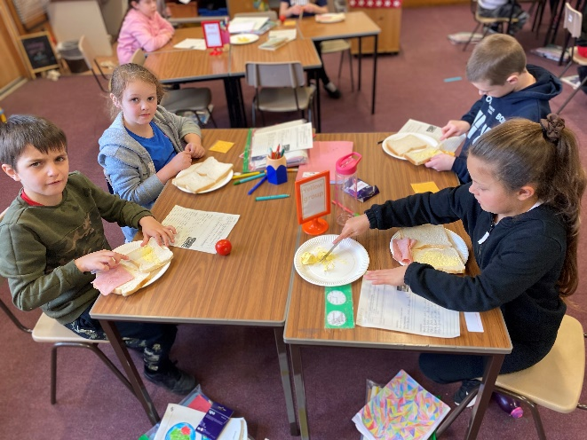

**P6M, P6/7 and P7J**

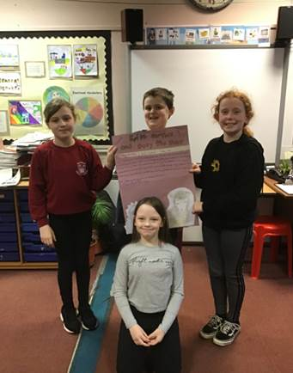

P6M, P6/7 and P7M have been investigating different Scottish inventors, and how their fantastic inventions have changed the modern world. They worked in cooperative learning groups to research their chosen inventor and together they created informative and attractive posters and fact files. The pupils have been applying their IT skills, using search engines to discover facts and information, as well as their social skills in working together and fulfilling their group responsibilities. Finally, they presented their findings to their peers and they shared their discoveries.

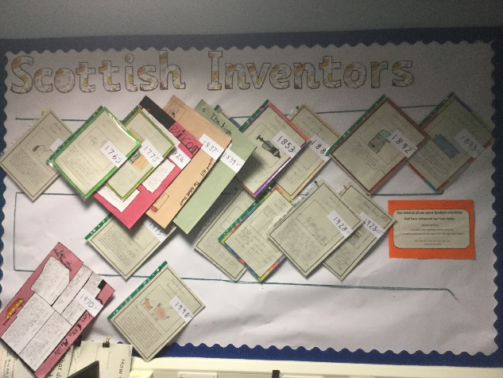

**P3/4**

This term P3/4 are really enjoying our Charlie and the Chocolate Factory topic. We have been reading the novel in class and used this as our inspiration to create and describe

our own inventing rooms, we then wrote imaginative stories about the adventures that happen in them. We have also been learning about Fairtrade and where chocolate comes from. In this photo we are sampling different types of chocolates and using our senses to help us identify them.

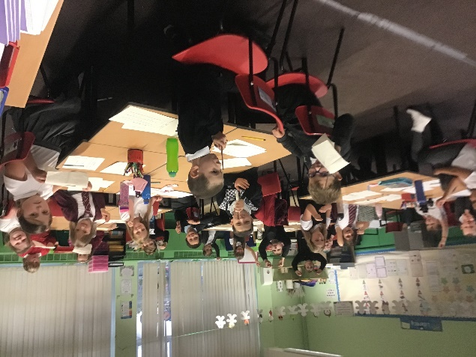

Thank you for taking the time to read our newsletter. We hope you enjoyed it and we look forward to creating another one again soon.

The Rattray Senior Prefects