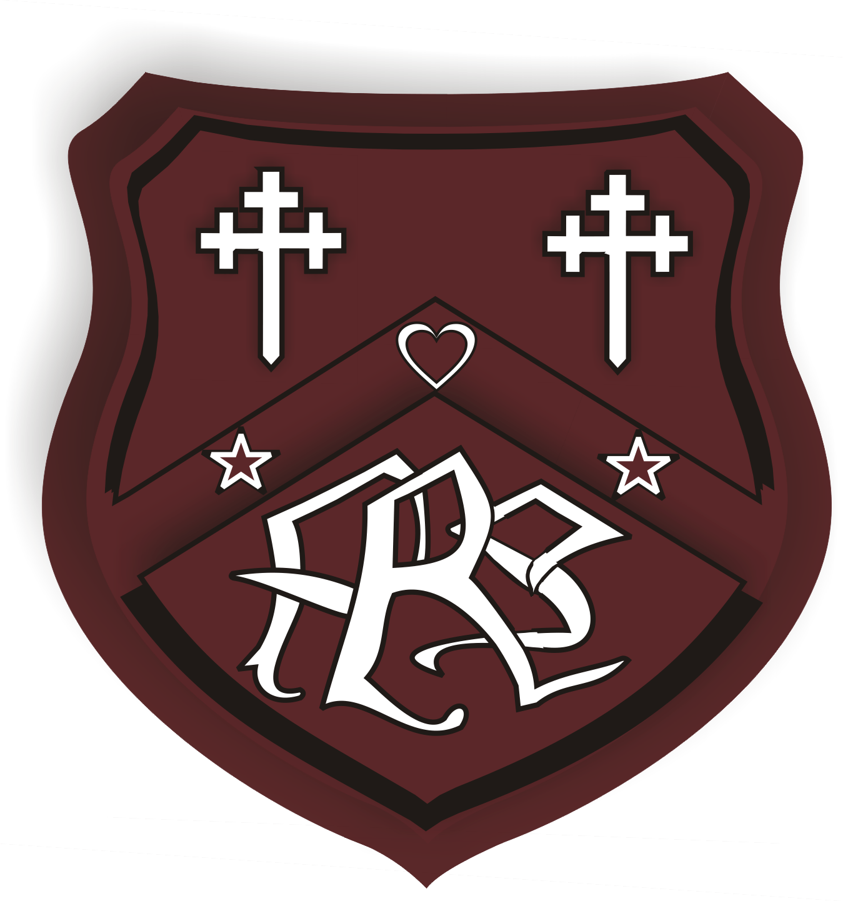

Rattray Primary School Sports Day

When? Wednesday 31st May 1.30pm (contingency date Wednesday 7th June)
Where? Davie Park 3G Football facility
Who? All P1-7 pupils
What should children wear? Sportswear and trainers
Food and drink? No food allowed, only water allowed on the pitch
Organisation? We will run both the infant and upper races side by side. The upper races will be held on the side of the pitch furthest away from the entry gate, whilst the infants will be held on the side closest to the entry gate.

Who can watch? All parents/carers/family friends are welcome to spectate. However, spectators are not allowed on the pitch and can spectate from around the other side of the pitch fence.

Can I help out? Yes please, to support the event we will require additional adult helpers to help with placings and scoring, if you can volunteer your time on this afternoon please get in touch with the school office, it would be greatly appreciated.

End of the day pick up? We are aware that many parents will want to take their children home straight from Davie Park. To allow us to do this in a safe way, we need you to complete the following form.
https://forms.office.com/e/qqaLBQiTGP
This will tell us:
- If your child will be collected by an adult from sports day
- If your child is to go home on their own from sports day approx. 2.45pm
- If your child is to return to Rattray PS where they will be dismissed at 3.20pm

If you do not complete the form, we will assume that your child is to return to the school and be dismissed at 3.20pm. The form will close at 9.15am on 30th May.

Anything else? Lunches will have different timings on sports, please get in touch with the school office if your child is a home lunch to confirm their class lunch time.

Finally huge thank you to Blairgowrie and Rattray Community Football Club for allowing us to hold this event on their 3G football facility.

