

**Education Resources**

Executive Director **Tony McDaid**

# High Mill Primary School

# Head Teacher: Kirstine McDonald

**22nd April 2021**

**Dear Parent**

**Rapid Coronavirus (COVID-19) Testing & COVID Mitigations**

There is currently a particular high number of COVID-19 positive cases within the Carluke area.

Due to this, rapid coronavirus (COVID-19) testing is now available for people without any symptoms at Asymptomatic Testing Centre at Carluke Lifestyles Centre from Wednesday 21 April 2021.  The community testing initiative aims to drive down COVID-19 rates and transmission by identifying positive cases more quickly, as people can spread the virus to others before symptoms appear.

You don’t need to book a test and can turn up at the Lifestyle Centre between 9:30am and 5:30pm.

At High Mill we have been fortunate not to have classes or groups of children unwell or self-isolating due to a positive case. In light of the increase of cases across the Carluke area, we ask that all adults continue to follow the COVID mitigations around the school. Please (unless exempt) wear mask or face covering and ensure that social distancing is followed. This is to ensure the school community; children, staff and parents are as safe as possible.

Your ongoing support is appreciated.

**Yours sincerely**

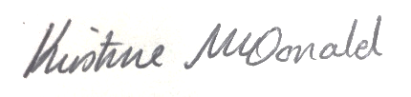

**Kirstine McDonald**

**(Head Teacher)**