
Sprouston Primary School
Sprouston Road
Sprouston
Kelso
Scottish Borders, TD5 8HP

Sprouston : 01573 224873
Ednam Primary : 01573 224172
 tamsin.ashby@scotborders.gov.uk website http://sprouston.scotborders.sch.uk
Mrs Catriona Finn – Headteacher, Sprouston & Ednam

June Newsletter



Last day of term - Wednesday 25th June
Upcoming Events

Sports Day - Monday 9th June
Starting at 1.30pm. All parents and family welcome to join us for the afternoon.
We are going to be doing things a little bit differently this year. Instead of lots of races we are having some fun games and a couple of races.
As usual please feel free to bring a picnic blanket / chairs / tea or coffee in a travel mug and settle in for an afternoon of fun. After the event, if we finish early, you are welcome to refill your tea and coffee in the school whilst the children have a play in the park.
Hopefully the weather will cooperate, if not our back up day is Monday 16th June.

Kelso Laddie Visit - Wednesday 18th June
The Kelso Laddie and his entourage will be joining us on the afternoon of our Summer Fair. More below.

P1 Moving on days – 16th and 17th June
New P1’s will be joining us for the morning on these days to get used to the school and meet all their new classmates, we are looking forward to welcoming them.

Summer Fair - Wednesday 18th June. 1.30 – 3pm
We are holding a Summer Fair in school. There will be lots going on through the afternoon. As part of the ‘Fiver’ enterprise challenge the children will be selling homemade items including jewellery and squishies. There will be a plant sale, lemonade stall and homemade cakes. We are very lucky to have Berwickshire Swap setting up with us for the afternoon too which should draw some crowds in to join us. We will be drawing the winner of the 50/50 lottery and the parent council will be providing tea, coffee and biscuits.
The Kelso Laddie will be also be joining us as our Fair coincides with his visit to the school.
It is going to be a great afternoon, we hope you can all come along and bring as many friends and family as you can.
50/50 Lottery – Forms and information has been sent out. Please send your forms back ASAP.

Rag Bag – We raised £32 with our last collection. Thank you to everyone who contributed.

Garden Centre Vouchers  Please remember if you make a purchase at any Klondyke garden centre, including Kelso, you can ask for ‘gardens for schools’ vouchers.  You will receive a gardens for schools voucher for every £10 spent in a single transaction in the Garden Centre or Coffee Shop.  For every 250 vouchers we collect we will get a £100 garden centre voucher.  You do have to ask for them though. | 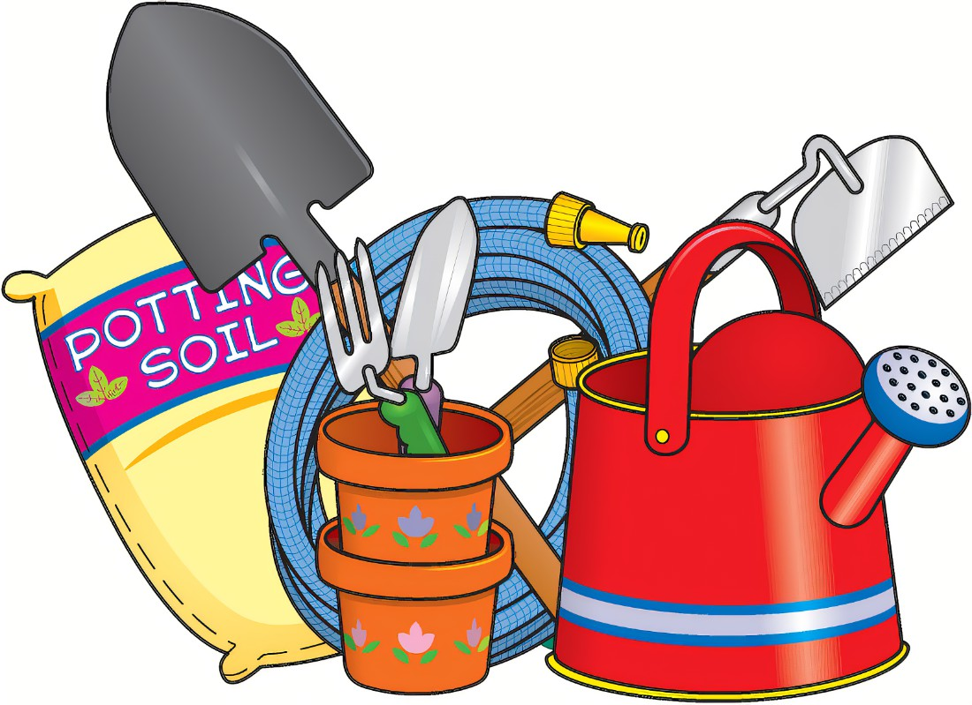
We have received our £100 gift card and worked out what to spend it on during our trip to the garden center. We purchased lots of gardening gloves for the class, a watering can, various plants and canes amongst other things.

At the moment we have 46 towards our next gift card! Thank you to those who have been collecting them and sending them in.

If you have not already done so, please sign up for the new Parents Portal

Have you signed-up to parentsportal.scot yet?
The parentsportal.scot app makes staying connected with your child’s school effortless. Favourite your most used services, check attendance, update contacts and their details, reply to permission slips and sign up for notifications to get quick access to important information. Available on App Store and Google Play. Download it now!

Lunches
We will need to place the order for the first couple of weeks back after the holidays before the end of this term. So we will take pupil’s lunch choices from their last orders for these weeks. Please go in and order for the third week onwards once the menus show on ParentPay.

Please remember to send children to school with a water bottle and a hat as the weather is heating up. Please also apply sunscreen to exposed areas.

Please remember to look regularly at the School Website / Facebook page for information, news and messages and don’t forget to use Easy Fundraising for online purchases ☺



