
Sprouston Primary School
Sprouston Road
Sprouston
Kelso
Scottish Borders TD5 8HP

Sprouston : 01573 224873
Ednam Primary : 01573 224172
 tamsin.ashby@scotborders.gov.uk website http://sprouston.scotborders.sch.uk
Mrs Catriona Finn – Headteacher, Sprouston & Ednam

August
Newsletter



It was lovely to see all our pupils back at school after the holidays and hear about all their adventures. We hope everyone had a relaxing and enjoyable summer.
---------------------------------------------------------------------------

Staffing
Head Teacher Mrs Catriona Finn
Principal Teacher Mrs Barbara Shiel based at Ednam Primary
P1-7 Mrs Angela Georgeson
Learning Support Mrs Isla Burgher
Classroom Assistant Mrs Heather Waddell
Additional Needs Assistant Mrs Lynn Wills
Music Ms Michelle Gillies
P.E. Miss Denise Fairbairn
School Administrator Mrs Tamsin Ashby
P/G Supervisors Mrs Heather Waddell and Mrs Tamsin Ashby
School Cook Miss Katharine Kokot
Janitor Mr Alan Currie

New Staff
Ms Wills – Additional Needs Assistant
Ms Gillies – New music teacher, taking over from Miss Scott

Roles and Responsibilities
Team Sprouston Captain: Archie
Junior Road Safety Officers: Lily and Evie

School Uniform
The children always look very smart in their school uniform. We ask that all children wear the school uniform of a navy blue sweatshirt / cardigan, white or light blue polo shirt, dark skirt / trousers or shorts, plain tights or socks and dark shoes. Girls may also wear gingham dresses during the warmer weather.
School uniform can be ordered from www.border-embroideries.co.uk
Can we ask you to label all items of clothing and gym kit. It makes it so much easier for us to reunite children with their lost belongings. Thank you.

Please make sure your child/ren has a pair of indoor shoes that they can keep at school to wear during the day.

PE
Children will be having PE lessons on Monday afternoons and Wednesday afternoons. Please remember to make sure that your child comes in dressed for PE on these days. The PE kit that we would like all pupils to wear, so that they all look smart as they will be wearing their PE kit for the whole day includes: Black or navy tracksuit bottoms / shorts, a plain T-shirt and their school jumpers.

Lunches
Please remember to book lunches at least 2 weeks in advance.
If you cancel any lunches after the orders have gone in please let Mrs Ashby know.

Please remember to send children to school with a water bottle and raincoat.
In line with Scottish Borders Council and Scottish Governments Healthy Schools guidance Water bottles must contain water only please and not juice.

Please make sure that your child has something healthy for a mid morning snack at school. Please keep chocolate bars / sweets / haribos for home treats. Thank you for your cooperation with this.

Playground supervision is from 8.25 – 8.40 before school starts. We ask that children do not come to school before this time.

Parking
Reminder that there is no parking for parents in the school grounds, unless the parent holds a blue badge. Parents should park along Dean Road and walk with children to the school. Please do not park on the grass.

Nametags
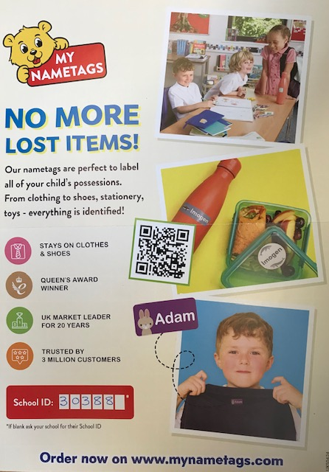 | My Nametags  If you want to order nametags for your child’s belongings. The school gets commission back on this website.  School Code: 30388  Order online, by going to www.MyNametags.com using the School ID above; (please insert your school id at the checkout page/delivery address)



Sprouston Primary School is registered with easyfundraising, which means you can raise FREE donations for us every time you shop online. Over 7,000 brands will donate to us when you use easyfundraising to shop with them – at no extra cost to yourself!

These donations really mount up and make a BIG difference to us, so we’d really appreciate it if you could take a moment to sign up and support us. It’s completely FREE and only takes a moment.

You can find our easyfundraising page at https://www.easyfundraising.org.uk/causes/sproustonps/?utm_medium=email&utm_campaign=pmc&utm_content=gs-email1

Please remember to look regularly at the School Website / Facebook page for information, news and messages and don’t forget to use Easy Fundraising for online purchases ☺



School term dates for 2024-25

Autumn term
- Monday 12 and Tuesday 13 August 2024 - Staff resume, In service days
- Wednesday 14 August 2024 - Pupils resume

Mid-term holidays
- Monday 14 October - Friday 18 October 2024
- Monday 21 October 2024 - In service day
- Tuesday 22 October 2024 - Pupils resume
- Monday 2 December 2024 - St Andrew's Day, schools closed
- Tuesday 3 December 2024 – Casual holiday, schools closed
- Wednesday 4 December 2024 - Pupils resume
- Friday 20 December 2024 - Last day of term

Christmas holidays
- Monday 23 December 2024 - Friday 3 January 2025

Winter/Spring term
- Monday 6 January 2025 - Term starts, all resume

Mid-term holiday
- Friday 14 February 2025 - Last day of term for pupils
- Monday 17 to Friday 21 February 2025 - Mid term break
- Monday 24 February 2025 - In service day
- Tuesday 25 February 2025 - all resume
- Friday 4 April 2025 - Last day of term

Easter holidays
- Monday 7 April to Friday 18 April 2025

Summer term
- Monday 21 April 2025 - Term starts

Mid-term holidays
- Monday 5 May 2025 - May Day holiday, schools closed
- Tuesday 6 May 2025 - Staff resume, In service day
- Wednesday 7 May 2025 - Pupils resume
- Wednesday 25 June 2025 - Last day of term

