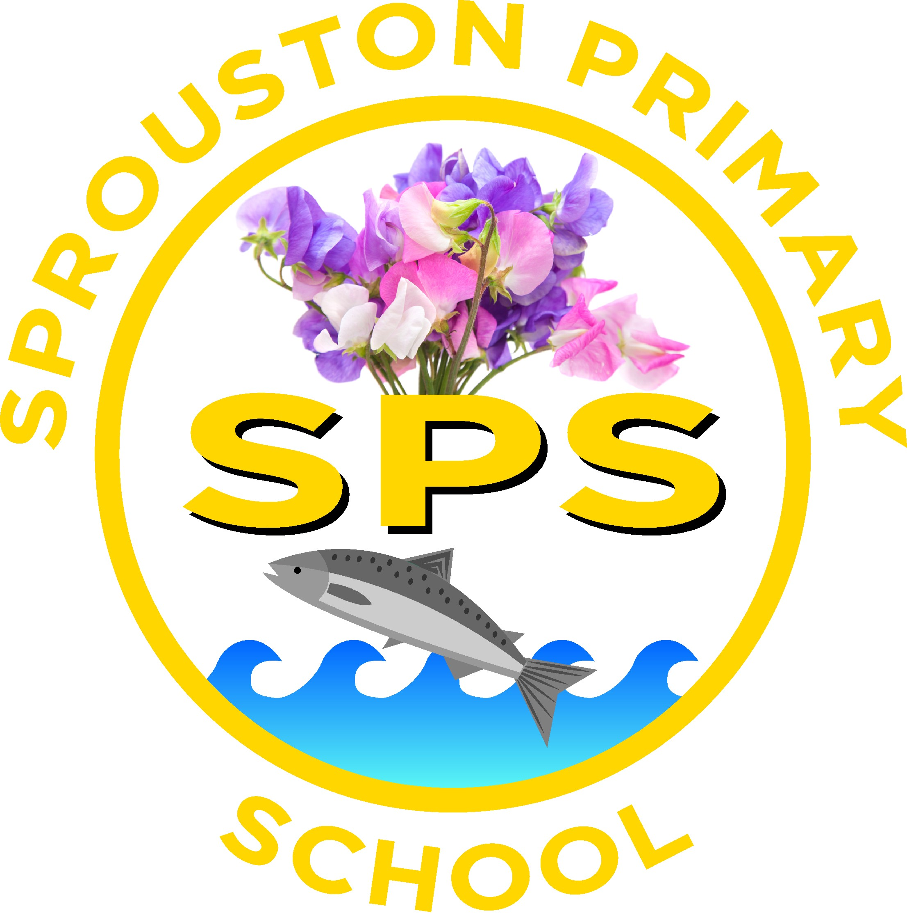
Sprouston Primary School
Sprouston Road
Sprouston
Kelso
Scottish Borders, TD5 8HP

Sprouston : 01573 224873
Ednam Primary : 01573 224172
 tamsin.ashby@scotborders.gov.uk website http://sprouston.scotborders.sch.uk
Mrs Catriona Finn – Headteacher, Sprouston & Ednam

March / April
Newsletter


Last Day of Term: Friday 4th April
Easter Holidays: Monday 7th – Friday 18th April

 | Robert Burns Poetry Competition  We took part in the Scotland Shop’s Burns Poetry Competition for Scottish Borders Primary Schools. Everyone did an amazing job with their entries and whilst we had no winners, we were very proud that Archie and Lily’s entries were ‘highly commended’ by the judges from the Borders Association of Burns Clubs and they both received a rosette.

Open Afternoon – 27th March, 2pm
All parents, family and friends are invited to come in and join us for an Open Afternoon and to see what we have been doing in school this term.

Edinburgh Museum Trip – Tuesday 1st April
We will be taking the class along with Ednam’s P5 and P6’s to Edinburgh for an educational visit to the National Museum of Scotland.
More information and consent will be in ParentPay shortly.

Library Bus
Our next visit will be on Wednesday 12th March. Please make sure that your child/ren bring their books back to return.

Lunches
Please remember to book lunches at least 2 weeks in advance. The further in advance you can book the better!
The menu will be changing after the Easter holidays, so menus will be sent home soon to mark your child/ren’s choices for the first 3 weeks.

Garden Centre Vouchers
Please remember if you make a purchase at any Klondyke garden centre, including Kelso, you can ask for ‘gardens for schools’ vouchers.
You will receive a gardens for schools voucher for every £10 spent in a single transaction in the Garden Centre or Coffee Shop.
For every 250 vouchers we collect we will get a £100 garden centre voucher.
You do have to ask for them though.
At the moment we have 205! Thank you to those who have been collecting them and sending them in.

Spare trousers and indoor shoes
Could all children please have a pair of indoor shoes to keep in school at all times. Also a spare pair of trousers or waterproof trousers that they can keep in their bags in case they need to change out of wet or muddy clothes.

Please remember to send children to school with a water bottle and a suitable coat for the weather, also hats and gloves are advisable

Please make sure that your child has something healthy for a mid morning snack at school. Please keep chocolate bars / sweets / haribos for home treats. Thank you for your cooperation with this.

Parent Council Meetings
Tuesday 4th March - 2.30pm
Tuesday 20th May - 2.30pm

Please remember to look regularly at the School Website / Facebook page for information, news and messages and don’t forget to use Easy Fundraising for online purchases ☺



Dates for your diary

27th March, 2pm – Open Afternoon
27th May – Parents Evening
9th June PM – Sports Day
16th June PM – Back up Sports Day
19th June – Celebration Assembly

School term dates for 2024-25

Winter/Spring term
- Monday 6 January 2025 - Term starts, all resume

Mid-term holiday
- Friday 14 February 2025 - Last day of term for pupils
- Monday 17 to Friday 21 February 2025 - Mid term break
- Monday 24 February 2025 - In service day
- Tuesday 25 February 2025 - all resume
- Friday 4 April 2025 - Last day of term

Easter holidays
- Monday 7 April to Friday 18 April 2025

Summer term
- Monday 21 April 2025 - Term starts

Mid-term holidays
- Monday 5 May 2025 - May Day holiday, schools closed
- Tuesday 6 May 2025 - Staff resume, In service day
- Wednesday 7 May 2025 - Pupils resume
- Wednesday 25 June 2025 - Last day of term

