Water Safety

During the school holidays, and in particular in hot weather, increasing numbers of children and young people put themselves at risk of drowning.
In 2018, 11 children aged under the age of 14 and 20 young people aged 15 to 19 years accidentally drowned in the UK, 26 were male and 5 female.
To keep yourself safe, when you are in, on or beside water, always follow the Water Safety Code.

The Water Safety Code
Spot the dangers! Water may look safe, but it can be dangerous. Learn to spot and keep away from dangers. You may swim well in a warm indoor pool, but that does not mean that you will be able to swim in cold water.
The dangers of water include:
- Very cold temperatures
- Hidden currents
- It can be deep
- It is difficult to estimate depth
- There may be hidden rubbish like shopping trolleys or broken glass
- It can be difficult to get out (steep slimy banks)
- No lifeguards
- Water pollution may make you ill
Take safety advice! - Special flags and notices may warn you of danger. Know what the signs mean and do what they tell you.
Go together! - Children should always go with an adult, not by themselves. An adult can point out dangers or help is somebody gets into trouble.
Learn how to help! - You may be able to help yourself and others if you know what to do in an emergency. If you see someone in difficulty, tell somebody, preferably a Lifeguard if there is one nearby, or go to the nearest telephone, dial 999, ask for the Police at inland water sites and the Coastguard at the beach.
Understanding Water Safety Signs and Symbols
At the seaside there is a flag system to let you know when and where it is safe to enter the water. If you follow these it means that a lifeguard can assist you if you get into difficulties while in the water.
If you do not use the flags there may be no one around to help you.
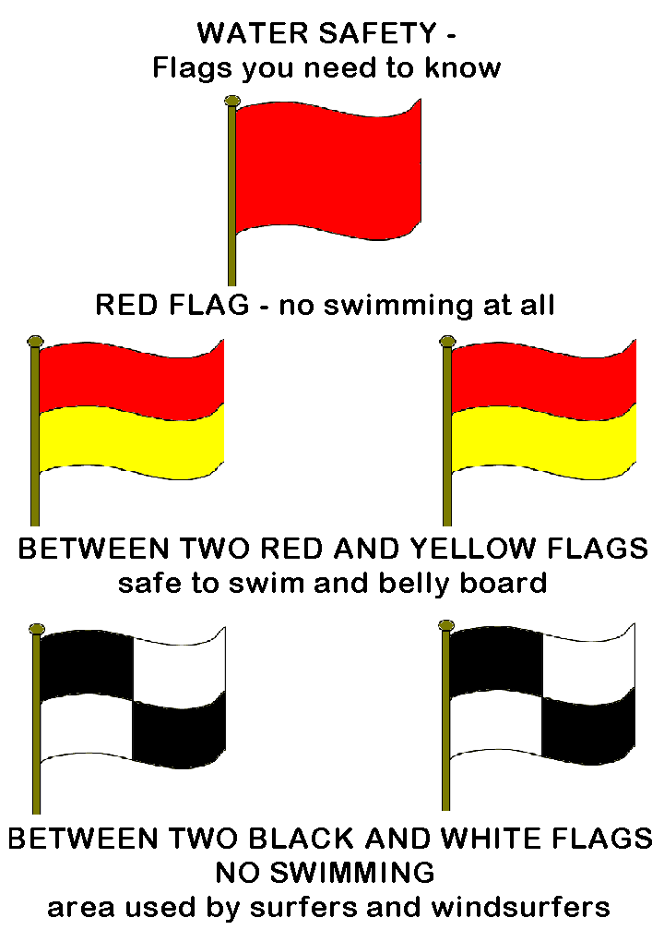
The red flag means it is dangerous to bathe or swim and you should not go into the water.
Red and yellow flags mean Lifeguards are on patrol. You should only swim or boogie board in the area between the flags.
The quartered black and white flag indicates the area zoned for surf craft and Malibu boards. It is not safe for swimmers and bathers.
There are also national water safety signs that are commonly used around the country. These let the public know what is safe to do on a particular stretch of water and what the dangers are. They can warn of dangers that the public may not be able to see themselves. Using the same signs around the country means that everyone can understand the messages wherever they are.
Some examples of national water safety signs are:

