
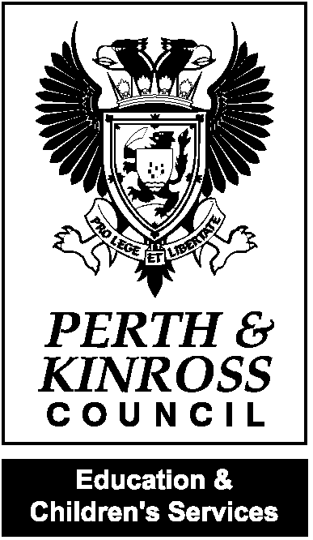


Rachel Cross
Headteacher
Health Promoting School
Awarded 2010

Kettins Primary School
Kettins
BLAIRGOWRIE
PH13 9JL
Tel 01250 871410
Email
kettins@pkc.gov.uk

Dear Parents/Carers,

It has been great to see all the children back in school this week. There are a few changes in school and a few reminders:

Communication

Over the lockdown period using teams and seesaw to communicate made things a little easier. Now we are back at school can we please ask that teachers are not messaged on either of these platforms. All communication should come through the school office via email, phone call or a pre-arranged appointment and will be passed on to the teacher.
We will be using the school app as our main platform to keep parents informed, this can be downloaded on a mobile device/ipad. Log in details are Username: KettinsPS Password: 4321 and all school trips/event information can be accessed parentpay. Payments can also be made here. Please access your parentpay account settings and ensure you have set this up to receive alerts/emails and your email address is up to date.

PE Days

Our PE days are
P1-3: Monday and Wednesday
P4-7: Tuesday and Thursday

Due to the current situation we are unable to change into PE clothing. Children are welcome to come in PE clothing on their PE days.

Lunchtime

From Monday 17th August our lunchtime break will begin at 12.35pm instead of 12.15pm.

Ipad Return

If you borrowed an ipad over the home learning period, please ensure these are now returned to school.

Tuckshop

As we are now a cashless school there will be no tuckshop facilities available. Please ensure your child has a snack for break time.

School must haves

In the current situation children should not bring backpacks to school. Children should bring their snack, packed lunch, water bottle, a hat for hot weather when required and apply sun cream before coming to school in the warmer weather. Water bottles are essential at present as the water fountain cannot be used to directly drink from.

Kind regards,

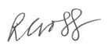

Rachel Cross
Headteacher Meigle and Kettins Primary Schools

