****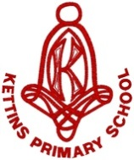



Health Promoting School

Since 2010

*“Our goal is to provide the knowledge, skills and mindset required for a successful future.”*

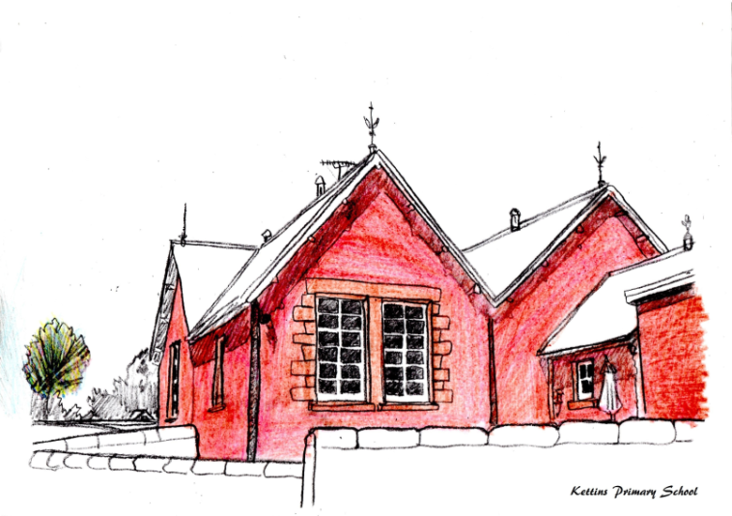

**KETTINS PRIMARY SCHOOL**

**Standards and Quality Report 2022-2023**

The purpose of this report is to share information on the impact that school improvement actions have had on pupils’ learning and progress over the course of this session. Using “How Good is Our School 4?” (Education Scotland 2015) our self-evaluation grades for key quality indicators are shown below.

|  |  |  |
| --- | --- | --- |
| **Quality Indicator** | | **Evaluation** |
| 1.3 Leadership of Change | Very Good | |
| 2.3 Learning, Teaching and Assessment: | Very Good | |
| 3.1 Ensuring Wellbeing, Equality and Inclusion | Very Good | |
| 3.2 Raising Attainment and Achievement: | Good | |

**Progress on Priorities**

Our priority areas for session 22-23 were to raise attainment in writing, enhance learning through digital technology and to review our curriculum. Good progress has been made towards our overall aims. Our progress against these priorities will inform next session’s Quality Improvement Plan. This report is evaluative and reflective of the various educational experiences over the last academic session and was produced in consultation with staff, parents and pupils.

**Miss Rachel Cross (Headteacher)**

**1 June 2023**

**LEADERSHIP**

The Head Teacher and Principal Teacher work effectively together as a Senior Leadership Team (SLT) with the Principal Teacher spending management days at Kettins on a fortnightly basis. Together, the SLT are united in their expectation that any change in school must result in a direct positive impact on learners. All staff are committed to the school and its community, sharing consistently high expectations for all learners. At school level, leadership of change is human-centered with all stakeholders involved in decision-making processes. Our collective ability to demonstrate flexibility in change has been reinforced by our continued ‘adapt, adopt, abandon’ approach to improvement. Leadership at Kettins is underpinned by our aspirational vision that all pupils have the knowledge, skills and mindset for a successful future. Our school values are very well embedded now and are collectively labelled as ‘The Kettins Promise’. Regular reference to our values has ensured these are a prominent feature of our daily school life.

Through our committee’s system, pupils identify changes that they can take forward. The Pupil Council allows children the chance to lead school improvement and make decisions about things that are important to them and their peers. The Rights Respecting Schools Committee and the Eco Schools Committee have worked in tandem this session to explore global citizenship, biodiversity and sustainable goals. The ‘Junior Leadership Team’ (JLT) platform enables pupils to play an active role in the evaluation of learning. Pupils tell us that they feel more empowered to talk about their learning.

In collegiate sessions, teaching staff regularly reflect on and show commitment to their professional values, as embedded in the GTCS standards. All staff embrace leadership roles explicitly linked to our Quality Improvement Plan with teachers engaging in training from a Writing specialist. The staff team completed the Digital Schools audit as a baseline for future action. Staff also attended three French moderation sessions with LMG colleagues. Senior leaders support staff in creativity, innovation and change. Time is protected for professional learning that focuses on improvement for our learners.

Our Parent Teacher Association (PTA) continued to grow this year with many new members supporting the school in regular termly meetings. Families have been the driving force for successful fundraising and social events. Parents provide feedback on our ‘Sharing the learning’ updates with jotters going home for a weekend every term. The response to our most recent Family Survey was extremely positive. Partnerships with parents continue to be very good. Parents contribute well to change and participated in engagement sessions around our current curriculum offer. This will inform future changes.

**Our progress in Leadership of Change this year is very good.**

**ATTENDANCE**

Arriving on time and attending school is essential for pupil learning and progress. Below is a review of attendance across the school for the last three years.

|  |  |  |  |
| --- | --- | --- | --- |
|  | June 2021 | June 2022 | June 2023 |
| Attendance | 95.6% | 95.8% | 94.0% |

**ATTAINMENT**

When tracking the progress that children make, we use CFE levels. Typically, Early Level covers Nursery and P1, First Level covers P2 – P4, and Second Level covers P5-P7. We currently record attainment levels for Literacy and Numeracy. When considering the statistics, it is important to remember that the figures reported refer to a stage and the specific group of children who make up that stage.

It is also significant to consider the impact that the Covid19 pandemic and periods of remote learning, will have on achievement of a level this session.

In **Primary 1** all pupils are on track to achieve Early Level Literacy and Early Level Numeracy.

In **Primary 4**, the majority of pupils are on track to achieve First Level in Literacy and all are on track to achieve First Numeracy.

In **Primary 7**, most pupils are on track to achieve Second Level in Literacy and all are on track to achieve Second Level Numeracy.

All being 100% Almost All being 91-99% Most being 76-90%

Majority being 51-75% Less (or fewer) than half being 16-50% A few being up to 15%

We have carefully identified our pupils who require additional help in some areas of learning. All pupils who have received targeted support have made good progress in their supported areas. Learners with Additional Support Needs are very well supported by classroom teachers, our Primary Pupil Support Teacher and Pupil Support Assistants. Learning experiences are carefully differentiated to ensure that all learners are progressing appropriately and experiencing success in their learning.

**ACHIEVEMENT**

We are very proud of the achievements of our pupils at Kettins Primary School. This session, we have celebrated many solo, group and class achievements, both within and out with school. Photographs have been showcased on our ‘Kettins Superstars’ wider achievement board in the school foyer. Our assembly certificates are tailored to correspond with our school improvement priorities. This has continued to raise the profile of our priorities and make pupils feel like part of the progress. Our system to track wider achievements for all from P1 through to P7 is being well used to record and monitor the opportunities and experiences on offer in school, the local community and beyond.

Led by our RRS Committee and class teachers, we were recently awarded Silver: Rights Aware, of the Unicef RRS Accreditation. Our report celebrates our school ethos of trust, respect and integrity. Pupils are incredibly proud of this achievement.

Some of our most notable achievements this year include our participation in Bikeability sessions, rugby, swimming, tennis and county sports. Our beautiful ‘Scottish Christmas’ collage featured in The Big, Big Art Project in Perth. With the support of the Gannochy Trust, Cat MacKay and Kelly McIntyre, we created a fantastic QR trail around our village and a videoclip to promote our school values. In developing skills for learning, life and work, all pupils in the school took part in soup making workshops with our Community Learning Assistant.

As a community, we have achieved our first joint carol service with Meigle Primary School and will host a joint sports day which will celebrate our shared school value of effort.

**Our progress in Raising Attainment and Achievement has been good this session.**

**Our progress in Ensuring wellbeing, equity and inclusion was very good this session.**

**Positive outcomes for children have been achieved.**

**LEARNING**

Learning and teaching at Kettins Primary School is underpinned by our vision, values and aims. The ethos and culture of our school reflects a commitment to positive relationships and children’s rights. Most pupils are eager and active participants in their learning who are engaged, resilient and motivated. Learning is enriched and supported by our effective use of digital technologies. Skillful questioning and engagement promote curiosity, independence and confidence and regularly enables higher-order thinking skills in all learners.

Our P1-P3 class are experts in using ‘Talk for Writing’ to support their creativity in literacy. Pupils in P4 to P7 enjoyed the opportunity to become Young Stem Leaders this session and shared their learning about micro: bits with the infants. Paired reading has learners at different ages and stages leading literacy activities with their tutee. Pupils have enjoyed workshops from the Guide Dogs, STEM ambassadors and Museum on the Mound in conjunction with Lloyds TSB.

A quality assurance programme is in place to monitor learning and teaching, and this was carried out throughout the school year. Learning and teaching was monitored in all classes by SLT to ensure appropriate pace and challenge for all learners. Sampling pupils’ work and tracking pupils’ attainment over time ensures progress, pace and challenge in learning. In both classes, learners have been observed actively engaged in relevant and interesting learning experiences with a high degree of enjoyment, such as Outdoor Learning and Digital Literacy. Learners select high quality resources including digital technology to enhance their learning experience. Lessons have been highly differentiated to provide both support and challenge for all our learners. Experiences are varied and matched to the needs and interests of pupils. Outdoor learning continues to be an integral part of the Kettins curriculum.

Pupils are actively involved in some areas of planning the learning. Pupils are also encouraged and empowered to express their views on how they are progressing. Pupils tell us that they enjoy time to set their own targets and to practice learning that they consider to be an area of specific needs. Optional brain breaks in literacy and numeracy are used well by pupils in both classes. Pupil focus groups show increased interest in the curriculum offer.

**Our progress in Learning, teaching and assessment was very good this session.**

**Improvement Priorities for 2023- 2024**

The outcomes that we will be focusing on achieving in the next academic year are:

* **Curriculum – Redesign our rationale**
* **Writing – Raise attainment in P2, 3, 4**
* **Digital Technology- Develop skills for learning, life and work**

These school priorities are in line with the National Priorities as outlined in the National Improvement Framework. The full Quality Improvement Plan is available on request at the school office from August 2023.