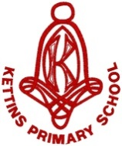****

*“Our goal is to provide the knowledge, skills and mindset required for a successful future.”*

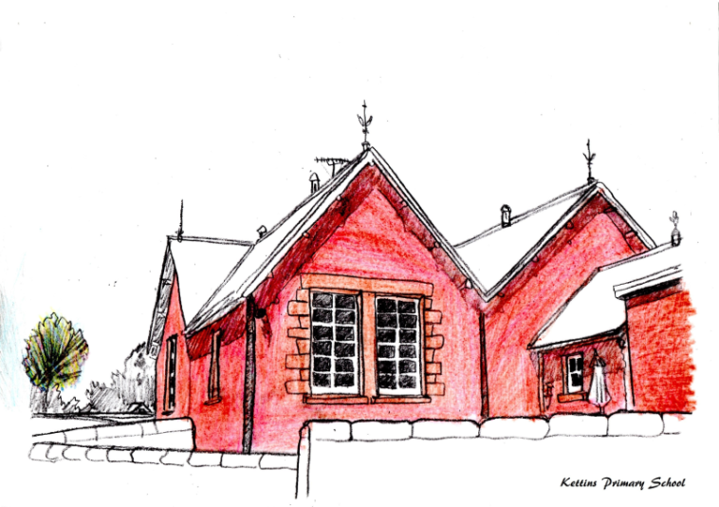

**KETTINS PRIMARY SCHOOL**

**Standards and Quality Report 2023-2024**

The purpose of this report is to share information on the impact that school improvement actions have had on pupils’ learning and progress over the course of this session. Using “How Good is Our School 4?” (Education Scotland 2015) our self-evaluation grades for key quality indicators are shown below.

|  |  |  |
| --- | --- | --- |
| **Quality Indicator** | | **Evaluation** |
| 1.3 Leadership of Change | Very Good | |
| 2.3 Learning, Teaching and Assessment: | Very Good | |
| 3.1 Ensuring Wellbeing, Equality and Inclusion | Very Good | |
| 3.2 Raising Attainment and Achievement: | Good | |

**Progress on Priorities**

Our priority areas for session 23-24 were to raise attainment in writing, enhance learning through digital technology and to review our curriculum. Good progress has been made towards our overall aims. Our progress against these priorities will inform next session’s Quality Improvement Plan. This report is evaluative and reflective of the various educational experiences over the last academic session and was produced in consultation with staff, parents and pupils.

**Miss Rachel Cross (Headteacher)**

**1 June 2024**

**LEADERSHIP**

Pupil leadership continues to develop at Kettins Primary School. This session our pupils have worked across four committees, now named ‘teams’, connected by their mutual interest in the Global Goals. Through involvement in their teams, children make decisions about things that are important to them and their peers. Pupils from P1-P7 planned, organised and delivered a MacMillan Afternoon Tea and invited our families to attend. This was a huge success. We introduced ‘Digital Champions’ this session, with pupils from P3 and P6 taking on additional responsibilities for our devices. The introduction of House Challenges has allowed pupils the opportunity to develop leadership skills like delegation, communication and self-awareness. Our work with our Community Learning Assistant this session connected us with the local toddler group and a group of pupils successfully leading an early year’s project. The P7 pupils have supported the monthly community village lunches.

Collegiate sessions are purposeful and are focused on meeting our improvement priorities. Teaching staff regularly reflect on and show commitment to their professional values, as embedded in the GTCS standards. All staff embrace leadership roles explicitly linked to our Quality Improvement Plan, engaging in both local and national training. Teachers participated in CLPL from Learning Through Landscapes to enhance their delivery of loose parts play. The Local Management Group in Blairgowrie have organised and taken part in French training sessions in order to collegiately ensure a smooth transition from primary to secondary school Modern Languages. Our PSA team benefited from PKC training, developing their confidence in the role of the adult in supporting additional support needs.

The Head Teacher and Principal Teacher work effectively together as a Senior Leadership Team (SLT) with the Principal Teacher spending one day per week out of class to support strategic development. Together, the SLT are united in their vision that any change in school must result in a positive impact on learners. Leadership at Kettins is underpinned by our aspirational vision that **all pupils have the knowledge, skills and mindset for a successful future**. Our school values are very well embedded and are collectively labelled; ‘The Kettins Promise’. Regular reference to our values has ensured these are a prominent within our school community, known by pupils, families and staff alike. At school level, leadership of change is values based with all stakeholders involved in decision-making processes.

Partnerships with families continue to be very good. Our active Parent Teacher Association (PTA) supports the school in hosting regular termly meetings. The PTA are the driving force for fundraising and social events. Families provide positive feedback on our ‘Sharing the learning’ updates with jotters and evidence of learning going home termly.

**Our progress in Leadership of Change this year is very good.**

**ATTENDANCE**

Arriving on time and attending school is essential for pupil learning and progress. Below is a review of attendance across the school for the last three years.

|  |  |  |  |
| --- | --- | --- | --- |
|  | June 2022 | June 2023 | June 2024 |
| Attendance | 95.8% | 94.0% | 96.0% |

**ATTAINMENT**

When tracking the progress that children make, we use CFE levels. Typically, Early Level covers Nursery and P1, First Level covers P2 – P4, and Second Level covers P5-P7. We currently record attainment levels for Literacy and Numeracy. When considering the statistics, it is important to remember that the figures reported refer to a stage and the specific group of children who make up that stage.

It is also significant to consider the impact that the Covid19 pandemic and periods of remote learning, will have on achievement of a level this session.

In **Primary 1,** all of pupils are on track to achieve Early Level Literacy and Early Level Numeracy.

In **Primary 4**, all pupils are on track to achieve First Level in Literacy and some are on track to achieve First Numeracy.

In **Primary 7**, the majority of pupils are on track to achieve Second Level in Literacy and Numeracy.

All being 100% Almost All being 91-99% Most being 76-90%

Majority being 51-75% Less (or fewer) than half being 16-50% A few being up to 15%

We have carefully identified our pupils who require additional help in some areas of learning. All pupils who have received targeted support have made good progress in their supported areas. Learners with Additional Support Needs are very well supported by classroom teachers, our Primary Pupil Support Teacher and Pupil Support Assistants.

**ACHIEVEMENT**

In March 2024, we were awarded the Digital Schools Award. Our report acknowledged the “rich and vibrant relationship that the pupils have with digital technology”. All classrooms are mature digital learning and teaching environments, where teachers and learners demonstrate the motivational capacity of digital technologies.

In May 2024, we achieved the Bronze Sport Scotland Award. This recognises our commitment to continuous improvement in school sport and physical activity.

We are proud of the opportunities for success and achievement that we create for our pupils. At Kettins Primary School, we track wider achievements from P1 to P7 to ensure that pupils take part in a variety of opportunities and events throughout their primary years. A selection of pupils from P3 and P4 represented the school in a tennis tournament. P6s pupils competed in the PKC Euro Quiz and P7s attended the Rotary Quiz. In addition to this, individual pupils participated in the Cross-Country Event at Scone Racecourse. A number of our pupils receive tuition from PKC Music Service and play in the Central Music Group.

To celebrate wider achievements out of school, photographs are displayed on our ‘Kettins Superstars’ achievement board in the school foyer. Our assembly certificates are tailored to correspond with our school improvement priorities. This has continued to raise the profile of our priorities and make pupils feel like part of the progress.

We have continued success this session in organising shared events with our sister school, Meigle Primary School, that celebrate our mutual school values. We shared a fantastic joint Carol Service Sports Day at Victory Park in Meigle, which was supported by Active Schools and our Community Link Worker.

**Our progress in Raising Attainment and Achievement has been good this session.**

**Our progress in Ensuring Wellbeing, Equity and Inclusion was very good this session.**

**Positive outcomes for children have been achieved.**

**LEARNING**

Our curriculum rationale is designed around the four contexts for learning; the life and ethos of the school, subjects and areas, interdisciplinary learning, and opportunities for achievement.

Learning and teaching at Kettins Primary School is underpinned by our vision, values and aims. The ethos and culture of our school reflects a commitment to positive relationships and children’s rights. Most pupils are eager and active participants in their learning who are engaged, resilient and motivated. Learning is enriched and supported by our effective use of digital technologies. Skilful questioning and engagement promote curiosity, independence and confidence and regularly enables higher-order thinking skills in all learners. Lessons are highly differentiated to provide both support and challenge for all our learners. Experiences are varied and matched to the needs and interests of pupils. Outdoor learning continues to be an integral part of the Kettins curriculum given our surroundings.

A quality assurance programme is in place to monitor learning and teaching across subject areas. Class visits this session have monitored appropriate pace and challenge in Literacy and Numeracy and the planned learning experiences within Digital Literacy. Sampling work and tracking pupils’ attainment over time ensures progress is recognised and built upon.

P1-P3 enjoyed a trip to a local farm and visits from RHET and Professor Potato which enhanced interdisciplinary learning topics across the terms. P4-P7 participated in Generation Science workshops on electricity and Saints in the Community workshops about racism. In addition to this, pupils in P4-P7 interviewed a local politician to further develop their knowledge about the Scottish Parliament. During ‘Values Fortnight’, all pupils enjoyed a visit from PC Blackhall who delivered a valuable input on his role within Police Scotland as our local Community Police Officer. In developing skills for life, our P7 pupils have embraced an intergenerational project visiting Balhousie care home on a weekly basis in term four.

Pupils are actively involved in aspects of planning their learning and in considering opportunities for achievement. Pupils are encouraged and empowered to express their views on how they are progressing using our ‘Learning Ladder’ as a supportive tool. The Learning Ladder has been shared with families this session to support discussion about learning at home. Through termly ‘Learning Conversations’ with the SLT and class teachers’ pupils tell us that they feel more skilled in talking about learning and have an enhanced understanding of progress in learning. Most can identify suitable next steps.

**Improvement Priorities for 2024-2025**

The outcomes that we will be focusing on achieving in the next academic year are:

* **Reading- build a culture of reading through participation in the Reading Schools Award.**
* **Numeracy- focus on high quality learning, teaching and assessment in numeracy.**
* **LMG priority-** A 3-year focus on sharing good practice in the moderation of Learning, Teaching and Assessment.  In 2024-25, all relevant staff across the LMG will share practice and undertake moderation activity with a particular focus on literacy or numeracy.

These school priorities are in line with the National Priorities as outlined in the National Improvement Framework. The full Quality Improvement Plan is available on request at the school office from 14 August 2024.